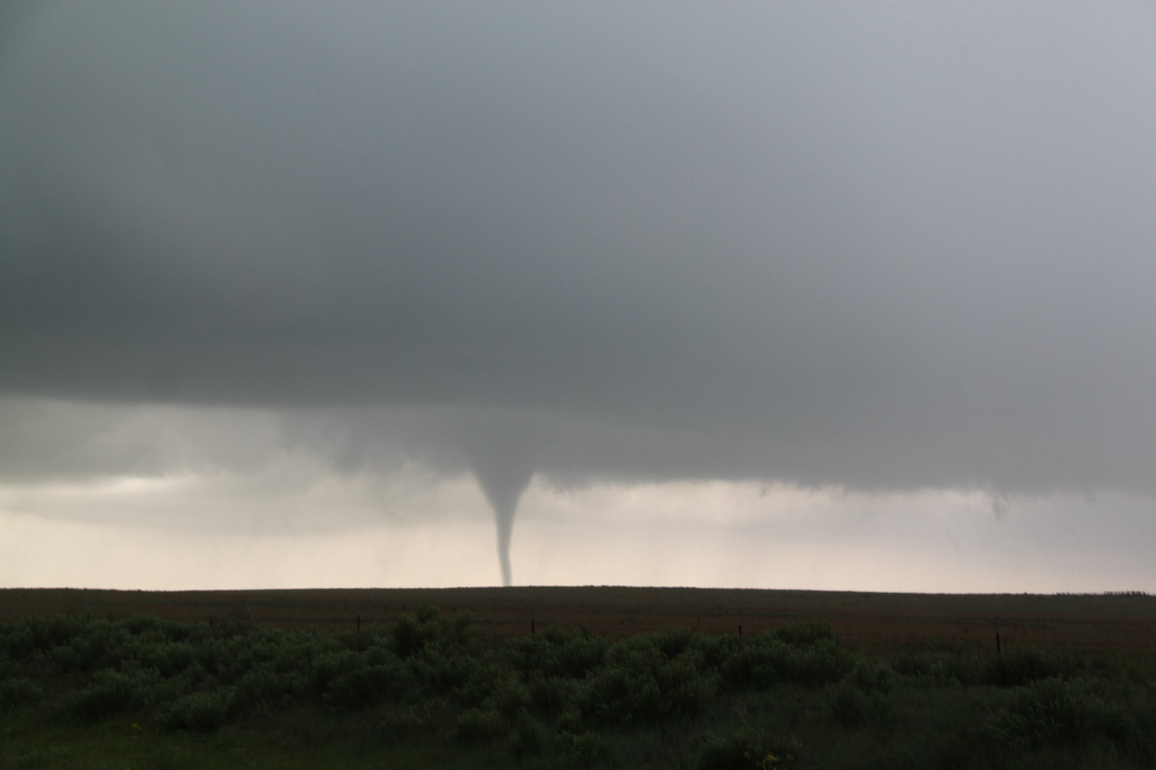

Silver Lining Tours
2017 Prime Time Tour
Daily Tour Log

Day 0: May 15th, 2017
Arrival day chasing!
I arrived at Will Rogers airport in OKC at Noon, and by 1 PM I had the keys to Van 2 and we were off to the Texas Panhandle with whatever guests were on hand. Our targets were split between storms projected to form along a shallow dry line west of Amarillo and a confluence zone north of Amarillo. Storm motion was going to be north-northeast and the storms would be moving pretty fast. We headed to Amarillo to see which solution would win out. The failure mechanism was that dew points were about 10 degrees lower than optimal, meaning that the storms would be very high based and thus limit the tornado potential. Hail and strong winds were the goal for the day.
Once in Amarillo, we stopped just northeast of town to wait a bit as towers bubbled up and down the line to our west. The northern option was looking better even though the dew points up there were only in the high 40’s, compared to low 60’s to the southwest. Nonetheless, things soon popped and we were quickly surrounded by pulsing severe storms. We decided to chase one to our north and headed up Rt. 87 towards Dumas after the best-looking storm at the time, also watching another to our southwest, and an isolated storm to our south east near Claude that looked like it might take over. We eventually decided that we’d never catch the northern storm, which was pulsing down regardless, and gave our attention to the storm that was now right to our west with a big visible hail core just west of the road. We turned around and tried to drop ourselves right in front of the core, but it missed us slightly and we were only pinged by nickel to quarter sized hail, though it was rock hard.
Ultimately, we shifted targets to the storm coming up from the south which we now almost east of us. We flew north, and then east on FTM 1913 out of Masterson/Four Way. About halfway to Lake Meredith, driving towards a brilliant rainbow, we plowed into the southern flank of the hail core, which now had maxed out VIL’s, and were pummeled by golf ball hail right at the edge. Not wanting to blow out the windshields before the tour even started, we let the big core cross the road right in front of us.
Meanwhile the storm developed a big hook echo almost right over us and in fact we effectively “hook punched” the storm, with violent rotation just south of the road with hail falling in a merry-go-round just a couple of hundred yards south of us coming straight at us, and the main core just to our northeast. We charged in between them and other than a few big stones that you could track individually as they fell out of the sky, we skirted east just before the southern hail core crossed the road behind us.
We were still in a hurry, however as the one road available to us turned northeast and we paralleled the big core, containing reported tennis ball and baseball sized hail (we heard of a few chasers losing their windshields) which was travelling about 50 mph just about ½ a mile west of us and closing along the same path. The structure was fantastic, with big striations and a nice wall cloud spinning like a top, albeit a mile off the ground, and hail pouring out of the precipitation core. Another storm just north of us in the meantime was dropping numerous repeating cloud-to-ground lightning bolts not far ahead.
In an attempt to beat the storm to Stinnett and buy ourselves some room to the east, we turned on to FTM 3995 through Sanford, and eventually FTM 687 as we headed for town, weaving through valleys and cool terrain all the while, stopping every so often to take some great structure shots. It soon became clear we wouldn’t be able to keep up with the storm for long, and since we were already looking at a 4-hour drive back to the hotel, we decided to peel off and head south for I-40, calling it a day. A fun warmup chase day and some great storm structure and big hail!
A long drive on pre-tour day, 612 miles.
Day 0 1630Z Convective Outlook, Tornado Probability, and Storm Report:
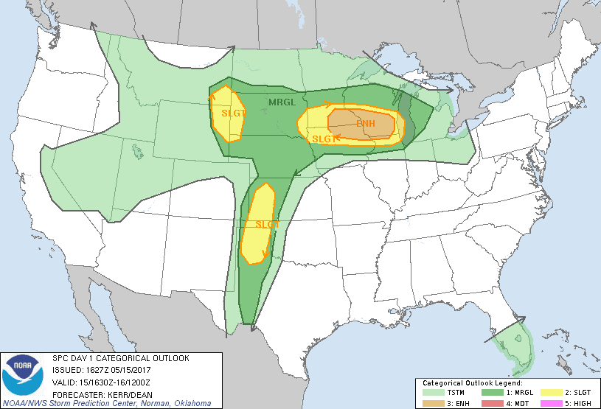
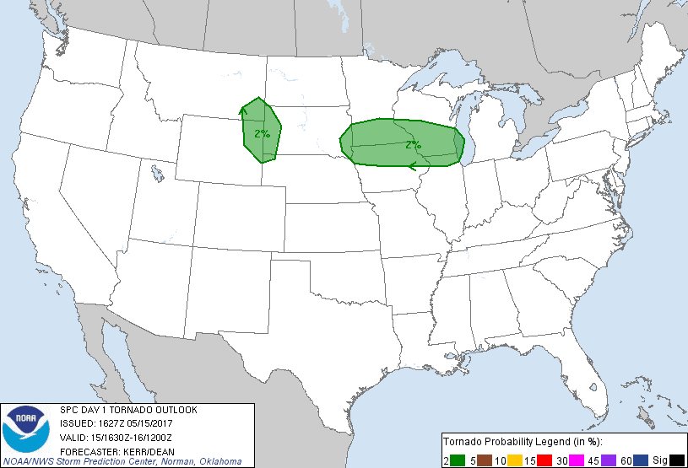

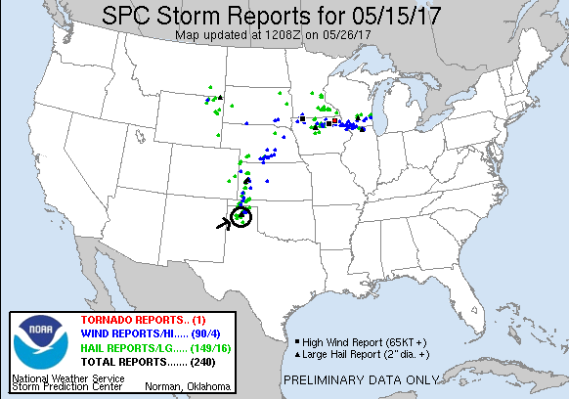
Day 1: May 16th, 2017
A fun, but challenging chase day! The setup was similar to the previous day except the dry line was sharper and better defined, and the moisture was better as well. There again were two distinct targets, though unlike the previous day it seemed clear that both might verify. The first target was along the frontal boundary in the northeast TX panhandle / eastern OK panhandle, and the second along the dry line down towards Childress. Storms were going to be moving fast from the southwest to northeast, and with large lapse rates big hail was definitely going to be in play. Although we generally liked the southern target better, traveling from OKC we didn’t need to decide and, like half the chasers in Oklahoma it seemed, we headed to Shamrock, TX to get into position where we could easily go north, west, or south as needed.
After lunch and a bit of a wait as storms bubbled up along on dry line and had already fired way up near the Oklahoma panhandle, we headed west on I-40 as a string of storms was coming up from the south. We met the first storm of interest around Alanreed, stopping on the service road just south of the highway and watching as a raggedy wall cloud zoomed across the highway and headed north. We were more interested in the next storm in line, so we headed south out of Alanreed on FTM 291, only to discover that the pavement ended a few miles south and the road was already muddy! We turned around and headed back north and then east on the highway again to get back in front of the storm, which had a second hook echo somewhat to the south of the original one. We made it to McLean then dropped a couple of miles south of town on Rt. 273 and watched as the storm came up from the southwest with a very long, broad base and a rotating wall cloud. We sat just on the edge of the front flank core as quarter to golf ball hail landed around us and suddenly a very stout funnel formed, not under the wall cloud, but in a separate area of the mesocyclone somewhat to its south heading almost directly at us, and soon, tornado!! It developed initially as a tall elephant trunk but soon morphed into a thick stovepipe heading generally in our direction.
As the tornado closed on us we needed to get north and east to stay with the storm, but now had a problem: the hail core was about to pass over I-40 and we needed to get to the highway then east to stay with what we thought could be a long track tornado (in fact it only lasted a few minutes). Thinking the hail wouldn’t be much larger than golf balls, we blasted north under copious amounts of hail and started heading east on I-40, and it looked like we’d make it out as the hail began to let up significantly until WHAM!! on the roof of the van, and then again, and again, and again, until the front windshields of all three vans were smashed by baseball to even softball (based on the size of one of the craters) sized hail!
Once clear, we quickly stopped to assess the damage but then we were right back off again, heading for a storm we’d been keeping an eye on for a while that had formed down near Turkey and was moving up from the southwest, already tornado warned. We zoomed east on I-40 back into Oklahoma and continued all the way to Sayre, stopping for a quick fuel up then heading south on Rt. 283 to get past the front-flank core and into position to see the updraft. As we headed south we received a report of a tornado in progress, though given the number of chasers who were there and the dearth of reports or pictures, that report may have been false. We found a good vantage near the entrance to Sayre Municipal Airport and parked there and waited for the updraft to come to us. As the cloud debris around us cleared out we were treated to a fantastic view of the storm’s rock-hard spiraling updraft up to 50,000 feet with two large inflow bands streaming into the base from the northeast and southeast. Hail was visibly pouring out of the vault region to our west, but as the mesocyclone got close enough to see, it was clear the storm was not producing a tornado, and didn’t look like it was imminently going to. Soon it was time to move but it was too late to go back north as the hail core was crossing the road up there already, and with our windshields compromised we couldn’t risk more big hail. We proceeded south on Rt. 283 to the junction of Rt. 34, but again, the fast-moving storm had already reached that road so we headed east on E1350.
Now we were debating: continue to try to get back to the northern storm, which was moving quickly away from us but now had a reported rain-wrapped tornado in it, or another storm coming up from Childress, TX to our southwest that was an easy intercept and also in better air. Ultimately, we decided the southern storm made more sense, and dropped south on Rt. 6 to intercept. Sadly, the northern storm ended up hitting Elk City, OK pretty hard and caused 2 fatalities.
Heading south, we passed through Granite under light anvil rain as we repeated the process of getting around the front flank core of a storm. As the Sun was starting to set, the sky had started to take on that orange-yellow glow to the clouds and rain, making for an eerie view. Arriving in Blair, we skirted east towards Warren and stopped to watch the oncoming storm which, despite a nice radar presentation, high VIL and tops approaching 50,000 feet, did not look very promising. One feature it did have was impressive was a massive inflow band coming in from the east, with the low-level inflow jet under it sucking dirt off the field into the storm. The inflow band was sucking in colder than expected air though, and was even raining out. This may have been the factor that kept the storm from really going off as the expected warm inflow really wasn’t there. We went back and forth on Rt. 19 around Warren for a while, then partially gave up and worked our way north and east toward Roosevelt. We stopped a couple of times along the way and as it got dark the storm became highly electrified, with smooth cloud-to-ground bolts hitting all around us west of Gotebo.
Eventually we called it a night and zigzagged north and mostly east to avoid the hail core from the storm all the way back to the hotel. The night wasn’t quite over yet as the guides and a couple of the guests watched as a severe squall line came through OKC, taking out the power for a couple of hours.
All and all a pretty cool chase day! We got a tornado, got smashed by big hail, and chased 4 strong storms.
Mileage for the day was 502 miles for a trip total of 1114 miles so far.

Day 1 1630Z Convective Outlook, Tornado Probability, and Storm Report:
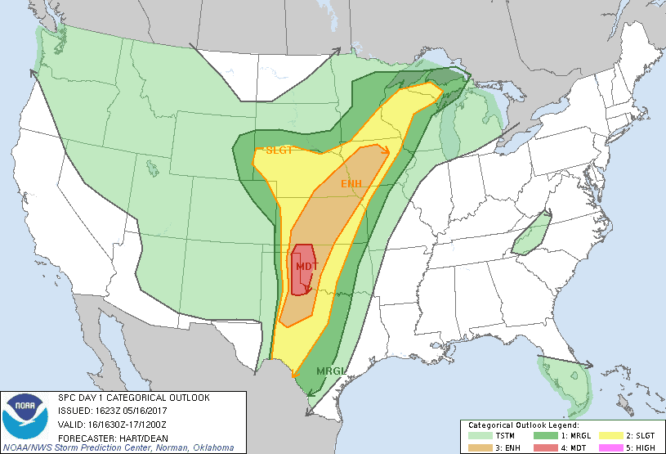
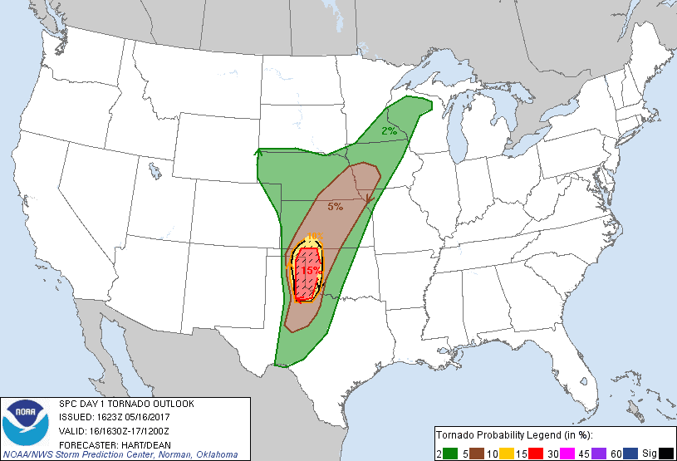
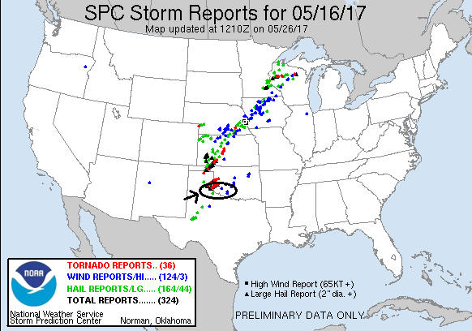
Day 2: May 17th, 2017:
A down day as the only potential chase location was eastern, IA which would have put us out of position for Thursday. Plus, we had to replace the windshields of all 3 vans.
Miles for the day: 1 mile! Trip total: 1115
Day 3: May 18th, 2017:
A High-Risk of severe weather, or, in storm chasing parlance, a high risk of a bust! We started the day in OKC, and with potential targets ranging from northwest Oklahoma to southwest Oklahoma, we started west on I-40. Though our initial choice of targets was in the Seiling area, we wanted to keep the southern option open and decided to head to Watonga and stop there and wait. As we reached Greenfield though, we decided to turn around and head back to I-40 as the model runs were progressively making the southern target look more appealing. We stopped in Hinton for lunch and to wait and see which target area would present the first opportunity. The way the models were developing it looked like early storms would fire in the Altus area and eventually line out, but then a secondary group of isolated supercells would fire along the OK/TX border and provide additional opportunities to chase.
After a wait of an hour or two, storms began to start popping not only up on the warm front, but also down the dry line. The one that immediately caught out attention was developing near Duke, OK and quickly had maxed-out VIL’s and cloud tops approaching 50,000 feet. We decided to go for it and blasted west on I-40 with the intent to meet the storm around Hobart. By the time we made it to Clinton and turned south on 183, the storm was tornado warned and soon produced two tornadoes well before we were able to get there. Once arriving in Hobart we headed west on Rt. 9 planning to go to Lone Wolf, but it became clear that we would not beat the hail there and instead dropped south on 2180 Rd. out of town to try and get around the core.
After some navigational fun, the wall cloud came into view, hanging low over the small mountains in that region of Oklahoma. We turned west to approach the storm and get around the hills and were treated to a neat view with the spinning wall cloud just over some low mountains. Soon the storm started wrapping up and generated a big funnel that made it about halfway to the ground, but then got disorganized and dissipated. We followed the storm north for a bit but then our attention was drawn to the tail-end storm near Vernon, TX that looked like it could take over the show, with tops near 60,000 ft., and a scorpion tail hook echo on radar. The storm in front of us looked raggedy and disorganized, so we ultimately violated one of the rules of storm chasing: Stay with your storm! The storm ended up producing another tornado about an hour later, though it was rain-wrapped.
We started blasting south and were in a hurry as we had to beat the new target storm to Oklaunion, TX or be cut off on the north side of the Red River. We got back to Rt. 183 in Roosevelt and rushed south, but by the time we made it to Frederick, it was clear we weren’t going to beat the hail core to the river crossing, so after a brief stop in Davidson we headed east to parallel the river on the Oklahoma side. Luckily, the storm wasn’t right-turning as hard as it had been and did indeed come across the river. We sat in Grandfield and waited for the storm to come to us. As the storm neared, it was showing signs of becoming a high-precipitation (HP) supercell, with that turquoise glow that says “big hail”. We adjusted just to the west of town then south on a gravel road and waited as the storm closed to where we could start to see details of the structure. That was a consistent theme of the day: lots of rain and cloud debris made for a gloomy, wet chase day. Finally, we saw the wall cloud area, low to the ground and developing a big inflow band stretching off to the northeast. We stayed and watched as long as we could as the hook wrapped up and it became more and more difficult to see the wall cloud through the rain and hail. In fact, we almost stayed too long as we suddenly had to beat-feet east to stay ahead of the monster core with 3” hail!
We raced east out of Grandfield on Rt. 70, then turned north at Randlett on Rt. 277 through Cookietown, then east towards Walters, staying with the rotating area of the storm. The rotation indicated on radar was very strong, but totally embedded in the hail core so we couldn’t see it. Wind and hail damage reports started popping up on Spotter Net as the big HP started gusting out. He headed east out of Walters and stopped on Rt. 53 in Corum, now that we were out of the rain, and waited for the storm to come to us again. Now, a little farther ahead of the storm, we could see the structure better: a striated updraft showing strong rotation, the green hail look, and a shark-toothed shelf cloud as the outflow rushed out ahead of the storm. We stuck around for as long as we could (again, almost too long!) and had to blast east as the core got to us. Around this time there was a report of 104 MPH winds in Walters, suggesting there may have been a brief tornado in there but again, we’d never have seen it. We charged east to Comanche then south to Addington. But at this point the storm was completely wrapped up, and with several other cells training along with it, it was quickly becoming a flash-flood machine. We decided to call it a day.
Turning west at Waurika, we cut through the weaker cores to the south of the main one, struggling through driving rain and a little bit of small hail until we hit the Interstate just west of Randlett, completing a big circle. As we headed north and stopped in Lawton for dinner, we were treated to a nice mammatus display with the setting Sun glowing orange off the clouds, and some great cloud to cloud lightning which persisted all the way to Oklahoma City.
All in all, another High-Risk bust. Giving up on our initial northern target was the fatal flaw, though given the way the models were trending hard to the south it made complete sense. Leaving the first storm “violated the rules” but ultimately the only difference staying with that storm would have made would maybe have been a brief glimpse at rain-wrapped tornado.
Miles for the day were 489 for a trip total of 1604 miles.
Day 3 1630Z Convective Outlook, Tornado Probability, and Storm Report:
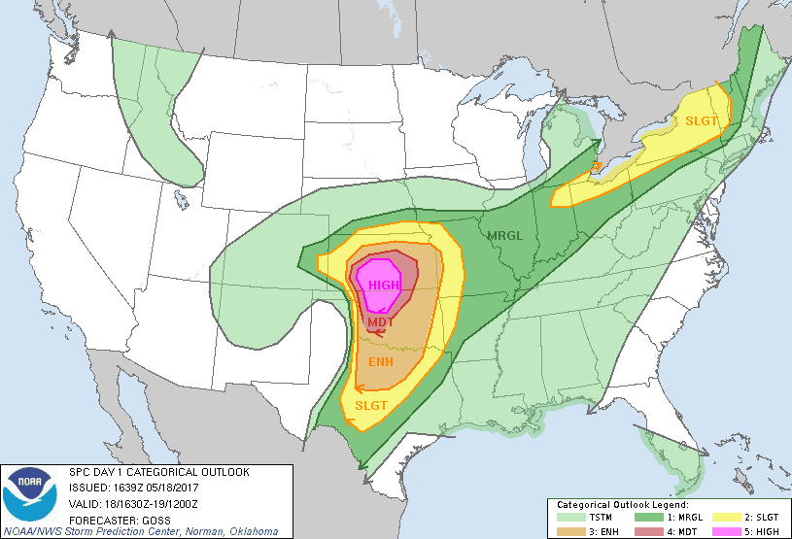
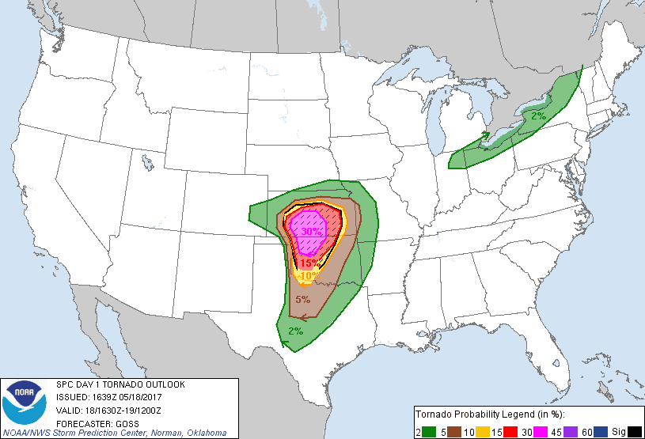
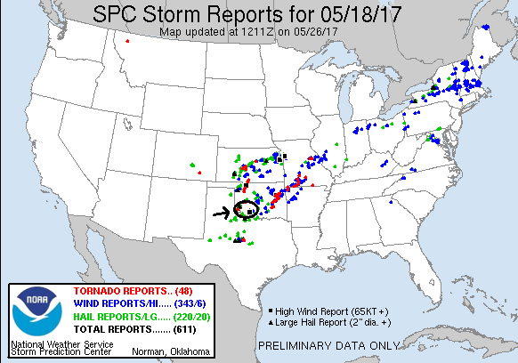

Day 4: May 19th, 2017:
A long day of driving with a nice reward at the end. The convection from yesterday had left a long line of storms extending the length of the front, and our play was to get as far south as we could to get on the tail end while some of those storms remained isolated. Models projected a couple of big supercells down near Abilene, so that was our initial destination. We headed out of OKC down I-44 towards Wichita Falls, TX and already there had been a tornado warned storm that reportedly had produced a tornado far to the south. As we got to Lawton, we faced a decision as to whether to blow the whole thing off and head for Illinois for the next day, but decided against it and crossed into Texas. After Wichita Falls we headed southwest to Seymour, skirting a storm there, then turned south on Rt. 283 through Throckmorton and all the way down to Baird on I-20, passing in and out of cores all the way. Once in Baird, our target storm, tornado warned and already with one reported tornado, was just to our southwest approaching Lawn, so we headed west off 283 on FTM 2926 for a roller-coaster ride of up and down hills towards Oplin, then onto FTM 604 to close on Lawn. Unfortunately, we realized that the rotation in this segment of the storm was completely embedded in the core, and the big hail was going to beat us to Lawn, so we retraced our steps out to 283 and headed about halfway to Coleman then stopped to wait for another tornado warned segment to meet us. Finally, as the storm approached you could begin to make out the features and it was clear that it was a big HP, and while striated and rotating, it was nowhere close to dropping a tornado.
Meanwhile, the very southern edge of the line appeared to be trying to break off and become isolated. It was clearly a supercell and had a pronounced hook echo on radar. We headed south to intercept the storm that had right-turned and was moving directly east. Right about this time, Verizon cell service went out for the whole area and would remain out for the next several hours so we were reliant on Mobile ThreatNet and visuals. We passed through Coleman and then a little southwest before hopping onto FTM1026 towards Gouldbusk, then turned west on FTM 317 and stopped to watch the storm come right to us. Like all of the storms for the last two days, it was a big high-precipitation supercell, so we had to wait for it to become more visible in the murk, and soon a whitish wall cloud with an inflow band was visible straight across the road ahead of us. The wall cloud wasn’t showing much sign of rotation even though the upper levels were spinning hard, and soon the more interesting features were the shelf cloud and the turquoise glow that again said “big hail”. GRLevel3 was showing maxed out VIL’s and 3” hail, so we could not mess with the core. We eventually had to leave our position and took FTM 1026 back to 283 and stopped again south of Santa Anna.
We watched again as the big HP moose came towards us and the hail roar was constant and loud. We hung out as long as we could, watching the brilliant colors of the hail core… once again almost too long as it turned out as we had to race the core to Santa Anna and get east on Rt. 84 towards Brownwood to stay ahead of it. Eventually the storm was re-tornado warned, and after passing through Brownwood into Early we circled back around town to the south on FTM 2126, onto Rt. 377, and then FTM 1176 about 3 miles southwest of town to watch the big HP coming at us as the tornado sirens in Brownwood began sounding. The hail core was massive but there was also a distinct lowering under the meso on the nose of the core towards Bangs, and as we stretched our vision trying to see if anything as going on under the lowering, a funnel seemed to extend then FLASH! A power flash confirming a tornado! Several other spotters who were closer also saw it. From our vantage, you could barely see it and it probably only lasted a minute or two, but it was confirmed.
We watched for several more minutes until the core was almost right on top of us then headed back east on Rt. 377 and through Brownwood again, stopping once more to see the big core coming at us. As it got dark, we broke off the chase and called it a night. After stopping in Stephenville for dinner however, the storms had caught back up and we had to drive through heavy cores all the way to the hotel, beating the storm into Weatherford by only a few minutes. We scrambled to get the vans unloaded in the high winds, with cloud to ground lightning banging closely all around us! Finally, everyone had their keys and we dumped our stuff in the rooms and then watched the lightning show for the next half-hour or so before it passed. A fun, LONG chase day in the end!
Miles for the day were 562 for a trip total of 2166 miles.
Day 4 1630Z Convective Outlook, Tornado Probability, and Storm Report:
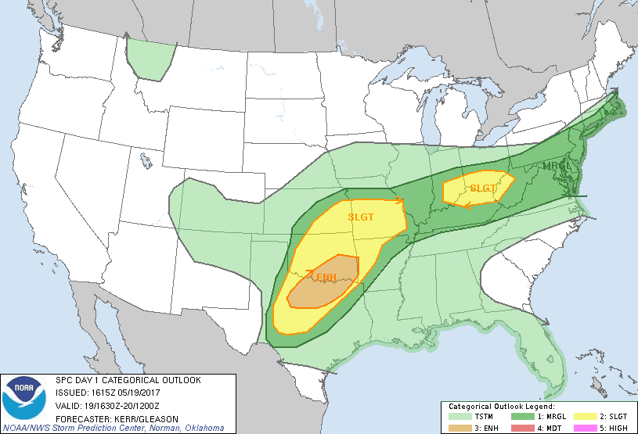
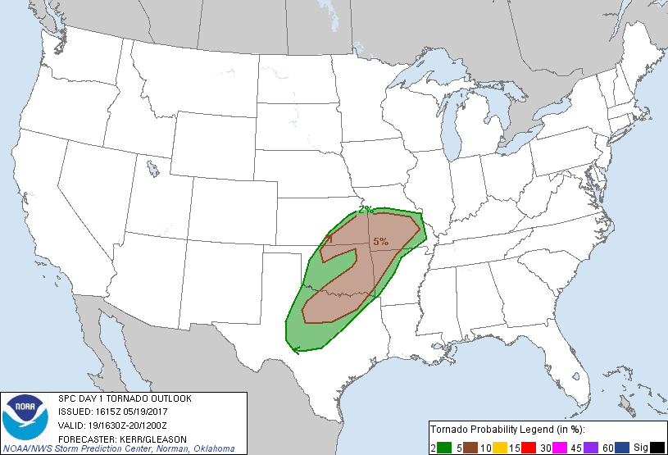
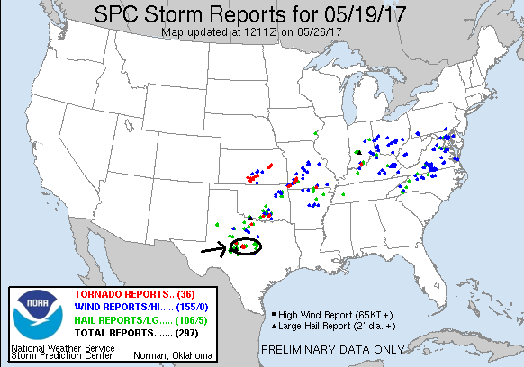

Day 5: May 20th, 2017:
Today was a surprise structure-fest. Having elected not to go to Arkansas or Illinois to play the warm front (thank goodness we didn’t as there was not a single storm report in either state before dark) we had no choice but to play the cold front as it pushed into far southern Texas south of San Antonio. The models were pretty gloomy in their outlook for the day but as there was nowhere else to chase today or tomorrow, we headed south out of Weatherford on I-35, passing through Waco and Austin, two Texas cities I’d never been through. In fact, the chase area today was the farthest south I’ve chased, never before having chased south of San Antonio.
After battling our way through heavy traffic all the way to the northern approaches of San Antonio, we targeted a storm to the southwest of the city that had been anchored there all day since the morning and according to one report had produced 7” of rain in a 2-hour period at one point. The HRRR model projected that the storm would finally start moving with the front into Duval County, and as we got closer it appeared it was doing just that and was showing big hail, a well pronounced hook echo, and strong rotation. The 19Z HRRR run also showed a meso-low developing in the area, enhancing the 850mb and 700mb flow and creating enough shear such that it could support discrete supercells if the model verified.
We skirted San Antonio to the east to stay out of the traffic, eventually connecting with I-37 and heading south from there as our storm had back-built, with the southwest cell taking over the show near Encinal. One plus of chasing near a city is that there are usually good road options. At George West, we turned southwest toward Freer on Rt. 59 (having passed right by the hotel we were staying at later) and were now finally within 50 miles of the storm after driving all day. But, as we got close, a small storm coming up from the south crashed into our target storm, and with our storm moving into the rain-cooled air from the crash, it looked like it was fading quickly.
As we got to Freer, however, the storm cycled back up and regained its look on radar, and as we turned northwest out of Freer on Rt. 44, we began to see glimpses of classic supercell structure. The road was set up perfectly to allow us to drive right up to the updraft but stay just clear of the hail core that was sporting 3” hail. Stopping a few miles up Rt. 44, we saw laid out in front of us a classic supercell with fantastic structure, something extremely rare this far south in the humid, maritime Gulf air. The storm had a great meso-cyclone and striations around the updraft with a cow-catcher wall cloud, and was spitting out cloud-to-ground lightning at a rapid rate. We watched the storm for a solid 30 minutes before the hail core got close, and then we backed off through Freer, then south on 16 to get into perfect position to watch the storm as it passed just north of us. The storm was still spitting out lightning all around (and now behind us), and still had fantastic structure, but it was clearly weakening. Finally, the updraft collapsed all together presenting neat looking rain and hail curtains as it collapsed in the fading, yellowish Sunset. We headed north to find Freer flooded in the main part of town, but after picking through the flooded areas we were able to get to our hotel in George West about an hour later to call it an early night and go get steak dinner to celebrate our two tornadoes for the tour so far.
Mileage for the day was 494 for a trip total of 2660.

Day 5 1630Z Convective Outlook, Tornado Probability, and Storm Report:
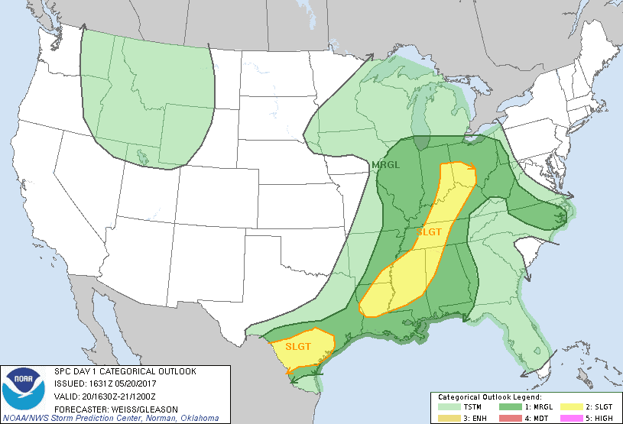
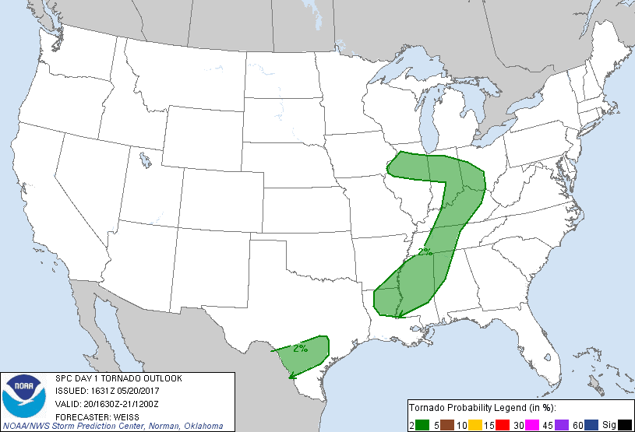
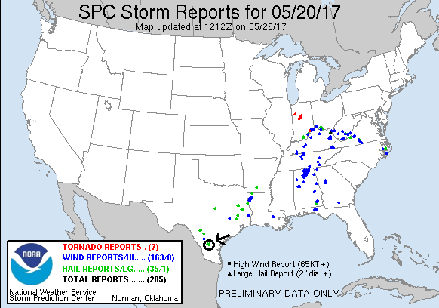

Day 6: May 21st, 2017:
Palm trees and storms! Today was the farthest south I’ve been in 17 years of chasing and so was a new experience for me. Starting in George West, TX, today’s play was storms coming out of the mountains in Mexico (we hoped), crossing into the states somewhere between Laredo and Eagle Pass, TX. Model runs looked decent, so we blew off our initial thought of going up to The Alamo in the morning and headed for Laredo instead.
We made Laredo by lunch time, and storms were already well underway in the mountains on the Mexican side of the border, as evidenced by the mammatus clouds drifting over our heads. We hung out at the mall for about 2 hours as the storms bubbled up and down and started to make very slow progress towards the US. By about 2:30 we’d progressed up Mines Rd. to Santa Tomas and took up position in a dirt lot about half a mile from the border crossing and were visited by the Border Patrol wondering what these 4 unmarked vans were doing here. It was just one of four interactions with the Border Patrol on the day.
We waited about another hour before our storm finally started coming across the river, a big HP moose with a greenish glow and well-defined shelf cloud. Inflow was streaming in to a pinch point in the updraft from two directions, but while a lowering formed under the updraft it never appeared to be rotating much. We hung there as long as we could until the hail got close, then repositioned south and east, taking Rt. 255 to La Tiendas Rd., stopping at the junction for another look. About this time the lightning really picked up, and being in a big lightning threat would be a theme for the rest of the day. Being a bit farther away from the storm, we were able to take a better look at the updraft and the big inflow band that had formed, with low stratus clouds screaming towards the storm. The southern end of the multi-cellular cluster seemed to be taking over, so we decided to head south.
Getting around Laredo took a solid hour at the storm started accelerating as it congealed into one monster high-precipitation supercell. We were barely ahead of it as we cleared the city, with the big shelf cloud indicating the leading edge of the wind and hail right over us and intense cloud-to-ground lighting banging all around us. In fact, our attempts to stop and film the “whale’s mouth” coming up behind us were thwarted twice when, right as we stopped, CG’s crashed all around us, more than once only a couple hundred yards from the vans! We proceeded east out of town on Rt. 359, watching more CG’s hit out ahead of us, and drove way out in front, not stopping until we got to Aguilares. One of the challenges chasing that far south is that you are in the land of endless mesquite trees, so finding a good vantage was tough. We found a lot next to some railroad tracks that was open and waited for the storm to approach, but just as the structure was really becoming visible lightning started crashing all around us again and we had to abandon ship and head further east.
After a brief delay near Oilton going through a secondary Border Patrol checkpoint, we continued east then doubled back, stopping somewhere southeast of Bruni as the storm caught back up. Finally, we headed north out of Bruni on FTM 2050 and got the payoff: a beautiful mothership updraft with striations showing strong rotation only a few miles to our west. We hung out there and watched for a solid 20 minutes (and I had a chat with the Corpus Christi NWS Office who called looking for an on-the-ground report on how the storm looked), as it approached. Despite the beautiful structure, it was clearly undercut by cold air and struggling. Finally, the show was over and the storm fell apart in a matter of about 15 minutes. We headed north to Freer after going through ANOTHER Border Patrol checkpoint, and started the 300-mile, in rain cores all the way, trek north to get ready for the next day, arriving at the hotel in Sonora at midnight. A fun day in some unique chasing terrain.
Mileage for the day was 549 for a trip total of 3209.

Day 6 1630Z Convective Outlook, Tornado Probability, and Storm Report:
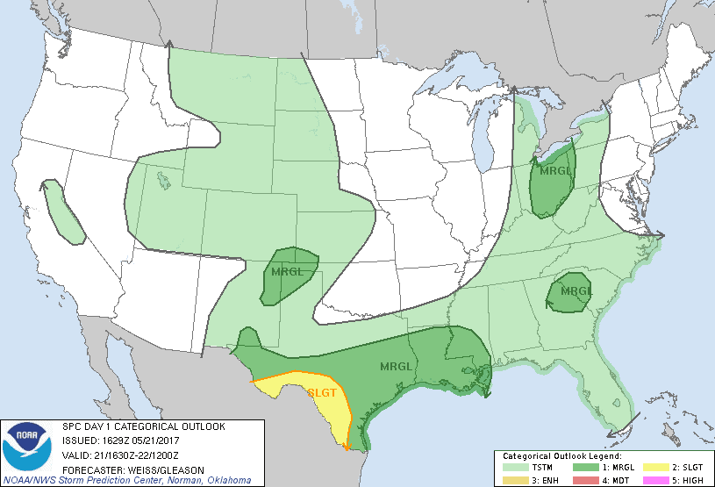
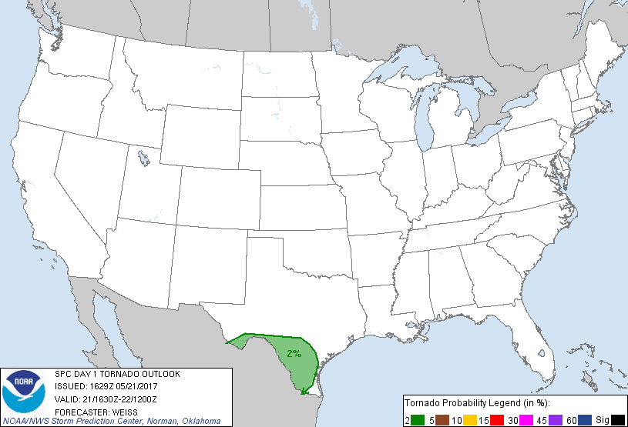
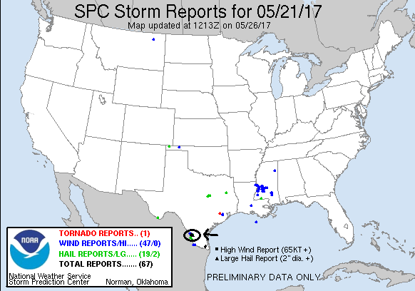
Day 7: May 22st, 2017:
I thought we were tornado chasing but we ended up in a hurricane! Today’s play was expected to be low-precipitation storms given the significant dew point depressions that were forecast, firing in the mountains of New Mexico then making their way east into the Carlsbad and Tatum area. With two targets in fairly close proximity, we planned on putting ourselves in between the two and reacting as model data was updated and storms started initiating. Starting in Sonora, TX, we made our way to Odessa, TX and then Midland for lunch. By the time we finished, there were already storms bubbling up and a severe storm up near Santa Rosa, NM. We decided to head northwest and up Rt. 385 through Andrews and into Seminole, then west on Rt. 62 to Hobbs where we waited and assessed the situation for an hour or so.
We now had a cluster of cells that had come off the mountains to the west, the storm up near Santa Rosa that was still sitting and spinning, and now another forming south of Tucumcari that was moving southeast. The best-looking cell, though they were all pulsing up and down, was heading for Artesia, so we elected to target that storm. Heading west on Rt. 62 out of Hobbs, we noted that most of the storms around us were elevated and stopped to take a look at a massively sheared over updraft right to our north which was spinning furiously as it keeled over and died. We then headed NW on Rt. 529 toward Loco Hills, twice getting heavy delays due to construction.
By the time we got to our turn at Rt. 82, there were again 3 storms to target, the Santa Rosa storm that was finally moving south towards Roswell, the storm coming down from Tucumcari, and the storm to our west which had back-built south and was now dive-bombing towards Carlsbad. We initially turned east to get out in front of the Tucumcari storm, but we could see the western storm clearly in the distance and it looked too good to give up, so we turned around and went after it. We headed back west then south on Rt. 222, twisting and winding our way south and southwest over bad roads until finally connecting with Rt. 360. Once we got there, we found we were now sandwiched between two storms as a huge core had opened east of us, and the southern storm was merging with another and extending towards the eastern storm, lining out. The storm to the east, which was just NW of Jal, was anchored and had a nice mesocyclone on the SE side, just out of our vision. We elected to go after that one on blasted down Rt. 31 to come around the SW side, with the intent of checking that storm out, and once we got to Jal we’d be in position to head north to get to the now tornado-warned Tucumcari storm.
We took Rt. 31 south then went east on Rt. 128, which seemed almost perfectly situated to skirt the anchored core now straight east of us. But, as it always seems to go, once we approached, the storm “weighed anchor” and came barreling south! We punched the hook area in heavy winds and were soon engulfed in the precipitation core. Blasting winds hit us from the north and we saw reports from about half a mile in front of us of 77 mph wind gusts and power lines down on the side of the road, and we soon saw a string of about 10 power posts snapped and on the ground, paralleling the road to our right. Visibility was near zero as the vans were pelted by a huge volume of nickel and quarter sized hail, and the gusting hurricane force winds blew sheets of water, tumbleweeds, and other debris across the road. At this point there was no turning back so we plowed through, and eventually the core passed over us and to the south. We entered Jal to find heavy flooding downtown and turned south, but now the storm was collapsing on radar so we gave up the chase and headed north, and looking on radar you could see that all of the other storms around were falling apart as well. Once we got about 5 miles north of town we stopped and saw an eerie double rainbow against a backdrop of yellow-orange caused by the setting Sun. We stopped to take pics and then called it a night and headed back to Seminole, TX for the evening.
This was one of those manic chases where we never really had the opportunity to stop and observe except at the very end, but still, a fun day. Funny looking at the vans later to see the dirt on the left side of the vans completely pock-marked by the hail while the right sides were clean.
Mileage for the day was 531 for a trip total of 3740.

Day 7 1630Z Convective Outlook, Tornado Probability, and Storm Report:
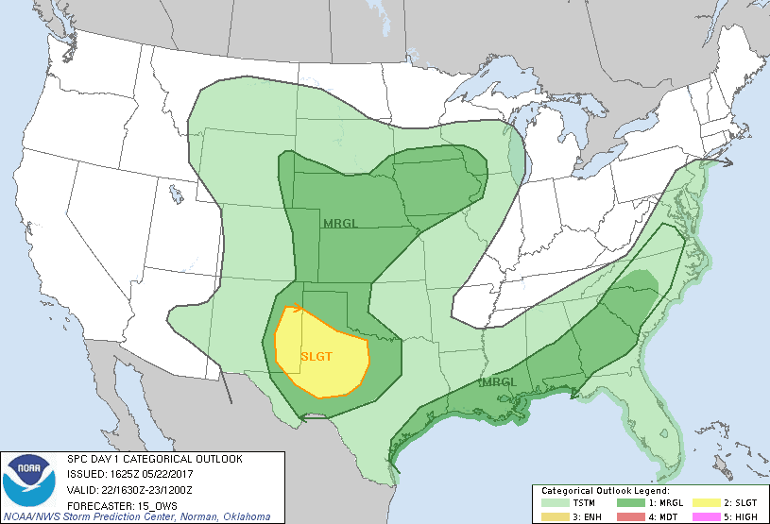
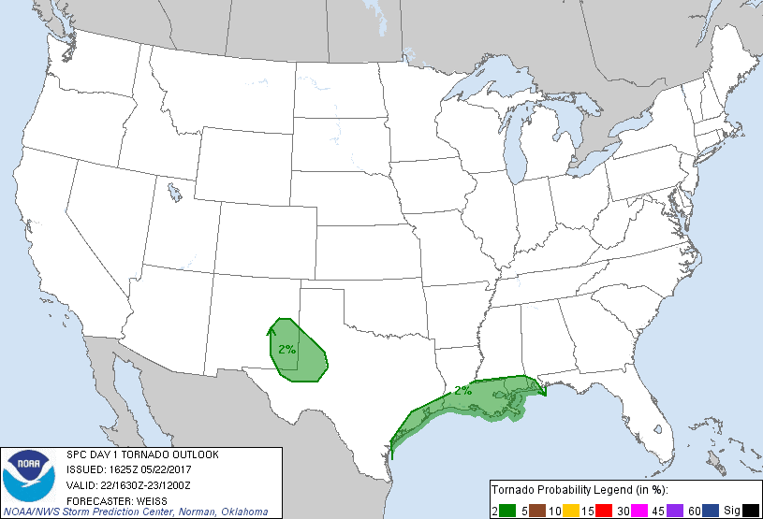
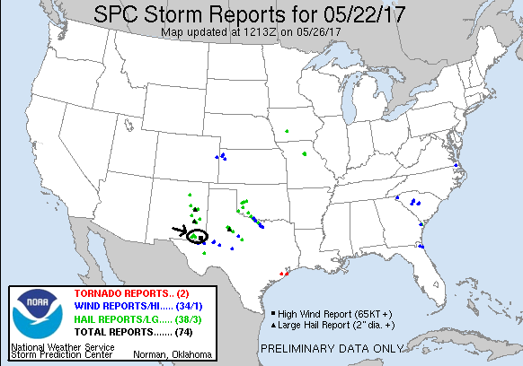
Day 8: May 23rd, 2017:
Today was a down day. We traveled from Seminole, TX to the Carlsbad Caverns (very cool!) near Carlsbad, NM, then to see the UFO Museum and shops in Roswell, before heading to Amarillo, TX for the night.
Mileage for the day was 445 for a trip total of 4185.
Day 9: May 24th, 2017:
And another down day. We went to the Big Texan then proceeded up to Garden City to set up for the last day.
Mileage was 249 for the day for a trip total of 4434.
Day 10: May 25th, 2017:
Bustola! A tough forecast for Day 10: There was a legitimate target in northeast Colorado/ northwest Kansas, but the target area was too far to go for a marginal setup having to be back at OKC that night. Our hope was that the tail end of what was predicted to be a cluster of high based hailers would be close enough for us to chase, or that a group of southern storms that the models seemed to alternately predict then back off on run by run would manage to break the cap and enter the better air near Dodge City. We hung around Garden City for several hours then moved north to Scott City to be better positioned in between the two options, but by 5 PM the one storm almost close enough to target off to our northwest looked unimpressive, se we headed south and hoped for the best.
Passing back through Garden City, we headed south on Rt. 83, stopping twice to watch extremely high based updrafts just to our northwest. They had some decent structure and were blowing dirt around all over but otherwise were not particularly exciting. Sort of giving up the chase, we headed on Rt. 160 through Plains and Meade, paralleling the last storm in line, which had become severe just to our north, but the anvil was very fuzzy and you could see right under the base of the storm. Eventually we broke off and headed south to Woodward, OK, then back to OKC.
Miles for the day were 412 for a final trip total of 4846.
It was a fun tour given the mediocre pattern. Counting the final day as a down day, there were 4 in the 10-day Prime Time Tour period which is more or less unprecedented, or at a minimum the least active since 2009. On the other hand, we had some great storms, two tornadoes, had the van windows smashed by baseball and larger hail, had very close lightning strikes, and drove through a hurricane core on our 6 (7 with the pre-tour day) chase days. Also, I had my first experience chasing south of San Antonio.
Day 10 1630Z Convective Outlook, Tornado Probability, and Storm Report:
