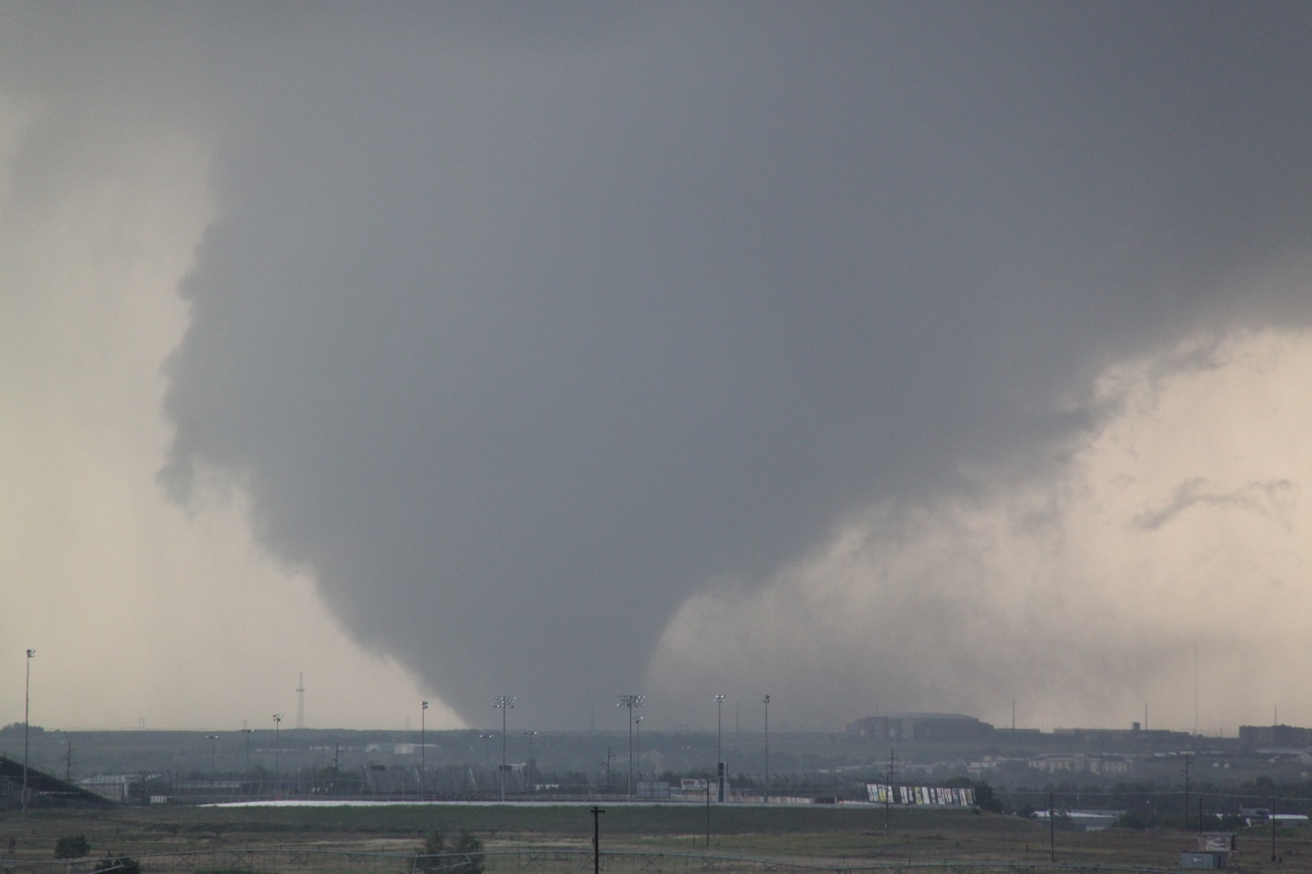

Silver Lining Tours
2016 Prime Time Tour
Daily Tour Log

Day 0: May 16th, 2016
Bonus chasing as arrival day ended up being a chase day, with the action focused on a stalled boundary draped across the OK/TX Panhandle. We set out for OKC targeting the are from Guymon, OK to Perryton, TX, but as the models had been consistently placing the boundary a little farther south each run, we chose to head west on I-40 towards Shamrock, TX then evaluate from there rather than head straight northwest.
Stopping for lunch, we debated heading northwest, or continuing further west. There were already storms firing in southeastern Colorado coming off the terrain, but we still expected the boundary down our way to light up so we headed for Amarillo. 2/3 of the way there the models were now putting supercells right along I-40 and a strongly worded forecast by the NWS Amarillo office convinced us to stay south, and as towers were now visibly developing on the boundary we decided to pass through Amarillo to Vega to stop and wait. As we got closer however, it was clear the area around the boundary was completely capped.
Meanwhile the severe storm to the northwest had inched its way into Oklahoma and produced a brief tornado! We decided to head north to intercept, stair-stepping on FTM 1061 up to Boys Ranch, and then on to Dalhart. As we slugged our way through Dalhart construction, we were faced with whether to head straight north towards the tornado warned storm, or northwest towards a new severe storm that looked to be taking over the show. Our decision was made for us as the new storm was tornado warned even before we got through Dalhart.
On arriving at the storm, we were disappointed to see that the outflow from the northern storm had completely undercut our storm, which was now dying a quick death and raining out of the updraft with cold-air cloud debris everywhere. We quickly abandoned the storm with the idea of getting to the northern storm, which was now in Stratford. Hammering our way back through the construction hopelessly slowed us down however. Once we cleared town, we headed east toward Etter on FTM 281, cutting through what was left of the storm we’d been chasing, watching a new updraft to our west, and the now HP monster to our north.
Eventually, the outflow boundary blew well south of us and undercut all of the storms, ending any tornado potential, so we called it a chase day and headed south towards Amarillo. But, the day wasn’t over just yet: South of Dumas we stopped to observe a spectacular shelf-cloud, running the length of 3 cells and rolling over itself in an ocean-wave look. We stopped briefly in Amarillo, then headed east on I-40 back towards OK, with the shelf approaching and the storms, which had now congealed into a long bowing complex, accelerating towards us. We were treated with a nice lightning show as we headed east, but by the time we got to the Oklahoma border it was clear that we were going to get run over by the line before we could get to OKC. With the segment right in front of us tornado-warned, we decided to stop in Sayre, OK and let it run us over.
Pulling into a gas station and setting up our view so we could enjoy the ride, we were soon hit with large amount of dime-sized hail and wind-gusts of at least 50 MPH, and the station briefly lost power. After about 20 minutes, the worst was past and we got back on the highway. Now behind the line, we were stuck in the stratiform rain for the rest of the ride as we were never again able to catch the line to get out in front. We got back to the hotel in the rain and could hear the rumble of thunder throughout the night.
So, it was not the day we’d hoped for but also not a complete loss, with some nice structure, a good lightning show, and getting to ride out the core in Sayre. It was interesting to see the whole life cycle of a Central Plains system: An individual storm formed off the high-terrain of southeast Colorado, eventually moving slowly east and having new storms form on its flanking line, then starting to move and congealing into a line, and finally turning into a bowing complex and blasting east at 60 MPH.
A long drive on pre-tour day, 705 miles.
Day 0 1630Z Convective Outlook, Tornado Probability, and Storm Report:
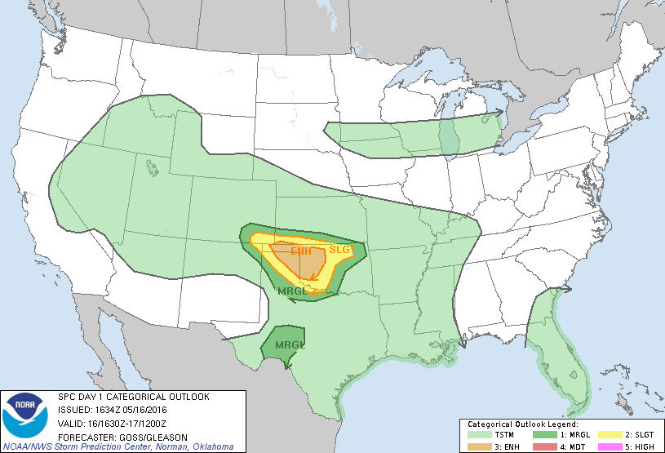
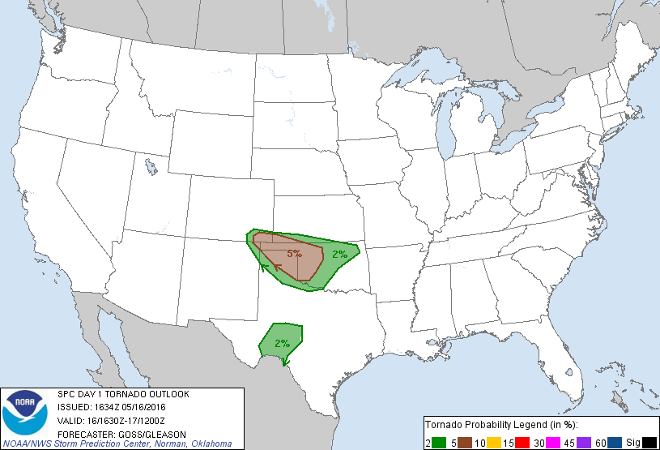
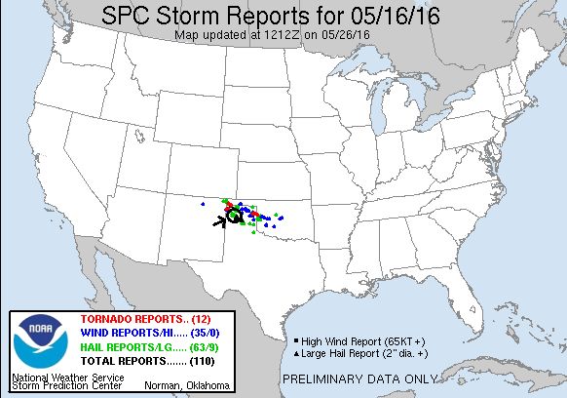
Day 1: May 17th, 2016
The first real day of the tour took us to southern Texas trying to get down to the same frontal boundary we’d chased the previous day that had now made its way well into Texas. Storms were projected to fire along the boundary with strong lapse rates yielding large hail, but the tornado threat was not especially high. We made good time out of OKC, not stopping until we’d covered 280 miles and made it to Abilene, TX. After a quick lunch stop we were back on the road heading for San Angelo.
As we got towards town, our attention had been on a storm down near Ozona that was anchored and eventually got tornado warned, though spotter reports there indicated that the storm was outflow dominant and didn’t look likely to tornado. Nonetheless, it was the only show in town and we headed southwest on Rt. 67 towards Mertzon to get around a cluster of storms between us and our target. West of Mertzon though we reached the southern end of the cluster and it was showing clear signs of rotation just over the road in front of us, with two large inflow bands streaming into the storm. We decided to observe for a while, letting the storm push us east. We dropped south on FTM 915 and let the cell, which was becoming more discrete and moving right, come towards us. It was a developing high precipitation supercell with large hail, and while it occasionally cycled up a hook echo right in front of us, the low level shear wasn’t strong enough to seriously threaten a tornado. Nonetheless it was an impressive looking storm with a big shark-toothed shelf cloud and that turquoise coloring all storm chasers love! We held our position until lightning started landing around us.
Now the road network came into play and we were forced to head all the way down to El Dorado so that we could get back north on Rt. 277. By the time we completed that maneuver our storm had become a monster hailer with a big area of rotation and well defined hook echo. We drove north right up to the inflow notch, then west on a county road directly into it! The lowering in front of us was ominous but not terribly organized, sucking in scud and churning away, and soon we were in the “bear cage” with the hook echo wrapping around us to our south! We soon turned around and ran back to the main road and south on 277, getting glanced by the RFD winds as we cleared the hook.
As we watched the series of storms pass to our north, our attention was also drawn to additional storms to our south that had fired on the true boundary. We were surrounded! As the cluster north of us started to look messy, we decided to head down to I-10 and prepare to head west to target the more isolated cells out that way. We were chased down Rt. 277 by our original storm however, and it was still the main show as we stopped in Sonora to fuel up right next to our eventual hotel for the night. As we stopped, we caught the full brunt of the RFD winds from the storm and soon we were experiencing 60-80 MPH winds blowing trash cans, signs, and all kinds of debris all over the place. I had been watching from outside but quickly realized there was so much debris flying around that I needed to get into shelter and ducked back into the van before I got nailed by something!
The storm once again had a big hook and reports of 3.5” hail, and was right along the highway so we decided to blast east on I-10 to skirt the core and stay in front. Even right on the edge of the core it was like driving through a hurricane: massive crosswinds and torrential rain sweeping across the highway mixed with a few small hail stones. It took us longer than expected to get through the rapidly expanding core, but eventually we got out in front and got off the highway at Roosevelt to let the storm come to us. As the “whale’s mouth” closed in we were treated to numerous very close cloud to ground lightning bolts, and soon as the core was just about on us we positioned the vans to face the wind and let it run us over. Once again 60+ MPH winds rocked the vans and we got pelted with dime and nickel sized hail with a few quarters mixed it. A hurricane with hail!
Once the brunt of the core passed over us, we got back on the highway and headed for the hotel. Piles of small hail lined the sides of the highway as we headed back and when we got to the hotel we were treated to a beautiful orange highlighted display of mammatus clouds on the very back edge of the storm. A great way to top off a fun chase day!
Mileage for the day was 608 miles.
Day 1 1630Z Convective Outlook, Tornado Probability, and Storm Report:
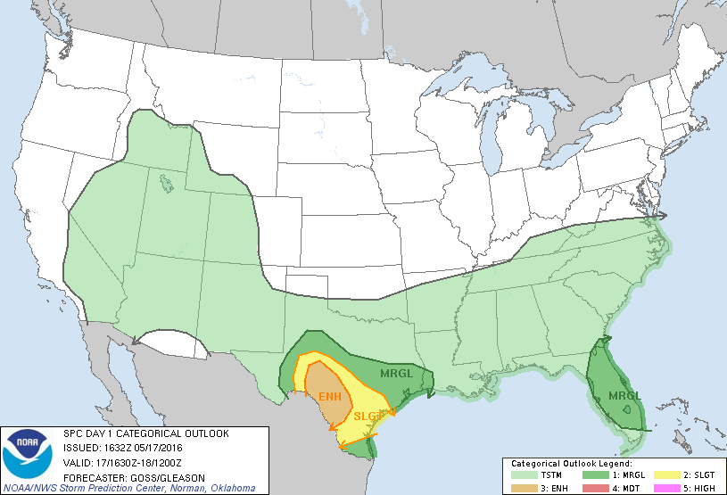
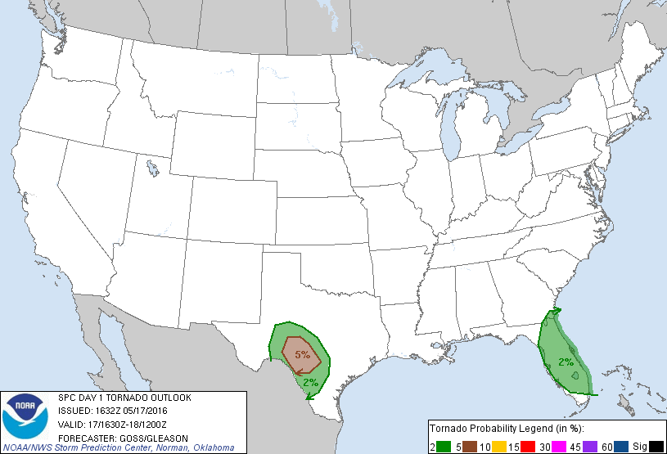
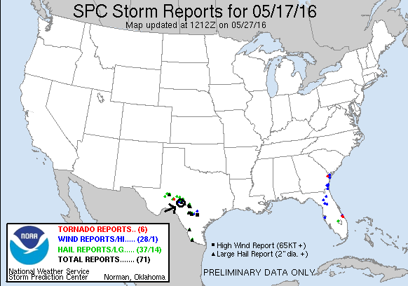
Day 2: May 18th, 2016
Somewhat of a down day as the front we’d been chasing had pushed into Mexico, leaving all of southern Texas socked in with 50 degree temperatures, showers, and a thick deck of stratus clouds. We tried the only option we could, driving from Sonora to Ft. Stockton. We paused for lunch there and evaluated, then continued on almost all the way to El Paso hoping to catch a storm coming off the mountains on the Mexican side of the river. We eventually stopped on a dirt road north of I-10 near Ft. Hancock to watch a storm that had looked promising around San Elizario, but by the time it crossed to the US side of the river it had strung out into a linear cluster of cells and weakened. We watched the storm weaken, hail out, and dissipate and enjoyed the interesting terrain in the area for a bit before returning to Ft. Stockton for the night.
Miles for the day: 526 miles
Day 2 1630Z Convective Outlook, Tornado Probability, and Storm Report:
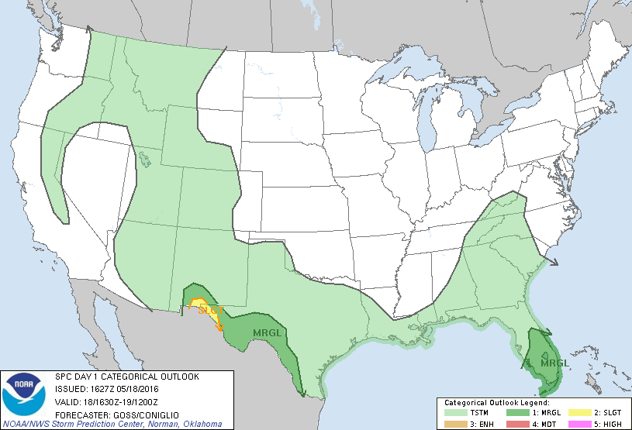
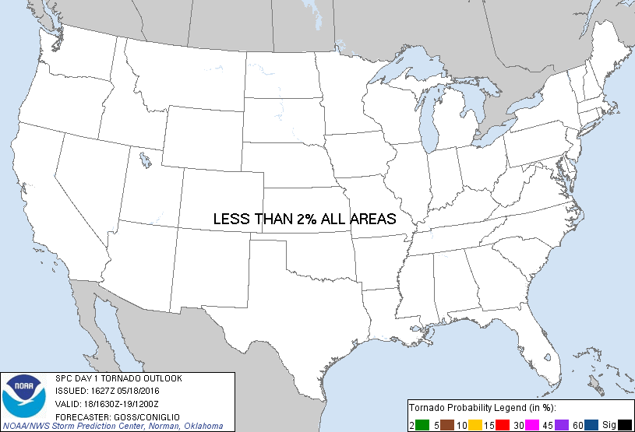
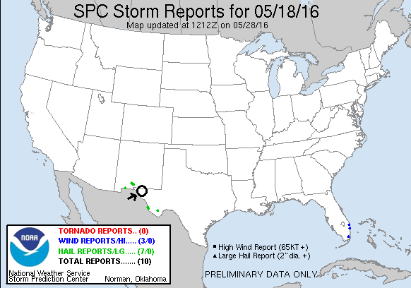
Day 3: May 19th, 2016
A down day with the cold front finally having finished doing its damage and scoured the plains of all its moisture. We repositioned from Ft. Stockton to Amarillo, then had a fun dinner at The Big Texan.
Miles for the day: 354 miles.
Day 4: May 20th, 2016
Tourist mode: Hung out around Amarillo and went to the Cadillac Ranch.
Miles for the day: 26 miles.
Day 5: May 21st, 2016
A tremendous chase day on “the day before the day”! We expected a solid chase day, but not the spectacular show we ended up getting. Starting the day in Amarillo, the morning model runs made the target obvious: The triple point, which was expected to be northwest of Garden City, KS by 0Z. The models forecasted storms to fire down the dry line in Texas late, but the conditions up north looked better and there was no sure thing that the cap would break before it got dark in Texas, so we headed north.
After a stop in Garden City for lunch and then again at a truck stop on the north side of town to evaluate the situation, we decided to head north towards Scott City, observing the cumulus clouds above the moist plume to our east wrapping into the triple point, as well as developing cumulus caused by convergence along the dry line to our west. As we were heading towards Scott City, the question was whether to continue to head north all the way to Oakley to position ourselves to intercept storms up near Sharon Springs, or to wait near Scott City for the towers that were trying to get going west of us to mature into storms. Ultimately, by the time we got to Scott City there were a couple of weak storms trying to get started near Lamar, CO, so we decided to wait to the south and headed to Leoti from Scott City.
On arriving at Leoti, we first moved to an open area west of the town to watch things develop, and then back into town to let people get snacks and wait, amongst the significant chaser convergence at the store. While waiting there, more robust towers started going up and soon we decided to head west of town again to play with some developing cells out that way. As we got there we found a cluster of 3 cells just getting underway, with flat bases and minimal lightning and precipitation cores. The middle one initially seemed to be the one with the most potential, but soon its front flank core was raining hard, producing a pronounced rain foot. The northernmost cell then developed a lowering and looked like it had a hook echo on radar, so we decided to head back east to Scott City to turn north, since the road north out of Leoti would soon be cutoff by the group of cores north of us.
Upon stopping east of Leoti, there were now two action areas: the northern cell which had a distinct flat base with rising scud attaching to the bottom and the southern cell, which had absorbed another cell to its south and was now developing a hook echo. Once the southern storm started showing signs of rotation and a tornado vortex signature, we chose to target that storm, turned around, and headed back to the west side of Leoti yet again, then north on a dirt county road to get a closer look. By now the storm had taken on supercellular characteristics: rain-free base in front of us, precipitation core to the northeast, inflow band streaming into the updraft, and soon a wall cloud. The inflow pumping into the storm from our position was very strong, a feature that would persist for the next several hours.
We continued to adjust north and east along the country roads, stair-stepping along roads “M” and “10” and crossing rt. 25.as the storm became a monster with 2”+ hail in the vault area, which now had a turquoise tinge to it. One fascinating feature was that the storm had two distinct mesocyclones right alongside each other, each with its own inflow band. The storm had already produced at least one brief tornado that we had not been able to see since it was related to the mesocylone out behind the one in front of us, but soon it was our turn as the beast generated a brief multi-vortex tornado with distinct dust swirls to our northwest, though only lasting for about 30 seconds. The structure of the storm was amazing, with multiple “wedding cake” layers and striations spinning around the base of the updraft. At this point the storm had become incredibly electrified, with white-purple cloud-to-ground bolts hitting nearby to the front, sides, and behind us! Definitely a “stay in the vans” moment!
We proceeded to the junction of country roads “H” and “15” and stopped as the road had become very muddy and slick. As we watched the cell churning to our northeast, the inflow had become the strongest I’ve ever experienced: I recorded inflow speeds of 48 mph on my Kestrel, by far the highest I’ve recorded on the device. I was able to lean back into the inflow and be completely supported by the wind, and at one point I literally could not close the van door against the blasting inflow. I almost lost my UML Hockey hat at it was ripped off my head, hit the roof of the van in front of me, and was lofted about 50 yards down the road before it stopped! Another guide wasn’t so lucky as his ended up in the field and had travelled at least 100 yards and was still going when we lost sight of it! The ride out of the muck was wild: The wind was literally sliding the vans off the road without them even moving! I had to ease the van to the extreme left side of the road as we tried to inch south, and every gust slid the van towards the right shoulder a couple of feet. There was nothing I could have done about it if a big gust pushed us off the shoulder. Luckily, we finally got to slightly better road conditions and repositioned to the east, and back north yet again.
Our final stop occurred at sunset and the amazing structure continued as the updraft was highlighted not only by the setting Sun but also by the non-stop lightning occurring around the updraft, and in the anvil of the storm which now extended for miles in every direction, displayed a beautiful mammatus field right above our position. The storm still had a large inflow band streaming in from the east and was spinning like crazy as dusk fell, and we spend a solid hour at the last stop, powerful inflow still to our backs, admiring the storm. Finally, as the storm died off, we called it a night and made the easy trip back to Garden City for the night, lightning illuminating every step of the trip back. It was interesting to note that because the anvil had spread so far, Scott City was in the midst of constant lightning overhead, yet not a drop of rain would fall there that evening with the precipitation cores miles to the north.
What a chase! With the storm only moving 5-10 mph, it was simple to get wherever we wanted to get the best view. The structure and experience chasing this storm was awesome, definitely in my top 2 or 3 storms of all time for the non-big tornado storms I’ve chased. Hard to believe this powerhouse developed with access to only a portion of the conditions the system moving in would bring in the following days.
Miles for the day: 424.

Day 5 1630Z Convective Outlook, Tornado Probability, and Storm Report:
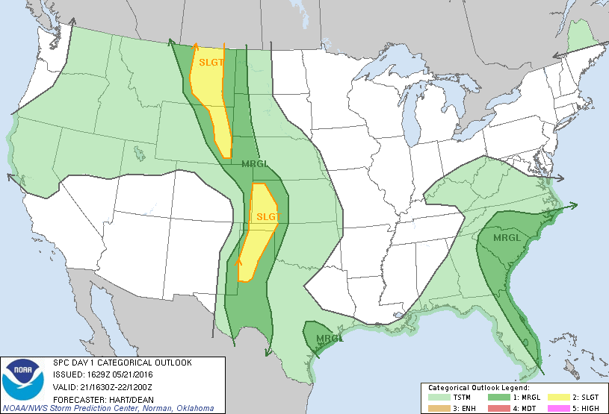
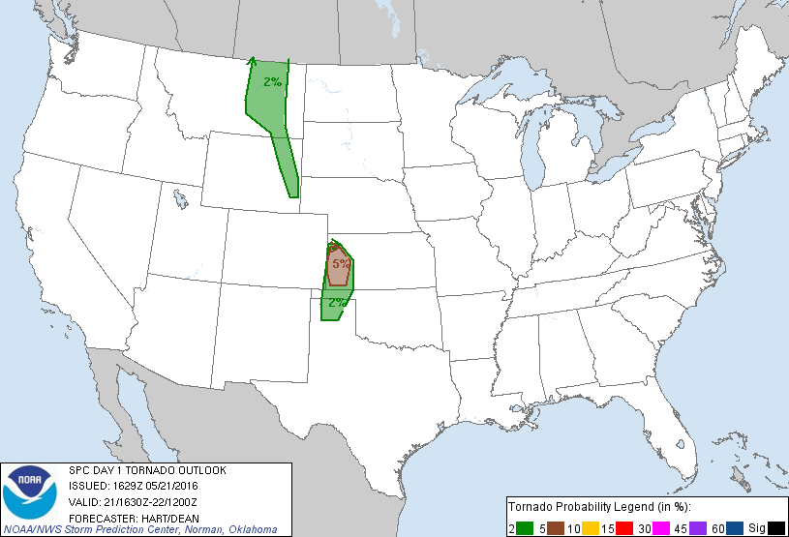
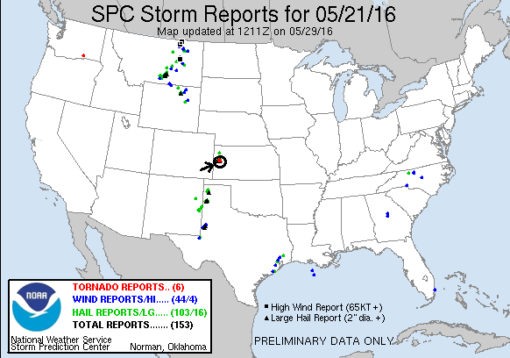
Day 6: May 22nd, 2016
A chase day that went from disappointment to a great surprise and adrenaline rush! We started the day in Garden City, KS and headed south, hoping to find the point where the outflow boundary from morning thunderstorms on the Texas Panhandle intersected the strong dry line that was setup along the New Mexico / Texas border. Initially it looked like we would have to head as far south as Lubbock, but as time progressed the models also fired storms further north. By the time we made it to Dumas, TX, we decided to stop for lunch and it was time for the first “Braum’s Encounter” of the tour. There were clearly far better dynamics in play compared to the previous day as towers were already trying to form all around us. We spent an hour or so in Dumas then headed south to Amarillo to set up in somewhat of a mid-point between the two potential targets.
Our stay in Amarillo was relatively short, as now more robust towers were firing north of us and there were now two cells near Stinnett pulsing up and down, and another heading towards Dalhart. We decided to go back north, all the while keeping an eye on the dry line to our southwest. We proceeded all the way to Stratford, and then positioned east of town as our cells, which were extremely high-based, cycled up and down. One went severe for a bit and produced quite a bit of lightning, but the storms along the dry line could never quite get fully going. Of note, one of the places we stopped was perhaps the worst smelling stop in the history of the tours! We were downwind of a feed and finishing lot, though pretty far away, and the smell was just vile!
Meanwhile, for a couple of hours we’d been watching storms to our east near Spearman and on an axis all the way south to Memphis, TX, that were severe and nearly anchored, colliding with each other and merging or dying as the conditions in that sector appeared to favor left moving segments. I liked the air over there: the storms were moving slowly into an environment with close to 70 degree dew points, and the winds were more backed than where we were. They were a mess though, and the area was covered in a flash flood warning. Nonetheless we finally decided to go after them, especially when someone reported a brief tornado on the western side of the storm.
We blasted east on Rt. 15 through Gruver and into the west side of Spearman with the plan of skirting the core to the south. There was significant flooding in town, and lots of small scale tree damage from straight line winds from the storm having passed through earlier, including a power line down. We observed what initially looked like a big bowl lowering out in front of us, but once we got close enough to get a good look it was clear that it was just a large ball of scud loosely attached to the base. Another lowering to our north then got our attention, and soon it was tornado warned! But, looking to the southern section of the storm where the inflow would be better, we noted a developing mesocyclone there and decided to get around the south side to take a look. We headed south of town, then east on Farm Road 281.
As we headed east, we could see the meso spinning wildly just north of the road, and suddenly out of the murk: Tornado! A white elephant trunk tornado was barely visible a few miles ahead in poor contrast, lasting for a minute or two then roping out in a big arc as we got closer. Then, as we continued to close on the meso, a big stovepipe tornado formed and quickly expanded into a huge cone / small wedge tornado just to our north!! We drove right up to it and got out to observe, but as the tornado neared, it pivoted around the mesocyclone and expanded at the same time, sending us scrambling back into the vans as the white tornado passed just about 200 yards to our northeast! The individual suction vortices coming around the west side of the tornado were amazing that close up! We moved a little west, then as the tornado cleared our area we continued east to get back in front.
We followed FM281 to the intersection of Rt. 83 and headed northwest into the notch of the now monster HP supercell, with lightning hammering all around and inflow streaming in overhead. We got as far northwest as we could without getting into the big hail in the front flank core and stopped to watch. To our west, we could see the large mesocyclone spinning like crazy. We edged up and down Rt. 83 looking for a good vantage point and adjusting as the storm started dive bombing southeast towards Canadian and got a different kind of excitement: On one of our stops, the lead van opened up and a guest jumped out…. And nearly landed right on a rattlesnake!! So close in fact that he dropped his tripod right on the snake! The guests scrambled in all directions as if the van was on fire, but luckily nobody got hurt.
The next piece of excitement was a reported tornado just to our north, so we blasted back up towards the front flank core to have a look, but we didn’t see anything and don’t believe the tornado was confirmed. If it was there, it was very brief. Finally, we called it quits and headed to Amarillo for the night with a nice lightning show to the north as we headed to the hotel.
Miles for the day: 552.

Day 6 1630Z Convective Outlook, Tornado Probability, and Storm Report:
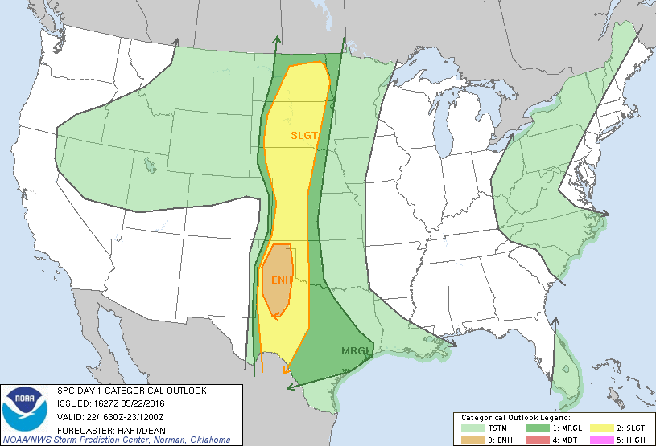
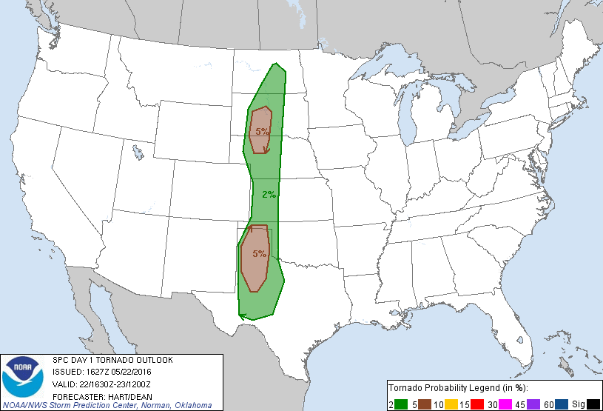
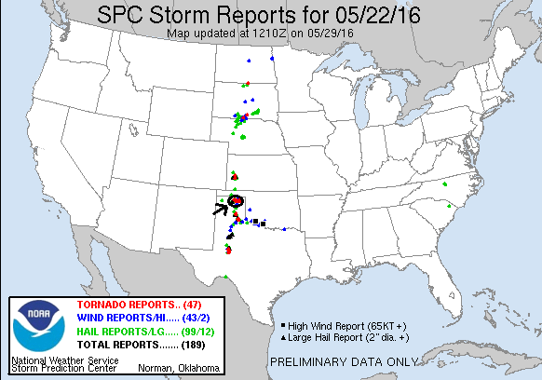
Day 7: May 23rd, 2016
For the 3rd consecutive day, a chase that seemed like it would end in a bust that ended up with a big bang! There were two distinct possibilities for targets today: east near Woodward, OK, or to our south from our starting point in Amarillo, down near Lubbock wherever the outflow boundary from early morning convection intersected with the dry line. Problem was, the two targets were far enough apart that playing in the middle risked being late for either show. We huddled up, watched one last model run, and decided to head south. We made good time from Amarillo down to Lubbock and stopped there for lunch.
There were already cumulus congestus all along the dry line, so we were hopeful something would pop between Lubbock and Midland before long and decided to relocate to our southeast, heading to Post. We stopped there for an hour or two as storms tried to bubble up, then died, then bubbled again, then died. We decided to inch our way farther south, heading out on FM669 on the way to Gail, stopping in the beautiful terrain just off the cap rock and waiting again as storms tried to go but just couldn’t get their acts together. After another long period a storm finally got going over Lubbock and we charged north to intercept, heading up to Floydada. We got there to find the shriveling updraft of our severe, but clearly dying, storm. To our north, just some junky storms, to our south, nothing until you got way down around the Mexican border. We eventually decided to head north with the cluster and drove through some decent sized hail near South Plains on the way up Rt. 207 towards Silverton. At this point we were about ready to give up for the day, but one cell northeast of us started looking beefier, so we decided to go after it, and soon it was severe warned as we skirted the rear flank core and got around to the south, noting a large amount of hail in the fields around us of up to golf ball size. We passed through Quitaque as the storm began displaying rotation just north of us and a wall cloud began to develop. We stopped west of Turkey to see jaw-dropping structure in the storm! It was a tall soda can, striated to the top, and with a well-defined wall cloud churning away at the base. It looked like it could tornado any time so we waited and watched. The structure was so tremendous it didn’t seem to matter to anyone that they were getting bonked repeatedly by hail of quarter size or larger, but once it reached golf balls again, we packed up the vans and passed through Turkey to the north side of town. There again, the structure was breathtaking and we paused for a few minutes to enjoy before we had to move to stay in front of the storm, which was right turning to the south.
We blasted south out of town on FM656 staying well ahead of the storm, and soon were far enough away to really take in all of the majesty of the storm: A big striated barber pole spinning hard all the way up the updraft, with hail streaks pouring out of the front flank core to our north and cloud to ground lightning again crashing all around. To add to the beauty: The setting Sun dropping behind the base of the storm, giving it all an orange hue.
We turned south on FM94 and stopped somewhere about halfway to Matador in the middle of the scrublands and watched as the storm approached us at dusk with the mesocyclone slowly nearing from the northwest. Again, amazing structure! The show for the moment was the lightning blasting all around, and all around the updraft of another left moving supercell to our south that was coming up to collide with ours. As the storm got closer, the lowering crept nearer the ground and the storm was tornado warned.
With a tornado seemingly imminent, we worked our way south of the meso in the dark and struggled for a glimpse through the bushes and trees when there was lightning to see if we could see anything. And soon, tornado: A nice thin cone tornado, well defined, to our north-northeast! We peeled off on a muddy farm road to try and find a vantage as the tornado churned along for a few minutes then dissipated. We (carefully in the mud) proceeded back to the road and found and even better vantage and soon the storm produced another big tornado, this time a multi-vortex looking wedge! We observed at least 3 separate power flashes as the tornado passed several miles to our northeast, somewhere between Turkey and Northfield. We sat and watched for a solid 10 minutes, catching glimpses to see if the tornado was still on the ground. Finally, the storm seemed to be fading and the tornado was gone, so we called it a night and headed into Matador, then Plainview, and gassed up for the long ride to Dumas to position for the next day, arriving at nearly 2 AM!
It was well worth it! A great day in the end and my 4th and 5th tornadoes over the last 3 days.
Miles for the day: 553.

Day 7 1630Z Convective Outlook, Tornado Probability, and Storm Report:
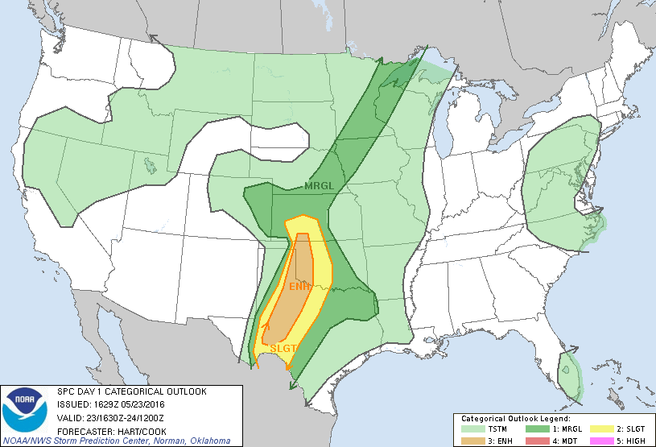
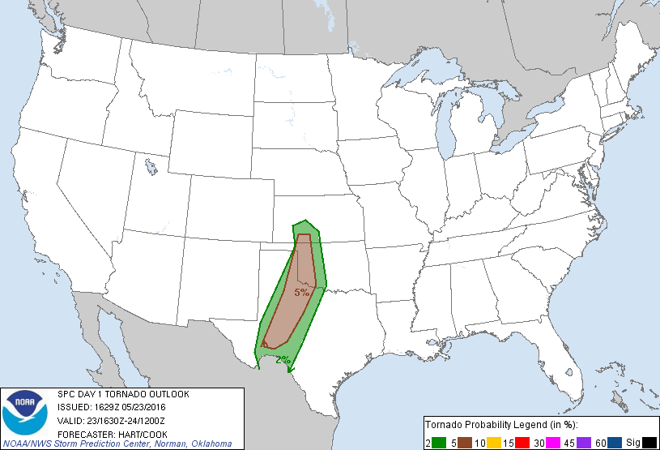
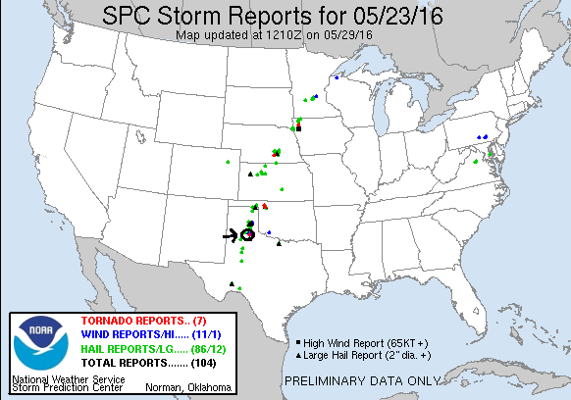
Day 8: May 24th, 2016
Wow! This chase may have replaced the Bowdle, SD day of May 22, 2010 as my favorite of all time. An incredible and fairly stress-free chase day with a number of firsts for me including the most tornadoes I’ve seen in a day and the first time I’ve seen three on the ground at once! All without ever being danger from the tornadoes or of even getting cored by big hail! Not to mention perhaps the worst chaser convergence I’ve seen, though that didn’t seem to cause much of a problem.
We started the morning in Dumas, TX after the long drive the previous night. The target couldn’t have been more obvious: find the triple point on the Kansas/Oklahoma border and be there, and SPC had outlined a tight 10% tornado threat that told every chaser around exactly where to go. Our initial target was Woodward, OK. We headed up through Guymon then east and arrived at about 2 PM, noting immediately the swarms of chasers everywhere. As we’d approached town from the west, the triple point was clearly evident and towers were already developing along the boundary so we grabbed lunch and headed back northwest to get ready for the action, passing through Ft. Supply and up through Laverne, OK on Rt. 283. At the junction of 283 and 64, there was an empty dirt lot at the side of the road, but not empty today! There were at least 30 chase vehicles of every shape and size, and it was like a pre-NFL game tailgate! We continued through Rosston and headed north towards Englewood, KS and now things were firing: an initial storm around the warm front up near Scott City developed and immediately started producing tornadoes, while a tower just to our west got going and soon had tops passing through 45,000 feet on the way to 50,000. We paused to watch for a while as the storm developed a broad base and strong upright updraft, and had that look to it.
Continuing to meander north into Kansas, the storm really got going and with a generally northern track at about 10-20 mph was very easy to stay alongside. This was an interesting trait of all the storms today: None of them, no matter how severe they got, were right-movers. Had they been, the chaser convergence could have been a much bigger problem, but on our storm, Rt. 283 became storm-chaser highway. As we passed through Englewood, the storm was now developing a big hook on radar and a developing wall cloud that was spinning crazily. Soon we were through Minneola, KS and the storm was ready to do its thing.
We stopped along Rt. 283 about halfway between Minneola and Dodge City and setup our tripods as the wall cloud showed rapid rotation and rising motion, with that barrel rolling horizontal motion that those who chase know well! And moments later at 6:00 PM exactly, tornado! An elephant-trunk tornado that soon turned into a robust stovepipe right off the south edge of the mesocyclone. But wait, there were 3 areas of rotation, and almost immediately there were dirt swirls under the second one. Two tornadoes at once! That one quickly dissipated though and the stovepipe took center stage and persisted in various forms for probably close to an hour, occasionally lifting but soon coming back even bigger as a cone, stovepipe, elephant trunk, rope, you name it! The storm also had very large hail: at one point we stopped and there were a few hailstones of baseball size that we took pictures of.
For the next 75 minutes, we observed tornado after tornado as the storm moved slowly north, and we were able to all take shots with the tornado behind us, spinning the tornado, etc. etc. The initial tornado turned into a big cone about 20 minutes in as we hopscotched north, stopped, watched and then jumped north again, etc. As we neared Dodge City with the cone still on the backside of the meso, another elephant trunk tornado formed towards the north side, and then morphed into a long ropey tornado. And then, another! Three at once! I initially thought the third, which was another ropey tornado, was a multi-vortex tornado with the second one, but as I zoomed my camera way in it was clear that the 3rd was on the back side of the rotation, moving right to left, while the 2nd was on the front moving left to right! They almost appear to be dancing in my video.
Now the storm neared Dodge City and things started to get scary as the town declared a tornado emergency and the whole mesocyclone got lower and lower to the ground and the storm looked prepared to generate a big wedge tornado right over town. As it approached from the southwest, still spewing touchdown after touchdown, I observed a few power flashes on the outskirts, but luckily no large flying debris. The rotation of the mesocyclone was intense: a merry-go-round all the way around the broad area of rotation. The storm then produced its largest tornado, a big cone just on the outskirts of town which I believe did most of the damage we’d see later. Luckily, the tornado missed the center of town, passing just to the west.
Soon we had to get north and were faced with what looked like a huge chaser traffic jam in the city, but we found a road that was relatively open and cleared the city to the east, watching to our north as the storm continued to drop tornadoes of every shape and size. We found ourselves on the north side of town by ourselves. Where did everyone go?? We weren’t complaining though as the storm continued to drop tornadoes, retract, and drop another, retract, etc.
Finally, the show was winding down and now we were worried about getting cored by the next storm in line to our south. We got very strong wind and a little hail but nothing major. Looking at radar, there were still tornado warned storms all around us, but none of them were easily approachable from where we are, so we decided we’d had our fill and called it a day, especially since there was a gap in the cores that would let us get west towards our stop for the night at Garden City, KS.
As we headed west, we saw some of the damage that had been done: Rt. 400 was closed due to tornado damage and a flipped semi so we had to detour down to Rt. 56 and up Rt. 23 towards Cimarron. As we did, we saw numerous power lines down and farm irrigation equipment flipped, as well as trees shredded by large hail. When we got to Cimarron, the power was out.
As we drove away though, the storm continued to give us a show. First, tremendous crepuscular rays like spotlights on a rainbow as we got west of the storm, and then a pretty mammatus show stretching for miles hanging out of the back of the merged anvils from the line of storms.
What a chase day! We saw a solid 12-15 tornadoes and what must have easily been 50-60 touchdowns as the various rotations skipped up and down. The storm motion was interesting: I can only conclude that the storm was so wrapped into the boundary that it couldn’t turn right even though it was spinning ridiculously hard. What a storm!!!
Here is the link to the Dodge City NWS Office’s report on the storm:
http://www.weather.gov/ddc/24may2016SevereWx
Miles for the day: 412.
Day 8 1630Z Convective Outlook, Tornado Probability, and Storm Report:
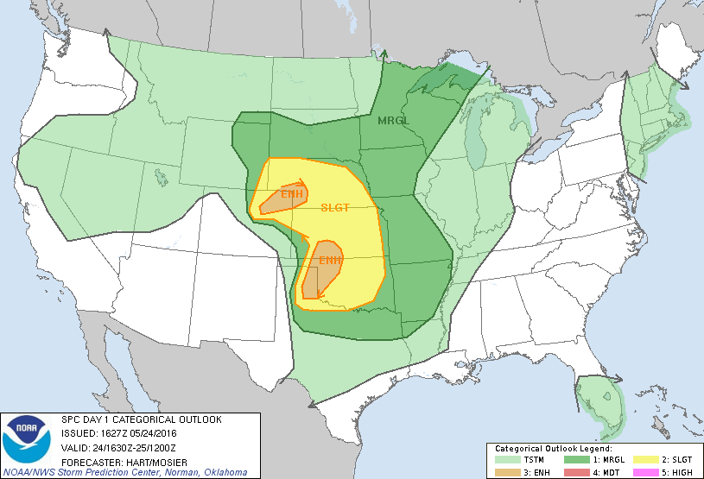
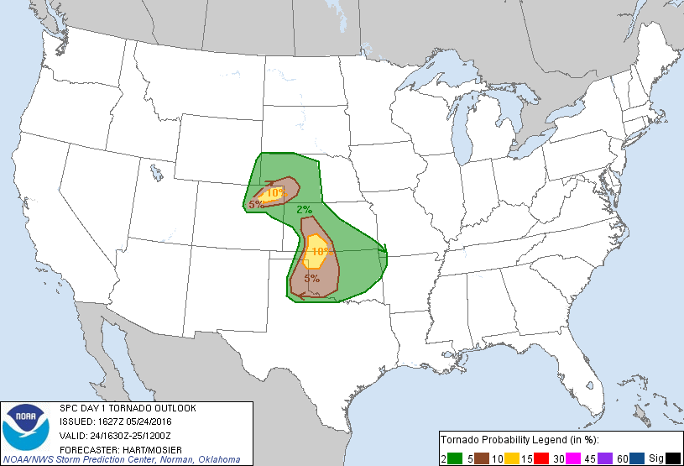
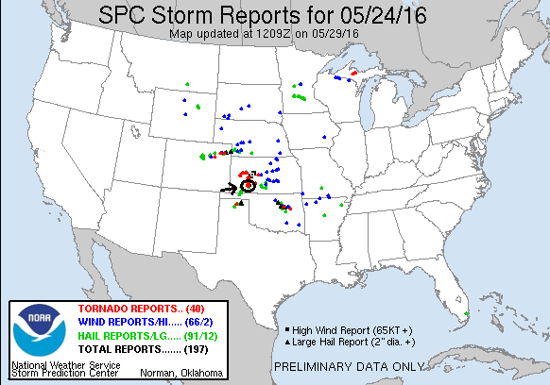
Day 9: May 25th, 2016
Somewhat of a down day for us today, mixed with a little chasing. We started in Garden City, KS and left late in the morning, making our way to Wichita. On our way, we passed through Dodge City and saw EF2-EF3 damage in the damage path from the previous day’s tornadoes west of the city, with power lines down, trees uprooted, and significant roof damage to a number of houses.
We first stopped in Mullinsville, KS to see the windmills alongside the road covered with political satire and other commentary. Always fun to take in. At least the guy who makes them seems to be non-partisan: he blasts everyone! By the time we left there, the Storm Prediction Center was getting more concerned about storms forming off the triple point on the KS/OK border and we picked up the pace, stopping briefly in Greensburg, and then not again until we got to the Belle Plain rest area on the Kansas Turnpike south of Wichita.
We waited for a while to see if storms would fire around us and eventually they did. We first followed a developing storm up to around El Dorado on the Turnpike northeast of Wichita, but eventually turned around and decided to target storms coming up from the Medford, OK area. We blasted back south as the storm we’d left died completely, but unfortunately the cells we targeted couldn’t get their acts together either and we called it a night, though one finally went crazy after dark up near Enid, OK. The big storm of the day that produced a long lasting tornado up near Salina was out of our range. You can’t catch them all! We spent the night at the host hotel in Oklahoma City.
Miles for the day: 449.
Day 9 1630Z Convective Outlook, Tornado Probability, and Storm Report:
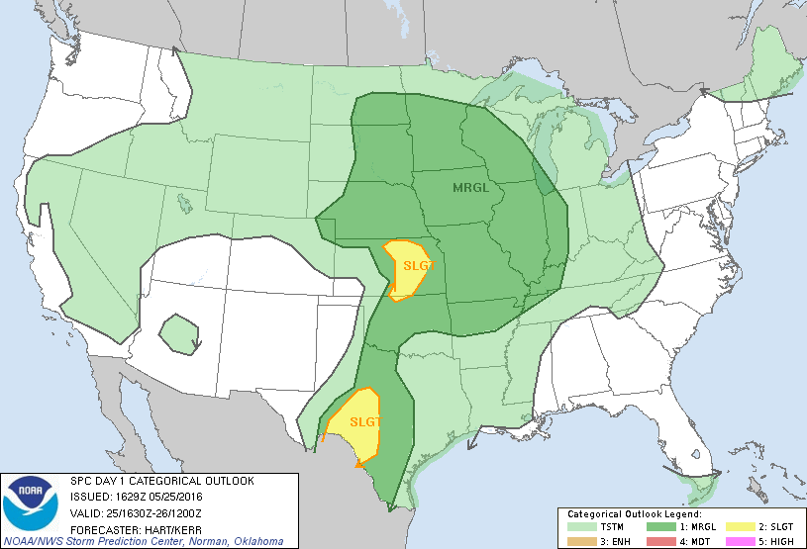
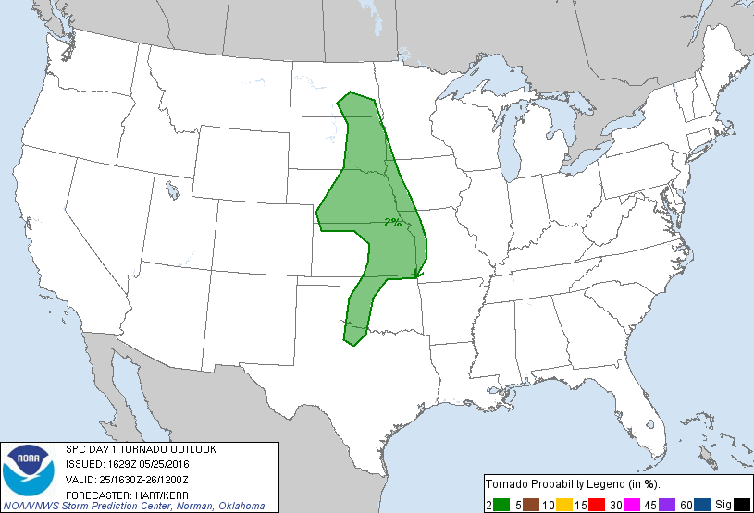
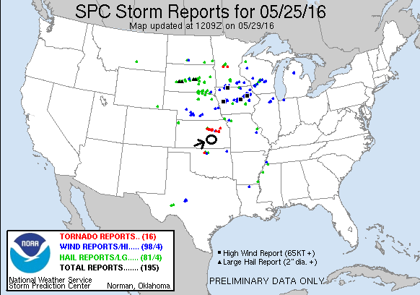
Day 10: May 26th, 2016
A long and somewhat frustrating chase day with a nice ending. Going in, we knew that the setup was the opposite of what we’d been dealing with thus far on the tour: plenty of CAPE yes, but no capping, meaning that the storms were forecast to explode early and quickly become a mosh pit of cells competing with each other and eventually lining out. The shear profile looked good however, so the opportunity for tornadoes was there during the early period after storm initiation.
We initially planned on heading to Salina, KS to target storms on the warm front, then adjust from there west as far as need be to meet storms as they formed. By the time we stopped in Wichita for lunch however, we decided that I-70 would be too far north so we started heading towards Great Bend to meet storms that were already developing that were coming up from the southwest.
After exiting the interstate at McPherson, we decided to head south to meet storms coming into Comanche County from Oklahoma, taking Rt. 61 towards Hutchison where we got cored by elevated storms in the area as we passed by, containing large amounts of small, very hard hail. As the storms were moving north quickly, we decided that we needed to get west to intercept them as they came north so we headed west on Rt. 50 towards Mackville and Belpre. About this time SPC upgraded the threat in Central Kansas to Moderate with a 15% hatched area all through where we were chasing, and elements of the group of storms to our west, though linear looking, were now tornado warned.
As we approached Mackville however, a storm to the south caught our attention so we retraced our steps to Rt. 281 and headed south to Pratt, then west towards Greensburg. The storms were not looking impressive by the time we got there though, and after a long stop in Greensburg we proceeded to meander back and forth between Greensburg and Pratt, apparently killing every storm we looked at. It seemed like the day was pretty well done but then a new series of storms, more isolated than before, started popping up on the dry line from Dodge City south and we turned west again to pursue. We went through Greensburg again, and then planned to turn south out of Buckland on Rt. 34 towards to intercept a storm coming up through Englewood that was all by itself. That plan changed quickly however as a cell to the north of Dodge City went tornado warned, and soon we were heading northwest on Rt. 400 through Ford and then up to Wright to get closer.
By the time we made Wright, the storm south of us was tornado warned as well and we were going to have to make a decision which storm to chase. The storm to our north had a nice corkscrew updraft but was clearly undercut, while the southern storm looked linear and high based. We continued to up Rt. 50 through Spearman to Kinsley, and by the time we got there the warning on the northern storm had been cancelled, so we went south on Rt. 183, clipping the northernmost core and ending up under the “whale’s mouth”, with dark tendrils hanging off the shelf cloud that extended the length of the line. We passed through Greensburg for about the 4th time of the day, and got to the southern end of the storm and stopped to observe and stretch our legs. The storm had a decent block wall cloud, but was very high based and also was being undercut, so soon we headed south again, both to check our additional severe storms south of us but also to get heading towards the hotel.

The tour had one last show for us however as we headed east of Selman, OK: an amazing mothership of a storm as dusk, showing an array of blue, purple, and orange as we passed under, and then as we stopped to its south to take pictures at Sunset. We then continued south through yet another core, and another surprise: the southern part of the line we were passing through became tornado warned and was headed in our general direction! We piled through the north side of the core and stopped in Woodward for a quick dinner break and were off again… and entertained by spectacular anvil crawling lightning all the way back to OKC.
All in all, not a great day, but the surprise storm in the remoteness of Harper County was a treat in the end and the sunset and lightning show a nice end to the tour. And a fun tour it was! 19 tornadoes over a 4-consecutive day period is my new single year record, surpassing the 17 I saw in 2010, and I believe my total is now over 100 tornadoes witnessed.
Miles for the day: 762.
Total miles for the tour: 4666
Total miles with the extra day pre-tour: 5371
Day 10 1630Z Convective Outlook, Tornado Probability, and Storm Report:
