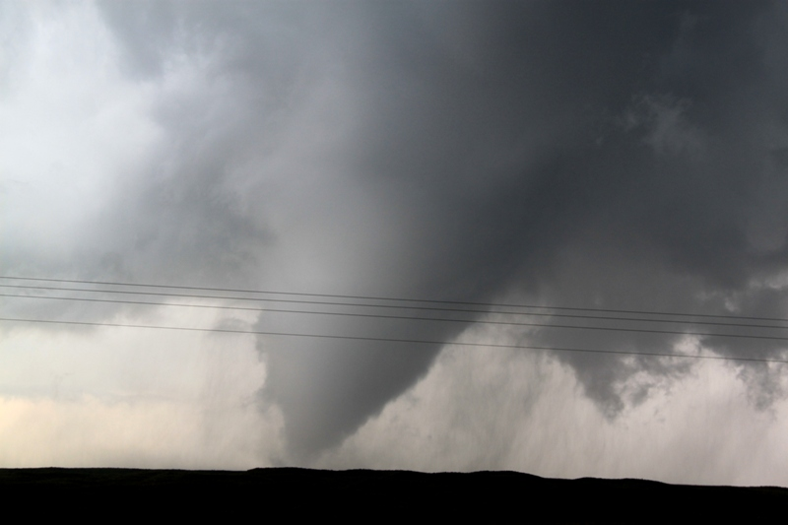

Silver Lining Tours
2015 Prime Time Tour
Daily Tour Log

Day 1: May 19th, 2015
A long chase day, but in the end it was worth the effort! We started out from OKC with the intent of heading to Amarillo, TX. From there the plan was to drop south to either play storms we hoped would form on the dry line / outflow boundary intersection or to head all the way south to Midland or Ft. Stockton to play the storms the models all broke out there.
Put mildly, the atmosphere was a mess: It rained all the way west into Texas and ultimately we did not see the Sun once all day. Usually a recipe for a complete bust of a chase day, but not today... Once we made it to the Oklahoma / Texas border, our plans changed: The models were now downplaying the dryline option, but were now indicating a strong play along an instability axis running from around Childress down to Abilene. We headed south to Childress and stopped for lunch and evaluated.
As the models continued to push the action area east, we decided to head east out of Childress for Vernon, through sloppy rainstorms all the way. Arriving in Vernon, it looked like the day was pretty much over, with multiple elevated rain storms in the area and nothing looking decent. After the obligatory Braum's stop, we decided we'd head south towards Abilene and evaluate, giving us some chance to catch any storms that formed way down south, or if the whole day busted we'd be closer to our hotel. We headed south on US 283 but as we got away from town one of the elevated blobs had congealed into a nice storm with a developing hook. We blasted east on a FTM 1763 towards Harrold as the storm quickly went tornado warned and there were reports of a tornado in progress! The problem for us was that the storm was crossing the Red River into Oklahoma and we were on the backside of the hook echo, where we’d never be able to see anything!
We rushed to Burkburnett and across the river back into Oklahoma, and then had to stair step north and east towards Randlett. By this time there was another storm coming up at us from Wichita Falls that looked better than the storm we were chasing, which was now looking like a high-precipitation blob and it was clear looking down the notch that the storm wasn't producing a tornado. We proceeded as far as Walters, then dropped southeast to Temple on Rt. 5, then all the way to Waurika, heading south as the storm moved along just to our west. We stopped just north of Terral as the hook passed to our west, a murky, rainy beast just like everything else today. The storm was incredibly electrified and we had to keep everyone in the vans as smooth lightning bolts crashed all around us with loud “Booms” every time (as opposed to the crackles you hear from branched lightning). This might have been the closest series of lightning impacts I've witnessed. In fact, even though we had everyone in the vans we still decided to move south to get out of the way.
A few miles later we stopped again as the mesocyclone passed just north of us. After it crossed the road, we looked back and could see the old occluded meso on the back side of the hook echo, and soon it produced a large cone tornado! The tornado widened out and lasted for a solid 2-3 minutes before becoming a multi-vortex tornado with 3 distinct vortices spinning around. The tornado then dissipated, but a few minutes later the storm produced another tornado, this time an elephant trunk east of the road, which lasted only a minute or so before lifting, and despite trying several more times did not appear to touch down again.
Cutoff by the river and the storm, we headed south on Rt. 81 back into Texas and east to Nocona, then north on Rt. 103 to Spanish Fort and along a dirt road to as close to the river as we could get. As we approached we could see a big lowering that produced a funnel about 1/2 way to the ground, but it never touched down. Eventually we had to settle for some nice structure shots of the striated updraft before giving up and targeting a whole series of storms coming up from the south, every one of which was tornado warned. It was getting dark though, and after traveling all the way to Bridgeport we decided to call it a night and head to Abilene, even as a nasty looking tornadic storm occurred just to our northwest and hit the towns of Vineyard and Runaway Bay hard. Always strange at night to know the storm just a few miles from you is producing a tornado doing significant damage but you can’t see it.
A LONG but ultimately successful chase day. I still can't believe that we never saw the Sun all day, meaning there was no ground heating, yet the atmosphere destabilized enough to produce a dozen or more separate tornadic storms. Unreal!
Mileage for the day was 696.
Day 1 1630Z Convective Outlook, Tornado Probability, and Storm Report:
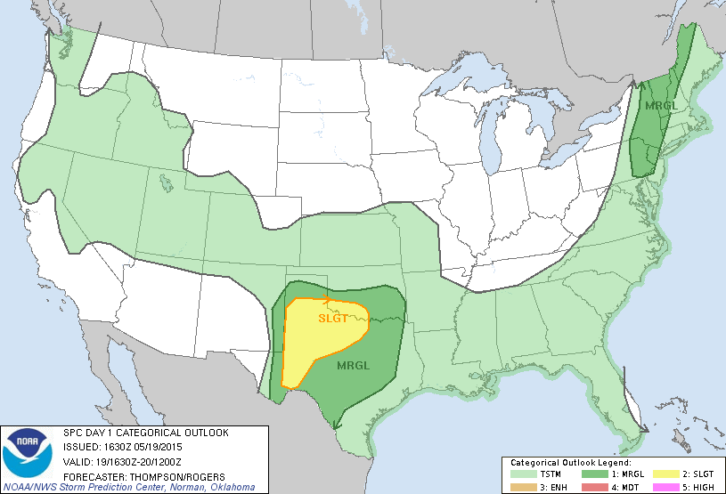

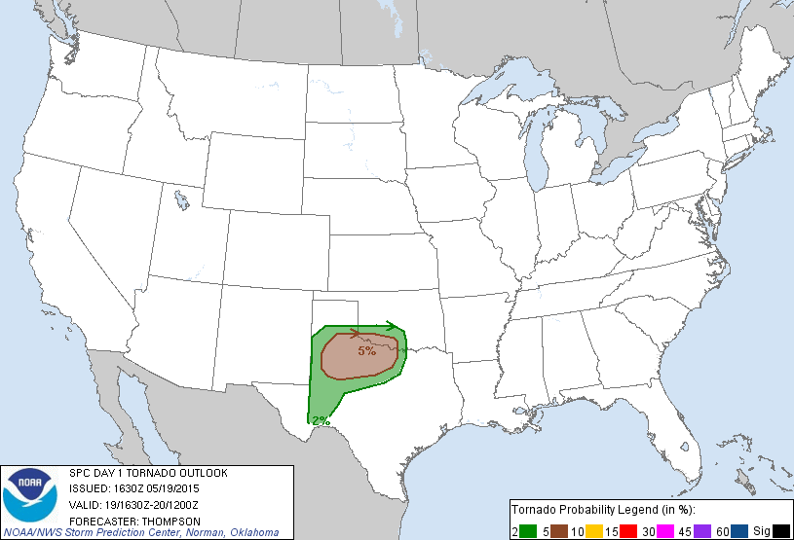
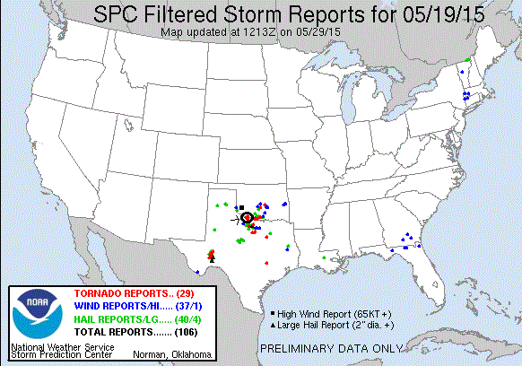
Day 2: May 20th, 2015
Starting in Abilene, we headed for west Texas in mist and fog, hoping to play storms along the sagging cold front in a high-instability, low shear environment. This was a marginal setup and we were mostly just looking for pulse-severe storms with good structure and some hail. The HRRR had two main target areas, one towards Pecos, TX and one south of Ft. Stockton. Either way, that meant heading west on I-20, so we trucked it down to Midland/Odessa, stopping quickly to grab lunch, then on to Monahans, where the Sun had finally come out. At that point we had to pick a target and we chose the southern of the two and headed down Rt. 18 to Ft. Stockton.
Once there, we sat and waited as towers popped up all around us, sheared over (not a good sign when you are supposed to have high instability and low shear) and died. Soon we could see the cold front approaching from the north, and knowing that it would undercut any activity that it passed, we started heading south towards Marathon to play with the storm bubbling along the Davis Mountains. But, after getting about halfway there, we noted a storm firing along the frontal boundary just north of Ft. Stockton and turned around to chase it. The storm had decent enough structure with a fairly broad base, and looked interesting for a time with several long inflow tails pulling air in from the north, but it looked “cold” and soon our location was getting hit with steady cool winds from the north… the front had passed and the storm, which we had hoped would anchor on the front, was now behind it and dying in the cold air. We’d mostly lost hope as we drifted back into Ft. Stockton, but another cell was getting stronger along the highway so we decided to go have a look.
The storm was east of us right along I-10, so the first bit of fun was a fairly long core punch through the entire length of the front-flank core. We got heavy rain and a good bit of hail up to quarter size, and in fact called that in and got the storm severe warned. Needing to get out in front of the storm, we drove south out into the middle of nowhere along FM 2886 and stopped at several locations to observe. The storm was somewhat linear looking but there was a lot of interesting motion and as the storm rode the frontal boundary and moved south it intensified and began throwing out lots of smooth bolt cloud to ground lightening immediately in our area. Still moving, we stopped near the junction of Rt. 285 and watched the roiling motion on the front end of the shear line, and at one point the storm produced a ropey shear funnel than made it pretty close to the ground. Several more times certain areas of the rotation looked like they were going to wrap up into something more substantial but never quite did.
As the core closed on us, the lightning picked up again and we saw a couple of bolts hit squarely in the fields around us, and another hit a large tank at a gasification facility we went by! We played with the lightning for a bit then headed north, plowing through the core of the weakening line segment for the easy ride into our hotel in Ft. Stockton.
All in all a pretty fun chase day. Our expectations weren’t high given the setup and we ended up with a nice storm with structure, hail, some motion, and a lot of lightning. Plus, the terrain in this area of Texas is really interesting, with lots of mesas, buttes, canyons, and cacti.
Travel distance for the day was 424 miles.
Day 2 1630Z Convective Outlook, Tornado Probability, and Storm Report:
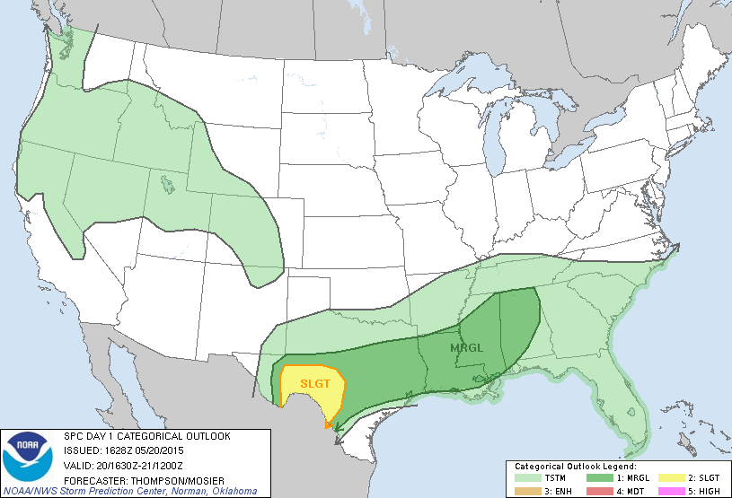
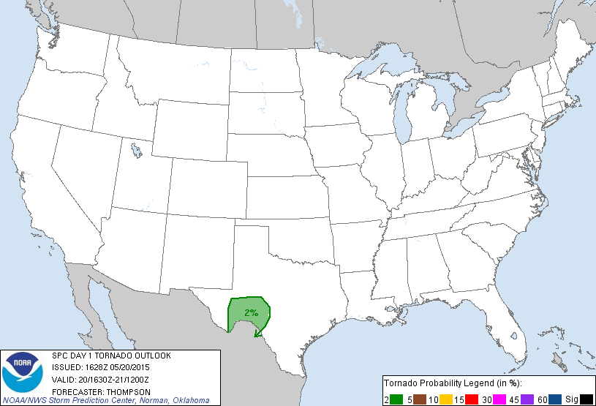
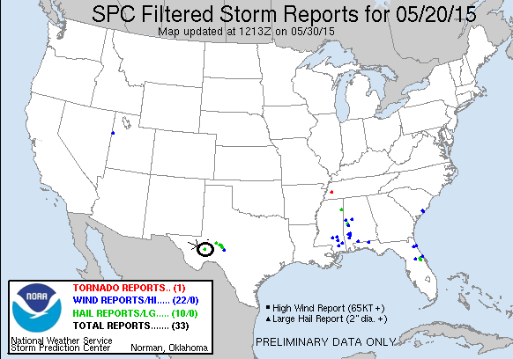
Day 3: May 21st, 2015:
A down day as the cold front smashed all of the instability southward into Mexico, leaving us in mist, fog, and a stratus deck at 55 degrees in Ft. Stockton. We had lunch in Ft. Stockton, hanging around to see if anything would happen out west towards El Paso or down in Big Bend National Park, but once it was clear nothing would we headed off to Lubbock to set up for the next day.
Travel distance was 233 miles.
Day 4: May 22nd, 2015:
The first order of the day was to decide between two targets: back down to Ft. Stockton, TX where there would be plenty of instability but a questionable wind profile, or up in Colorado on a warm front with a good amount of shear, but limited instability. By morning some of the models had enhanced the amount of CAPE that would be available for storms up north, so we chose the northern target and left Lubbock with a destination of Limon, Colorado. We made good time heading north, watching as storms started to fire along the warm front which was situated just north of I-70, and also in the mountains. By the time we reached Hugo (along with every other chaser who had selected the northern target that day) some individual cells along the front were looking more interesting, and we selected one just north of town to chase. Stopping north of town, the storm was off to the northeast and was of the low top variety, and produced 2-3 small wall clouds but none showed a great deal of rotation.
With that storm cycling down, we decided to move to get to a central location where we could react to whatever cell took over the show since there was also a mountain storm west of Pueblo that had potential but appeared to this point be anchored on the high terrain, and headed south and west on county road 2W, stopping a few miles south of Hugo to observe. The front was clearly visible in front of us with numerous small updrafts located just north of the front in the cold air. At one point, I think there were 4 wall clouds visible! None of them were rotating much if at all though, and with those storms north of the front, none of them were likely to. After about 30 minutes, a storm just north of us in Limon was looking more robust so we decided to go after it.
As we went through Limon, we caught the edge of the core and got some small hail, maybe with a few nickel sized stones, then headed east on I-70. We stopped in Genoa and looked back and much to our surprise the storm, which was north of the boundary and looked awful on radar, had terrific structure: A well-defined wall cloud with inflow tail, and laminar striations indicating rotation. It was also freezing cold! The weather station in the van indicated a temperature of 55 degrees and a dew point of 50 degrees and with the cold inflow winds it felt like it was in the 40’s! I was beginning to wonder if it could snow from a supercell! Certainly the coldest temperatures I think I’ve ever chased in. We continued down I-70 in front of the storm, stopping again in Bovina to watch the storm structure as it got better and better, taking on a mothership look. By the time we stopped at the rest area near Arriba, the Sun was popping through behind the storm and the view was breathtaking. Just beautiful structure, and amazing considering how unimpressive the storm looked on radar and in fact it was never severe warned.
Finally the storm looked like it was dying while a couple of cells along I-70 east of us were riding the frontal boundary and looked like they might be strengthening. We headed down the highway, running through a few small cores, but by the time we got to Stratton the storms were all dying down and with it getting dark, we turned around and called it a night. There was one more good looking storm down near Pueblo, but we couldn’t get to it before dark.
Talk about making something out of nothing! The models overestimated the amount of instability that would make it into Colorado and that was the failure mechanism that prevented a big day. Not one of these storms in Colorado was ever even severe but the structure of our little storm was a real treat.
Travel distance was 594 Miles.

Day 4 1630Z Convective Outlook, Tornado Probability, and Storm Report:
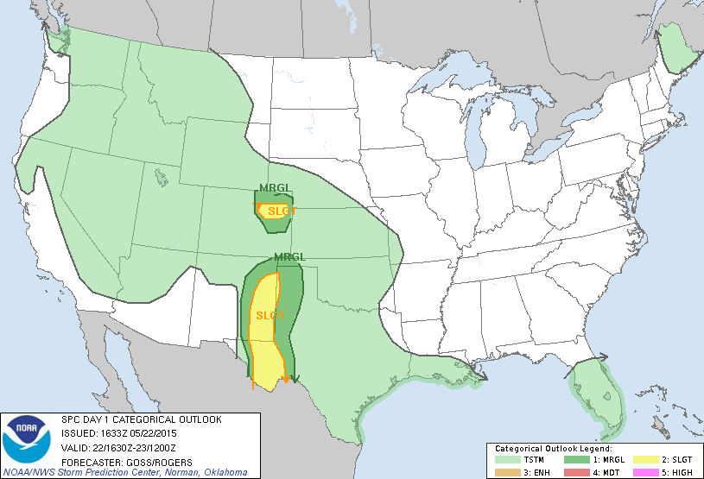
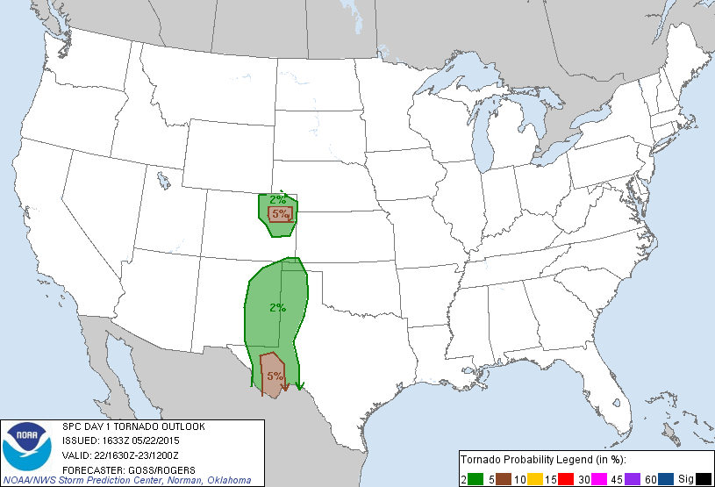
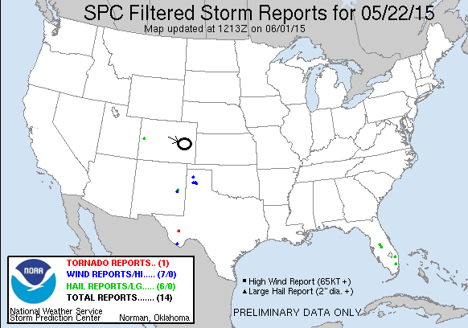
Day 5: May 23rd, 2015:
Another day with multiple targets, though at least this time we were within easy striking distance of both. The models broke out storms near Denver and intensified them significantly as the “Denver Cyclone” brewed up, and also down near Pueblo, moving off the mountains and out onto the eastern Colorado plains. Since we were in Limon, we were able to sleep in a little and sat for a while, waiting for the storms to brew up. By Noon, both areas had initiation, but the storms down south looked better on radar and were in a much better environment than the cold air up north, so we decided to target the storms to the south. We headed out of Limon straight south on Rt. 71 through Punkin Center, closing on the storms quickly as they were moving almost straight north to meet us. Though the target storm was masked by some small cores out in front of it, we could see the bases of several other storms in the area along a broad line of storms running north-south all along the mountains. You can see a LONG way out there.
As we closed on Ordway, we were facing 3 separate storms that were pulsing up and down, each alternately looking better than the others. We decided to get east in order to stay ahead of the line, and proceeded on Rt. 96 through Sugar City. As we headed east, the base of the southernmost storm, which was our target, came into view with a big blocky wall cloud almost on the ground! Once we cleared the precipitation core, we headed south on Rt. 31 towards Cheraw. We stopped and watched as the first lowering passed by to our east, and a new cell came up from the south with another lowering as the line kept expanding to the south. There were a few times that areas along the line tried to tighten up but none ever did. Later, as we headed south, then east out of Cheraw on County Road HH, a funnel appeared under the southernmost cell in the line and made it about three-quarters of the way to the ground before dissipating. We headed east until we intersected Rt. 194, stopping occasionally to watch the roiling motion along the line, where different segments kept bubbling up and down in intensity but none over really took off.
Realizing that we were running out of roads to get north as the storms moved off to our northeast, we blasted east to Wiley, but by then the line was dying and another segment of storms was coming up from the south, so we stopped at the truck stop north of Lamar and waited for them to approach. We ended up waiting for nearly an hour as the line segments slowly closed in on our position, but they appeared to be weakening and we were about ready to call it a day when there was a report of a wall cloud on the line segment passing just to our west, so we zoomed west and intercepted the line again. There was some pretty strong rotation at points, but not enough to tornado, and as the shelf cloud got to us it was time to head east.
We stayed out in front of the line, stopping every now and then to let the squall line catch us, passing north of Lamar on Rt. 196 until we were forced to turn around as a semi had somehow gotten its front wheels stuck in the mud on the north side, and was broadside across the entire road with the rear wheels stuck in the mud on the south side. We headed back west about 5 miles then flew south, just barely touching the core before heading east again on Rt. 50.
We continued along Rt. 50 to Holly and stopped again waiting for the new tail end storm to come up from the southwest, but it weakened as it approached and soon we decided to call it a day and headed to our hotel in Garden City, KS. A fun chase day but there never appeared to be enough instability to get the cells to severe parameters, nor was there enough shear to break the storms into discrete cells.
Total miles for the day were not bad: 295

Day 5 1630Z Convective Outlook, Tornado Probability, and Storm Report:
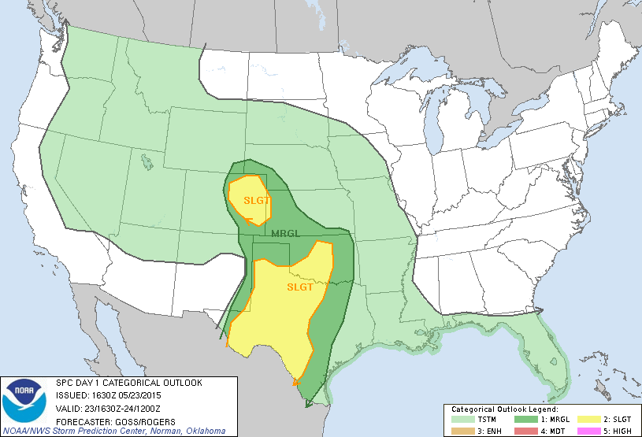
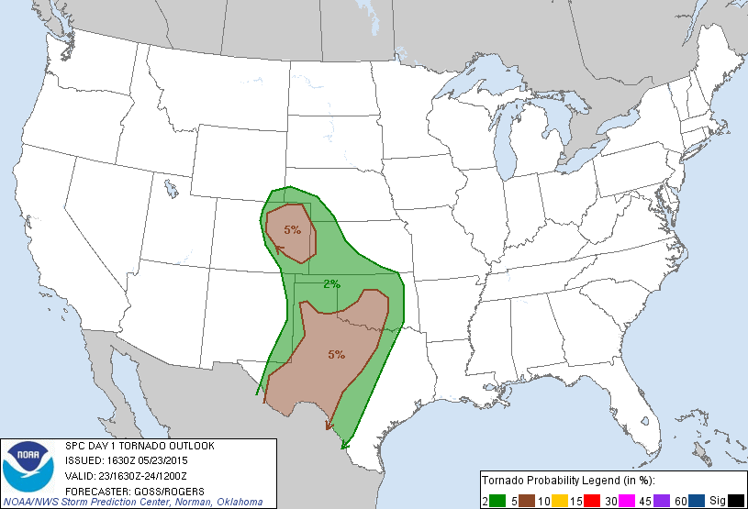
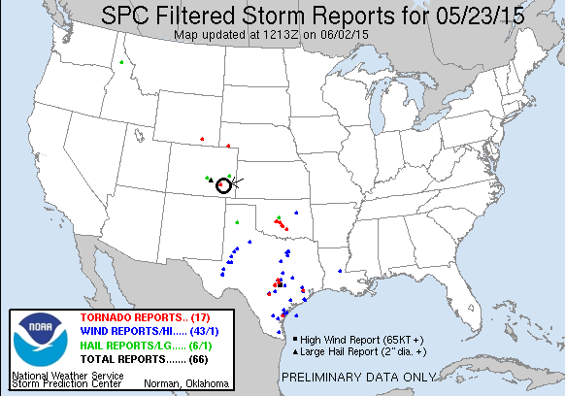
Day 6: May 24th, 2015:
Wow, my favorite chase day since 2013! Waking up in the morning, I didn’t have high hopes, mostly because the previous day was pretty tame and the models looked only a little better to me, but as the morning runs came out, things improved. First order of business was to decide between a Texas Panhandle play down near Childress, or a “La Junta Low” setup just west of our starting point of Garden City, KS. Each model run progressively backed off the Childress play, but developed an isolated supercell out in front of a line of storms that developed and moved into Kansas. Turns out the model knew what it was talking about! We headed west…
We retraced our steps from the previous day in reverse and headed for Lamar. Right away, things were different than the previous few days: It was actually warm and sunny out! Well, in the 70’s at least. The day wasted no time getting going either, as by the time we stopped for gas in Lamar at about 1:30 Mountain time, storms were firing over the Raton Mesa and heading north-northeast towards us. We headed south out of Lamar towards Springfield as the storms intensified, and were presented with numerous options: one storm well to the west that looked the best near Trinidad, another just west of Pritchett, and a 3rd just west of Boise City, OK. In order to place ourselves in a position to intercept any of them, we headed to Pritchett, stopping just north of town, where we waited to see which storm would become dominant.

We weren’t there for long before the storm just to our north took off and started to develop a hook, and soon we had to bolt back north to catch up to it. We headed back towards Lamar and stopped at a rest area about halfway there to take some photos and watch the storm develop. There were actually two cells, and the one in front developed a lowering that was most of the way to the ground while the second one intensified. We headed farther north toward Lamar and by now the storm was a full blown rotating supercell with tremendous structure and that turquoise hue that tells you the hail inside means business. The storm was terrifically striated under a corkscrew updraft, with mammatus and a blocky lowering that was spinning wildly. The storm wrapped up hard and the wall cloud became partially obscured by rain, but soon a cone tornado peaked out (with a little help from contrast-enhancement) and persisted for a minute or two before getting engulfed in the rain again! Tornado #3 for the trip. We watched the storm for as long as we could before the hail core, with baseball-sized stones being reported (and we saw a car with its back window blown out as supporting evidence) threatened to cut our north option off, so we moved out into Lamar and then east towards Granada.
The structure as we headed east on Rt. 50 was phenomenal! The storm was now a big striated HP supercell, right turning hard and heading east towards us. We headed south on a dirt road out of Grenada and watched as the storm approached, with a long, linear looking laminar updraft and a wall cloud on the nose end. The rotation of the updraft above us was impressive and the storm was now too big to capture without a wide-angled lens. We were in danger of getting stuck on a muddy road as the storm closed on Grenada and soon the tornado sirens in the town were going off so we headed east on Rt. 50 again to Holly, and then south on Rt. 89.
South of Holly, the storm now had a long, linear base trailing off the supercell to the north as multiple cells were now brewing up and the system was becoming a line, but the structure at the north end now had a flying saucer look to it and was still spinning hard. We spend a good half hour watching the storm approach and take pictures, but soon the shelf cloud was practically on top of us and we had to blast south to get out of the way. Another 5 minutes and we would have been pummeled as we stayed there a bit too long. The south end of the line was now taking over anyway and was soon tornado warned, though there was not the slightest sign of rotation in that area of the storm. We narrowly beat the line to Rt. 116, though at this point the line was so thin that you could actually see through to the other side. We headed east into Kansas to stay ahead of the storms.
As we headed east, we saw an atomic bomb of convection off to the southeast near Liberal, KS, with a mammoth overshooting top and big back sheared anvil. Once we saw that monster forming, we quickly forgot about the line behind us and bee-lined for the storm, which was already forming a hook. We zoomed through Johnson on Rt. 160 and could see off in the distance the lowered base of the storm that looked to already have a wall cloud developing on it. We had to make a decision: Do we keep going east to get out in front of it, but that would take a long time and while we were passing in front of the precipitation core we would not be able to see what was happening to the wall cloud, or do we head south towards Hugoton and approach the storm from behind, risking being forced to core punch to get to the storm? As we got to Ulysses, we chose the south option since it would get us to the storm quicker and in the worst case if it produced a tornado we’d still be able to see it, albeit from far away.
We blasted south along Rt. 25 and got a closer look at the explosive convection going on with the storm. This one was clearly a power house! There were now two distinct lowerings to the south, but then to our east under the updraft of a left-splitting cell there was wild rising motion and an area of white condensation on the group spinning like crazy! The rising motion was almost ridiculously fast, faster than I’ve seen in most tornadoes. The rotation on the group persisted for a minute or so before stopping. One of the only anti-cyclonic tornadoes I’ve seen, and #4 for the tour! Meanwhile, off to our west, we had to keep an eye on the robust shelf cloud from the line of storms we’d left as there were a couple of distinct lowering in that line as well.
We headed east out of Hugoton on Rt. 51 and were soon coming right up to the two updrafts, one straight to our east and another to the southeast. The structure on the southern cell was fantastic, with a Liberty Bell updraft and a mammatus field under the big back sheared anvil. Both cells had mean looking lowerings and were spinning hard, and as we passed the rear flank of the northern cell just off to our north in the field, the motion was amazing! There looked like there were about 4 areas where we could get a tornado at any time. Time, however, was the problem as it was now getting towards dusk. We got to Rt. 83 and decided to try and get on the southern storm but as we passed by the northern mesocylone we had to stop as it quickly tightened and tried to produce less than half a mile from us! In the near dark it was spooky as the lowering produced several funnels that made it about halfway to the ground that seemed to be getting nearer and nearer to us while inflow screamed into the updraft almost over our heads. We then turned north on Rt. 83 and as the light faded we inched forward on the road with the rotating mesocyclones of the two storms on either side of the van.
Unfortunately at this point it was dark, we would have had to go south and around to get back to the southern storm and with 4 vans in the caravan, chasing at night was not an option. Not to mention we already had a 3 hour drive to Amarillo to look forward to. As we headed south, the storm then went on to produce a massive tornado that lasted over an hour (much of it in the fog!) and traveled nearly 40 miles as the night went on, UGH…
Still, this was a GREAT chase day, with 3 storms that were better than any I chased last year. Tremendous structure and two brief tornadoes, and some great, adrenaline pumping chase moments.
Total miles for the day: 582

Day 6 1630Z Convective Outlook, Tornado Probability, and Storm Report:
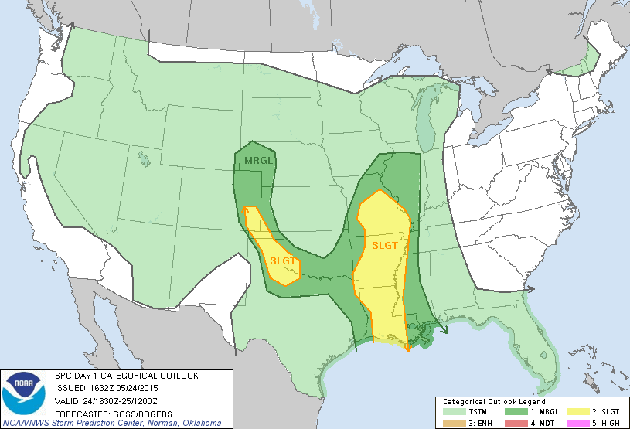
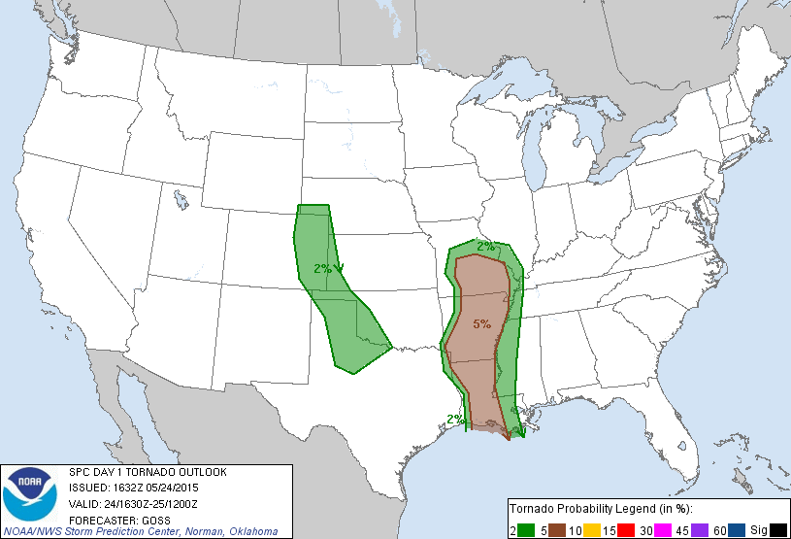
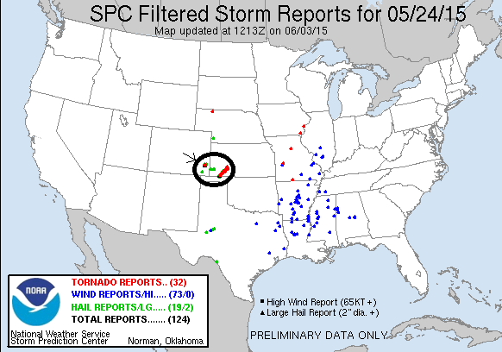

Day 7: May 25th, 2015:
Starting in Amarillo, we had an early start as our target was isolated storms forming out in front of a raging squall line already in progress in west Texas. We headed to Childress and then on to Wichita Falls in the rain, finally getting out in front of the line near Vernon. We intended to get down towards Ft. Worth as there was so much instability that storms were sure to go tornadic once they got into that region, but as we cleared Henrietta it was obvious that we would never get to Ft. Worth before, or be able to stay out ahead of, the squall line. Even if we did we’d be driving all day getting chased across the state and never be able to stop and see anything. So, we decided to halt in Bowie and let the line pass over us.
We parked the vans at an Allsups and the guests gathered under the awnings, and as the line came over we got some strong wind gusts and torrential rain for about 15 minutes. But, with lapse rates being pretty low there was no hail and it turned out to not be terribly exciting. Actually the best part for me was the 15-20 minute conversation we had with 2 police officers from Bowie. It’s just cool sometimes to get different perspectives from the local people. Anyway, with the line past us and no hope of catching it, the day was over for us and we headed to Weatherford, TX to spend the night.
Miles for the day were 339.

Day 7 1630Z Convective Outlook, Tornado Probability, and Storm Report:
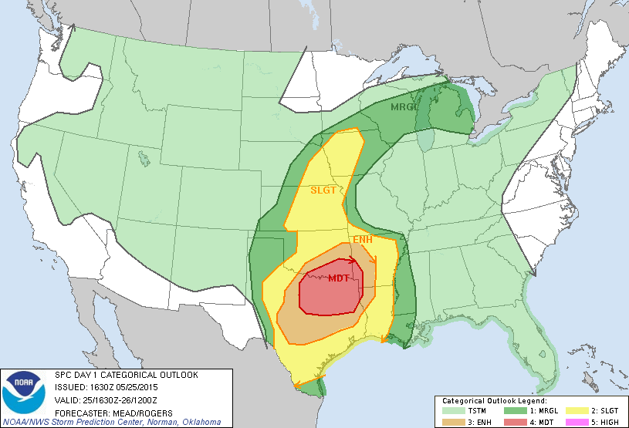
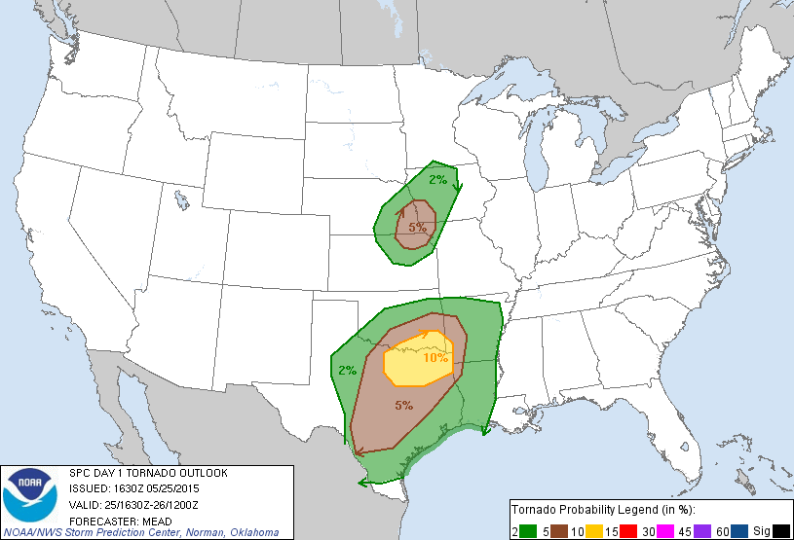
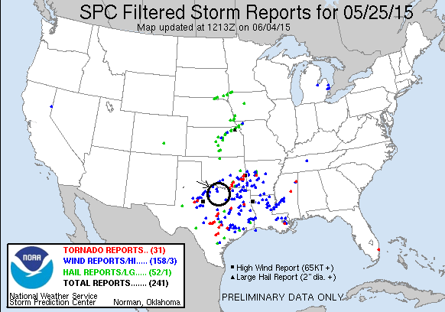
Day 8: May 26th, 2015:
This day the plan was to play the intersection of the dry line with whatever leftover outflow boundaries from the previous day there were. There was plenty of CAPE available from southern Oklahoma down to I-10 in west Texas, but upper level flow was limited and the shear profile was not very good. The morning models showed two primary target areas: along a line from Wichita Falls, TX down to around Throckmorton, which was the area where the severe parameters appeared to be best, or just south of Abilene, where the models broke out an isolated storm in an area with very high updraft helicities. We initially targeted the Abilene area, but soon adjusted to a more central location that would allow us to play either target. We stopped in Cisco for lunch and to wait for initiation.
We hung out in Cisco for an hour or two before storms started to pop to our northwest over Newcastle. With the Abilene area still quiet, we decided to head north to intercept. As you’d expect in a high-CAPE environment, once the storms initiated the updrafts went up quick and soon we had targeted a storm forming just north of Breckenridge. We headed northeast out of town on Rt. 67 and stopped on FM 1800 near a correctional facility and watched the nicely structured classic supercell as it grew from its infancy, though we had to move at one point because the prison perimeter guard came out and told us we were too close to the prison! I guess four unmarked white vans sitting within view of the prison fences made the guards nervous! We watched from our new vantage point up the road for another 30 minutes or so as the storm matured, grew an inflow band, and quickly developed a nice blocky wall cloud that soon was rotating rapidly. The storm was also highly electrified and at one point we were forced back into the vans to reduce the lightning threat. The hail roar from the storm was loud and constant all throughout our time chasing it. Low level shear may have been a problem though and the wall cloud never tightened up, and we soon headed back to Rt. 67 to stay with the storm as it moved east. As we headed back south though, the storm had cycled its wall cloud and now looked like it could tornado right over the road, so we quickly zoomed back north right up to the mesocyclone which had wild cascading motion as it crossed right in front of us. Unfortunately, it couldn’t focus though and soon the meso jumped and the new area of focus was to the east, so we headed back south, then east, in pursuit.
Road options were fairly limited, so we had to follow Rt. 180 for about 16 miles east before we could turn north again at Brad, which put us well out ahead of the storm as it was not moving very quickly. In the meantime, the storm had merged with a cell north of it and cycled back up. We set up on Rt. 16 and waited for the storm to arrive. The storm was now morphing into a high-precipitation supercell and had 3 distinct hook echoes on the southern side as it approached. The storm was turning right hard and dive bombing southeast so we got clipped by the front flank core a little before the inflow notch became visible. As it did, a dark cone/elephant trunk funnel developed off in the distance! From our vantage several miles away we could not tell if it was on the ground or not, but later pictures from chasers who were closer confirmed that it was indeed a tornado! It was the 5th one of the trip, albeit a very brief one.
With the storm expanding and closing on our position we had to leave to get back out in front of it. We headed southeast from Brad and through Metcalf Gap, and terrain now was becoming an issue on top of the poor road network since we were now passing through a series of valleys surrounded by high terrain. We continued northeast on Rt. 180 then south on FM 919, eventually finding a good vantage point to watch the now monstrous HP storm come at us. The dark turquoise color meant big hail, and the storm was surging towards us, so we couldn’t stay long and soon once again lightning was pinging all around us. Since the storm was now HP and the rotation was completely engulfed in the core of the storm, there was no hope of seeing a tornado, even though we knew there likely was one in there (there was, and the storm went on to produce one or two more rain-wrapped tornadoes), so we decided to target a new storm which was finally developing down near Abilene. Just can’t take vans filled with guests into the hook area of an HP storm!
We headed down to Gordon and hopped on I-20 towards Baird, targeting a maturing, anchored storm near Ballinger, but the first order of business was to get out of the way of our original storm, which was now crossing the highway. We got clear of that storm and dropped south out of Baird, heading all the way south to Coleman before turning west towards Ballinger. Unfortunately, the storm was struggling after a split and dying. We decided to get south of the storm by punching through the slimmest part of the core on the south flank and did so, heading towards Paint Rock as big cloud-to-ground lightning bolts hit all around us: Another highly electrified storm, this was a big year for lightning! Sadly other than torrential rain and high winds from the outflow, the storm was dying quickly and soon we turned around and gave up, heading up to Abilene for the night. Another day, another fun chase of a great supercell, and another tornado, although it was a brief one.
Mileage for the day was 397.
Day 8 1630Z Convective Outlook, Tornado Probability, and Storm Report:
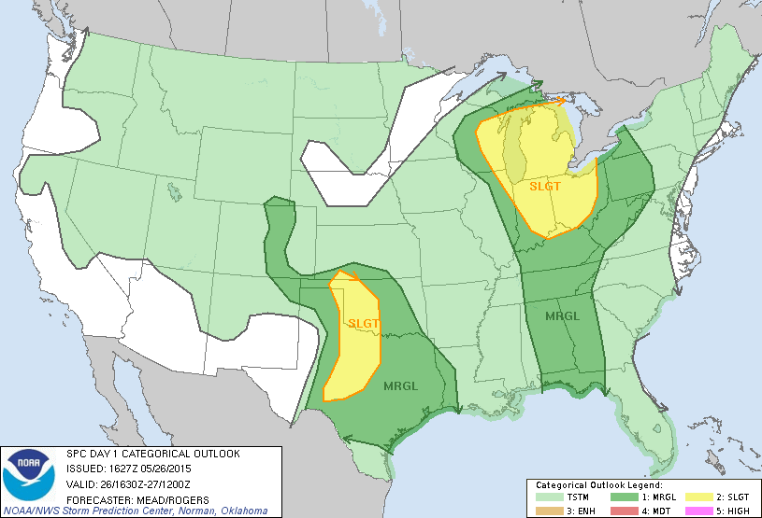
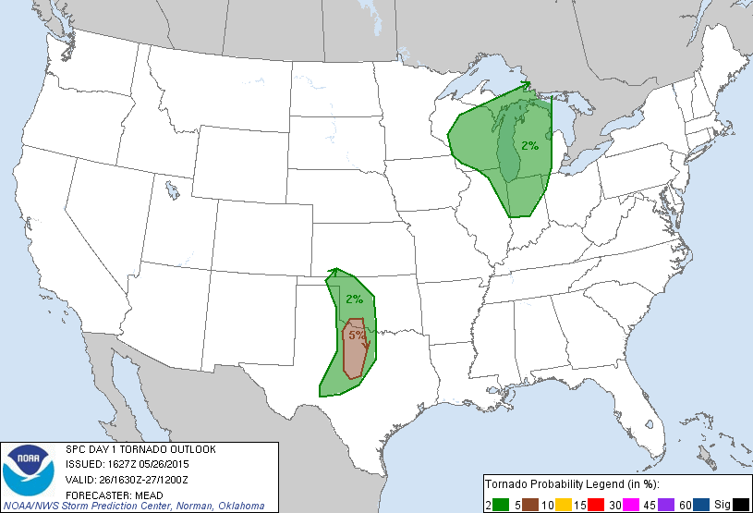
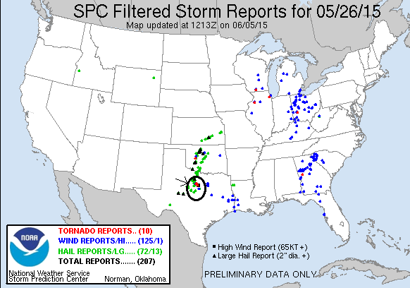
Day 9: May 27th, 2015
A top-10 chase day!! We left Abilene at about 9:30 with the intent of targeting storms at a triple point set up on the Texas Panhandle. Our target for the day was Canadian, TX as the earlier model runs which had favored Kansas backed off that play significantly and favored the Texas Panhandle. We made good time and, after a quick lunch stop in Childress, were in Canadian by about 2 PM with nothing to do but wait, so we hung out at the Dairy Queen. I had a fun talk with an Italian storm chasing tour group from Milan. At this point there were towers percolating on two distinct boundaries, one on the front just west of us and the other on the dry line, forming a triple point around Spearman.
After about an hour of waiting, the HRRR predicted monster was in its early stages of development and we left to chase it, heading about 5 miles out of town on Rt. 83 and pulling off on a side road to watch the storm grow. Our vantage point was perfect and soon the storm had classic structure with a vertical updraft (though it later tilted over hard), inflow bands, and a flanking line. It wasn’t long before it developed a nice wall cloud and not long after that dropped an elephant trunk funnel more than half way to the ground! It seemed like for sure the storm was ready to tornado, but after cycling through two additional larger funnels more than half way to the ground, the wall cloud dissipated and as the storm was slowly moving east, we had to as well. It turns out that the funnel did indeed contact the ground (from our vantage we couldn’t tell), tornado #1 for the day! But why is it that when you are in a perfect spot in terms of visibility, contrast, and everything else, they never put down a nice long tornado!!?
We headed back towards Canadian, stopping once more to view the storm as it cycled and generated a new wall cloud. The storm was barely moving, slowly drifting east, and was already becoming HP, so we had to see into the inflow notch to tell what was going on. We went northeast out of town on Rt. 60 and started experiencing significant amounts of chaser convergence, as well as a lot of other trucks that were stopped waiting for the storm to clear past the road which, as it turns out, took hours. We stopped and watched as the storm developed a lowering on the nose of the updraft in typical HP fashion and decided to head north to look into the notch. We weaved through heavy traffic and drove right up to the storm with the mesocyclone just a little in front of us and wild motion almost directly above the vans! Soon the meso was spinning away wildly just to our northeast and we got blasted by heavy RFD winds. We went even further north past the meso on the end of the hook to FM1920 where we watched another larger meso to our southwest move by. It looked like it could tornado right there, and the action was intense as we were pinned up against the front flank core by the meso, and once hail started falling we moved along with the meso to stay just ahead of the hail. As we did, the rotation to the right of the vans got stronger and stronger and soon a large cone shaped funnel lowered and contacted the ground. Tornado #2! This one was a big cone tornado at first heading straight at us about a mile away, then moving southeast, paralleling our direction as the storm dive bombed southeast, then later headed away from us as it curved around the meso. The cone grew in size and started to show a decent debris fan. One cool feature at this time was that you could look right up the clear slot and see up the whole updraft to the top of the storm. The tornado continued to intensify and grown into a larger cone until, after about 10 minutes the tornado roped out and that meso occluded, but no sooner had that happened then the next meso formed on the other side of the road from us and came towards us. We beat feet to get out of the way and stay ahead of the storm.
We traveled about a mile to get ahead of the new meso and watched as it crossed the road behind us, all the while throwing out funnels part of the way to the ground. We continued on south of the town, parking near a small airport. The storm began to look a little strung out, but still had wild motion under multiple lowerings as each took turns being the focus of attention. Soon to our west, the storm generated another tornado, this one an elephant trunk that turned into a multiple vortex, #3, then another multi-vortex which lasted a bit longer and looked almost stationary before getting swallowed by the rain core.. #4!! All the while the town’s tornado sirens were blaring.
Right after the 4th tornado, the storm belched out the strong, cold winds of outflow and a big precipitation core opened up under the updraft. The show was over for this storm.
After an Allsups break in Pampa, we proceeded towards Amarillo, intending to jump south towards Claude and another storm south of there in the Caprock Country but it was barely moving in the slow upper level winds: Unfortunately there was no road to get south on it, and even if we could, the roads in the canyons were slim and at the bottom of the valleys which made it hard to see anything. So we decided we couldn’t make it and gave up for the night, heading into town for dinner at the Big Texas steakhouse.
The night wasn’t quite done with us though as storms kept firing on the pinch point of a pair of boundaries south of town where our Claude storm had been, giving us quite a lightening show at the hotel.
What a great chase day! We only moved a total of about 10 miles over the course of the entire chase. Even an hour after we drove away from it, the Canadian storm, which was right over the town, was dumping water and hail amounting to over 4” of rainfall and causing flash flooding.
Mileage for the day was 399 miles.
Day 9 1630Z Convective Outlook, Tornado Probability, and Storm Report:
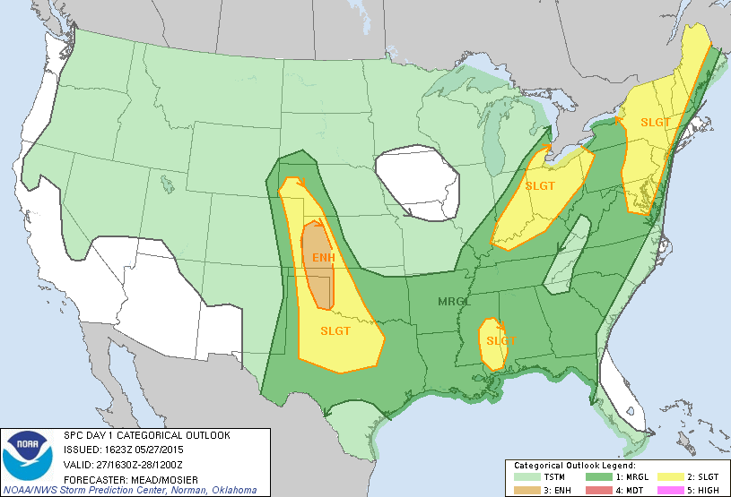
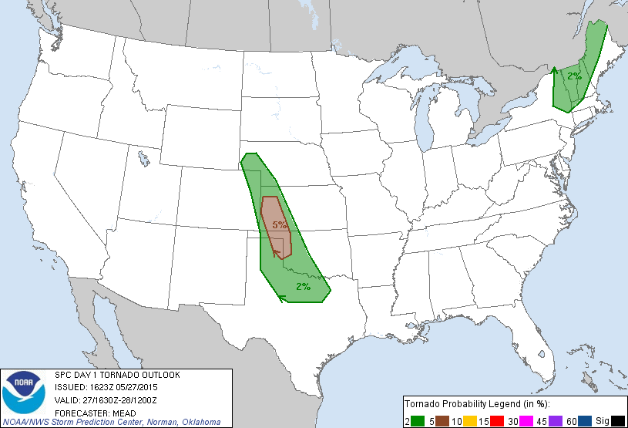
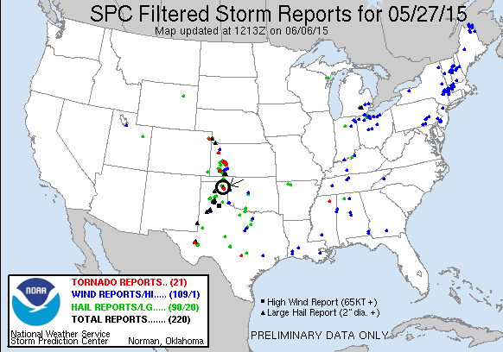
Day 10: May 28th, 2015
For the last day of the tour we had a choice of two targets in opposite directions from our location: north on the Oklahoma Panhandle where was a pinch point between a frontal boundary and the dry line, and where a speed max at 500 MB was projected to cross through, or down south near Lubbock along a dry line/outflow boundary intersection. While the southern play was almost certain to produce some tornadoes, they would be embedded in a line and very difficult to see, while up north offered the possibility of more isolated and better looking storms. Regardless, with very little capping inversion the convective mode today was going to be lines of storms with only an hour or two of isolated cells before it all lined out. We chose to head north and re-evaluate as we went. We stopped in Dumas for lunch as this was somewhat of a central point between the two plays and a 3rd that the models were developing to our southwest. By the time we stopped, the southern play was already underway, and with the storms moving south-southeast, was more or less no longer an option as they were too far away and moving away from us.
After waiting about an hour, we maneuvered northeast to Dalhart, where there were excellent road options to get north to Boise City, OK to play storms forming north of the Raton Mesa, west to a developing storm near Springer, NM, or southwest towards Tucumcari, NM as desired. We stopped at the DQ in Dalhart and waited…. and waited…
Eventually a number of storms were forming in a line roughly along the Texas/New Mexico border with our original Springer storm in the middle so we ended up targeting those. We headed north out of Dalhart but quickly realized we should have headed northwest and ended up taking FM296 west towards Texline. Out in the farmland, the Spring wildflowers in Texas were fully in bloom (thanks to all of the rain which has the Panhandle green for the first time I’ve ever seen it) and the fields of yellow flowers created a beautiful contrast with the purple and turquoise sky ahead. We planned on heading south out of Texline, but the storm beat us to that road so we headed southeast down Rt. 87 instead. Looking at the storm in person, which looked pretty good on radar, told a different story: it looked lousy: really high based with a long stringy shape. You could see clear under the storm to the blue skies and mountain storms far off in the distance. We decided to turn around and retrace our steps through Texline and back east on FM296.
As we got out in front of the storm, it now had a pretty nice looking shelf cloud and we stopped a few times to film the line as it came rushing towards us, and occasionally it would drop a lowering with some rotation but nothing spectacular. We more or less gave up for the day and headed to Dalhart, and then back to Dumas. The line had a really nice shelf cloud off in the distance by this point and we had the opportunity to take a few pictures while we waited for a good 20 minutes for follow car in the construction between Dalhart and Dumas.
We got to Dumas and after the mother of all waits at Braums (a solid hour, had to eventually tell people to get theirs to go), we headed back through Amarillo and back to the host hotel in OKC, arriving at 1 AM and ending the tour.
Mileage for the final day was 571, for a tour total of 4530 miles.
Day 10 1630Z Convective Outlook, Tornado Probability, and Storm Report:
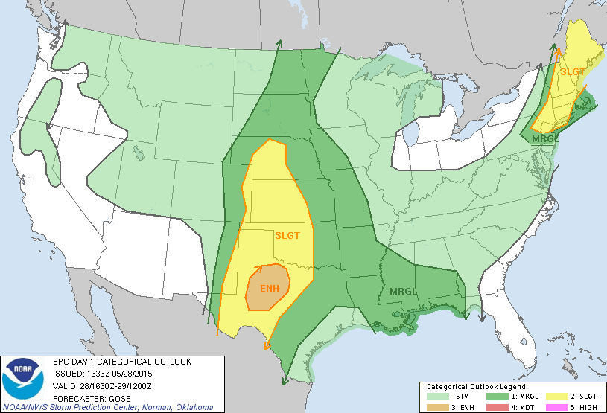
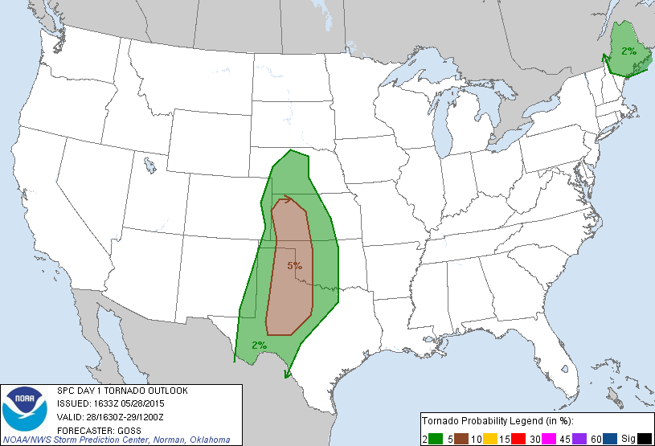

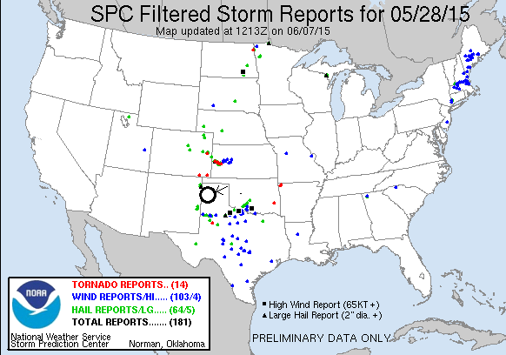
But, an excellent tour it was! 9 chase days out of 10, 7 of which were good once, and 9 tornadoes: 5 in Texas, 2 in Oklahoma, 1 in Colorado, and 1 in Kansas. Pretty good considering only one day had a moderate threat of severe weather, and that turned out to be the somewhat busted Bowie squall line day!
The 9 tornadoes on this tour give me a total of 81. Only 19 more until I reach the century mark! The most I’ve seen in one year is 17 so it’s not totally out of the realm of possibility that 2016 could be the year I hit 100!

