Day 1: May 20th, 2014
An awesome chase day to start the tour! We left OKC early with the expectation of heading all the way up to Scott's Bluff, NE to play the frontal boundary on the Nebraska Panhandle. We stopped for lunch in Hays, KS and decided to continue to head west before deciding on our target as the HRRR model was now showing two distinct target areas: Nebraska as advertised, but now it also developed storms near Denver riding right along I-70 all the way into Kansas. We decided to continue to Burlington, CO before deciding, and once there chose the southern target as the models were now killing the activity up in Nebraska by 02-03Z but kept the Denver storms going all night. That, along with the fact that a Denver intercept was far easier, made the choice simple.
By the time we reached Limon for a quick pit stop, there was already a severe warned storm over Denver heading east-southeast right towards us. We set up in Byers as the storm approached from Bennett. As it got closer, it organized a broad, blocky wall cloud for a few moments, but it soon dissipated. Cold inflow was the rule of the day as it seemed to be streaming in from where we were at every stop, yet somehow it never appeared to choke off the storm. After the first wall cloud dissipated a second briefly formed, but as the storm neared our position and had large hail in it, we repositioned to Deer Trail for the second stop. Once there, we saw that the storm had become a huge HP hailer with a very broad base and a “nose down” wall cloud / tail cloud look. Soon the hail core encroached on us again and we drifted down to Agate. With the storm moving southeast now, we then had to bolt all the way to Limon to try and get north towards Last Chance and beat it to an east road.
As we headed north out of Limon and into the huge wind farm in that area we just had to stop and take some shots of the huge beast with the wind farm in the foreground. We stayed there for about 10 minutes, at which point our north road was cut off by a hail core sporting baseball sized stones, so we headed towards the interstate, but then decided to head east on County Road 3. We stayed just out ahead of the storm until finding great spot for a photo opportunity and stopped and observed again. With the storm to our northwest, there were definite signs of rotation developing and, then behind us to the southeast there was rapid motion and a “cinnamon swirl” vortex above us, spinning hard enough that we thought we might get a landspout. That eventually dissipated and we had to quickly run east and south as rain and hail began to fall in our location and we were worried about getting swamped on the dirt roads. We made one more stop north of Arriba to shoot the fantastically structured liberty bell updraft, then stopped at a rest area along the highway for a break, but you could see the “stack of plates” look just above us and the clouds curving into the storm above us, so we headed east again to stay in front of the storm.
We continued east to Vona and as the sun set were treated to the spectacular structure of the storm backlit by the orange sunset! The storm also had a nice array of mammatus clouds hanging off the front part of the anvil.
At that point it seemed like the storm was finally dying, but as the sun set, perhaps the low level jet kicked in because the storm re-intensified yet again into a tall soda can look. We made another stop in Bethune, then another in Burlington, and the structure at dusk just kept getting more and more amazing! By now the storm was highly electrified, but interestingly it was almost all cloud to cloud, with very few ground strokes. It was sort of eerie as the spinning updraft came almost right over us, then off to our southeast a huge bob of dirt flew up from the rear-flank downdraft, right around the time that they tornado warned the storm! It was obvious that the storm was way too high based to tornado though and we waited south of Burlington for the storm to zoom by, and then got back on the highway, retracing our steps 150 miles back to the hotel in Denver.
A day that greatly exceeded expectations! The HRRR model was dead on, as the Nebraska storms blew up, one went tornado warned, and then in about 2 hours they were gone, while the Denver storm raged right down I-70 into Kansas well into the evening as advertised.
962.6 miles for Day 1!
Day 1 1630Z Convective Outlook, Tornado Probability, and Storm Report:
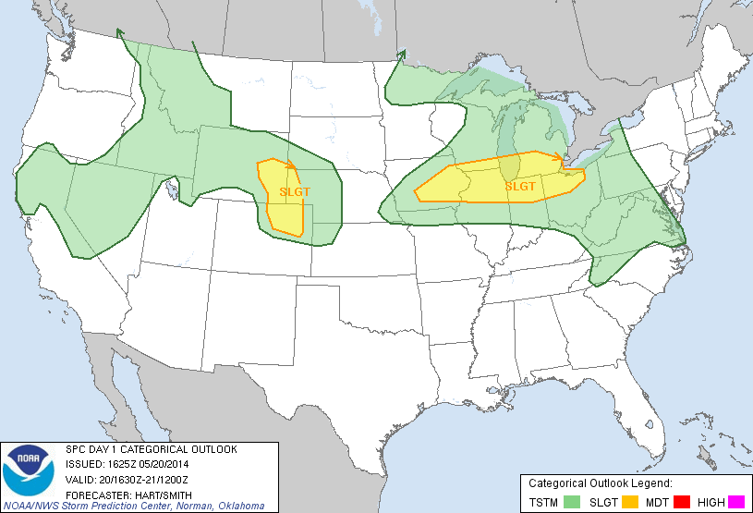
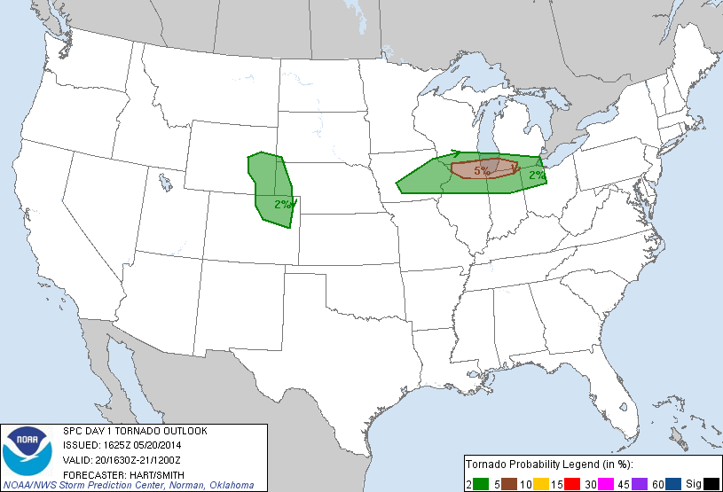
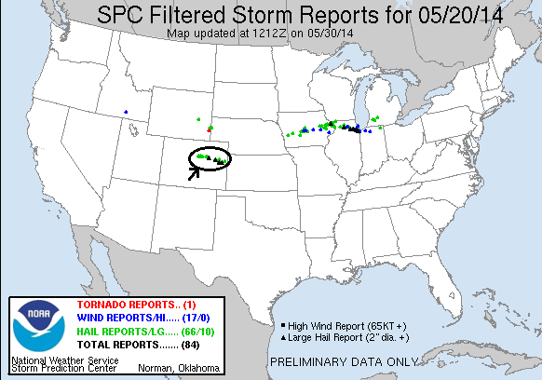

Day 2: May 21th, 2014
Another great chase day, and for the most part we were within 40 miles of our hotel the whole time. After sleeping in at our hotel near Denver airport, we met late and headed out for lunch as storms were already bubbling up in the foothills of the Rockies. By the time we got the group back together, one of those storms was already severe just south of Denver, so we headed towards Bennett to get set up, initially targeting a cell off to the south. We quickly elected to change targets to the storm near Denver, hopping back on I-70 towards Denver. We soon were driving directly towards a big, low hanging wall cloud and the chase was on by 2 PM local time, only a few miles from our hotel! We got off the highway just south southeast of Denver International Airport and made our first stop as the storm was already showing significant rotation and had that greenish glow of a storm with large hail. We began stair stepping on the roads to the east of the airport and soon the storm was tornado warned and had now developed a long tail cloud out of the wall cloud area.
We repositioned one more time and when we stopped and set up the storm was now showing violent rotation and quickly produced a brief elephant trunk tornado! The tornado quickly changed to a multi-vortex tornado then got swallowed by the massive precipitation core. From that point we were never able to clearly see it again, but now there were several reports of a tornado along Tower Road (where our hotel was!) so we knew it was in there.
The precipitation core kept getting larger and larger as we continued stair stepping northeast in front of the big high-precipitation storm. We let the core get right up to us a couple of times then pulled away to get a better view of the structure, all the while weaving in and out of the hundreds of storm chasers who were on the storm. When we got to Rt. 36 east of Byers, we were in a full blown traffic jam, mostly precipitated by the Doppler on Wheels crews crawling along the road. At this point the storm had cycled down, but by about 5 PM it was cycling back up and was again tornado warned so we headed north on county roads northwest of Last Chance to get in front of the updraft again. This unfortunately proved impossible as multiple cells were opening up all around us, turning the roads to mud and making any chance of seeing anything impossible. We aborted our chase and had a wild, muddy ride east trying to get back to the pavement, finally succeeding north of Last Chance.
As we got back on Rt. 36 heading back to Byers, the fields off to our north were covered with hail. After stopping at a restaurant for dinner we returned to the hotel, curious to see if there was any damage. It turns out they had gotten EIGHT INCHES of hail! It was 6 hours after the storm, and hail was still piled everywhere. The trees were absolutely shredded and there were numerous cars pock-marked by the dime and quarter sized hail. There were rabbits everywhere loving the “instant salad” created by the hail shredding the trees, and the neon sign at the diner we stopped at for breakfast was shattered.
All in all, another fun chase day, and we didn’t have to drive 962 miles to do it! The miles do rack up though, and by the time we’d finished we’d done another 213 miles, for a total of 1175 for the first two days of the trip.

Day 2 1630Z Convective Outlook, Tornado Probability, and Storm Report:
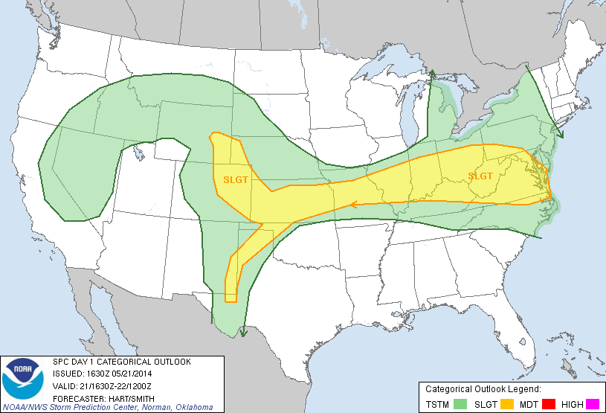
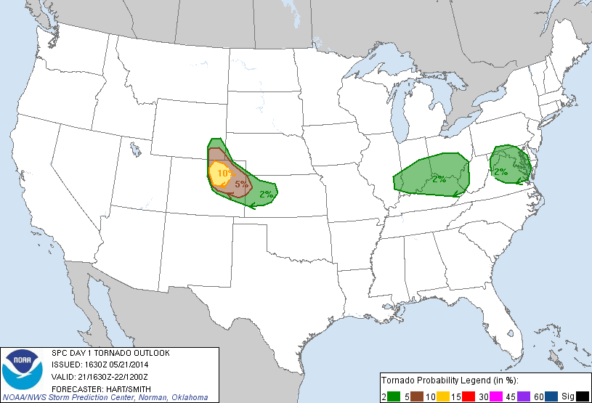
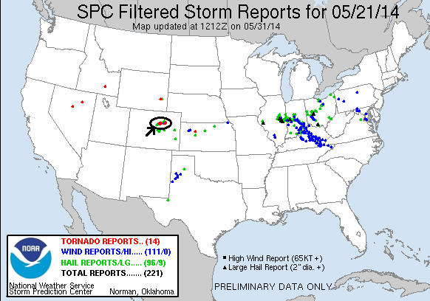
Day 3: May 22th, 2014
Mostly a repositioning day with a little chasing mixed in, and maybe even a nice surprise at the end. We left Denver with the idea of chasing the north side of the Raton Mesa, but by the time we were down there the small mountain storms to the west had already messed up the atmosphere, so we continued south towards our stop for the night in Amarillo, TX. We stopped in Dalhart, TX briefly to assess the line of storms to our west, but they all looked like junk, so we continued south. As we got into Hartley and approached the line of storms, we diverted east on Rt. 87 towards Dumas to take a look at the flying dirt kicked up by the gust front ahead of the line. After a few minutes, the line caught us and produced a large, persistent gustnado off to our west. Taking a look later at contrast enhanced pictures, I think this may have actually been a landspout tornado. It was under an area marked as rotating (and with a TVS) on radar, has a tall columnar look at least half way to cloud base, was long lasting and did not get shoved out by the front flank downdraft like a gustnado would have been, and occurred right at the point of a cell merger in progress. The only thing missing was a definitive funnel at cloud base. Hmmmm….
After that we headed back to Hartley and south to check out a new cell coming north, but it was nothing more than a rainmaker and we continued on, going through cell after cell as we got into Amarillo, where there was significant flash flooding.
All in all, not a successful chase day… or was it?? Either way, it was 444 miles for the day, putting us at 1619 for the tour.

Day 3 1630Z Convective Outlook, Tornado Probability, and Storm Report:
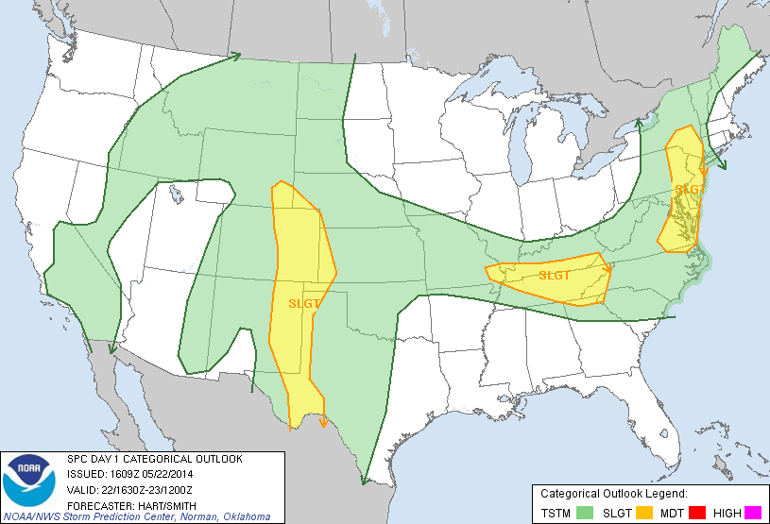
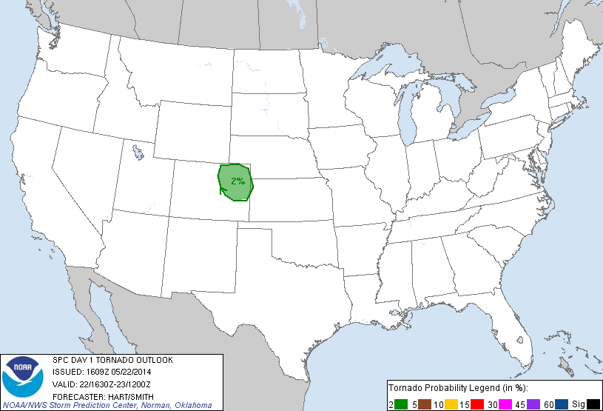
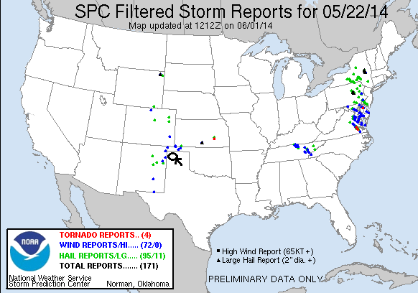
Day 4: May 23th, 2014
My first good day of chasing in New Mexico in 14 years of storm chasing, and the first time I’ve been in southeastern New Mexico. We started the morning in Amarillo under torrential rain from the storms that had been continuing overnight. The flash flooding on the frontage roads of I-40 was amazing! Once we navigated our way through that, we headed southwest through Clovis, NM to Roswell, where we stopped for lunch and shopping at the tacky UFO shops. Our target was the area east of the Capitan Mountains where an outflow boundary from the previous day’s storms intersected the oncoming warm front. There were already storms forming in the mountains, but we had to wait for them to develop and come off the hills.
After lunch, we decided to reposition to Artesia to the south. Things were still progressing slowly, but we had our eyes on two cells well off to the southwest over the Guadalupe Mountains. With plenty of time to kill, we headed west towards Hope, NM and stopped at a rest area as the storms pulsed up and down. After about 45 minutes, the cells we were observing, which had looked like they were dying about 30 minutes earlier, suddenly took off and the chase was on! We headed south on County Road 12 and soon were in the middle of nowhere on the New Mexican plains northwest of Carlsbad. We found a good vantage and watched the development of the supercell to our west for a good 45 minutes.
By this time there were additional cells blowing up around us, including a left moving supercell to the south across the Texas border that was tornado warned and heading towards us. While it looked like that cell was being interfered with by other cells, we wanted to get into a position to intercept it if we chose, and to do that we had to get south and east quickly in order to avoid the core of the storm we’d been watching as it was just about to cross the road. Unfortunately, it turned out our road option quickly became unpaved! It was called Rock Daisy Road, and while I didn’t see any daisies, it was basically made of rocks, and we were now 18 miles from pavement with big hail following right behind us! We were mostly able to stay out of the hail, but the road was horrible and I was worried about blowing a tire, not to mention that the dirt being kicked up by the other vehicles reduced visibility to near zero!
We eventually got well clear of the storm and parked the vans at an oil collection tank (this is really oil and gas country, with wells everywhere and the whole area for miles reeks of oil and signs that say “If you smell H₂S, leave the area immediately!”, as if I knew what H₂S smells like! We watched the storms from this vantage for a while but soon we had quarter sized hail dropping around us and it was time to get back in the vans and out to the pavement. We headed south on 285 towards Carlsbad then southwest on Rt. 137, stopping to watch the second storm behind the one we originally chased as it came towards us and intensified. Meanwhile, the tornado warned storm from the south was also clearly visible, having plowed through a bunch of smaller cells and survived. The structure of the storm to our west was fantastic! It had that spinning soda can look, and as the Sun set, was backlit nicely.
We watched that storm for another 30 minutes before the storms to the south began to interfere with it and it started to deteriorate, and with 3 hours to the hotel in Lubbock, it was time to go. As we stopped in Artesia to grab dinner before the long ride, we did get a nice mammatus display from the cluster of cells that the formerly tornado warned cells had become. We then drove to Lubbock with a nice lightning show going on around us, finally getting to the hotel around midnight.
Another good chase day! 518 miles for a tour total of 2138.
Day 4 1630Z Convective Outlook, Tornado Probability, and Storm Report:
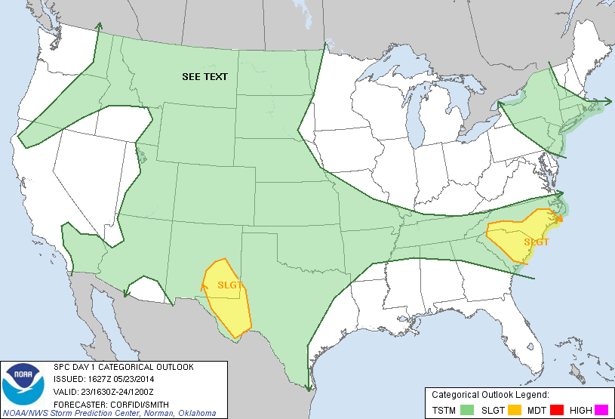
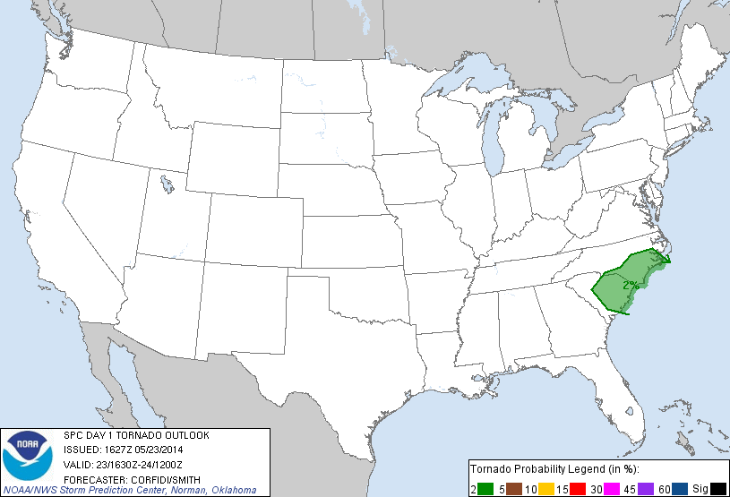
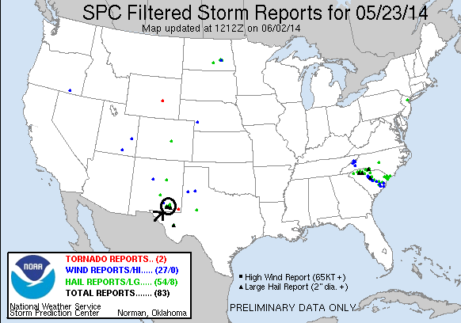

Day 5: May 24th, 2014
A long, slow motion kind of day that looked like it was going to be a bust but ended with a bang! We left Lubbock in heavy rain around noon after doing a Weather 101 class, with Ft. Stockton as our target to play storms as they came north and hit the outflow boundary that had been surging southward from the overnight convection. The first issue we could see was that the boundary had already surged past I-20, though it was forecast to retrograde as the day progressed.
Elevated storms were already underway as we got to Odessa and we passed just to the north of a big left-moving hail storm as we headed west. We were posed with a number of different options: Head northwest to Carlsbad, NM into the area with the best overall conditions and where HRRR was predicting large isolated supercells just before dusk, or head to Ft. Stockton to intercept the tail end of the elevated storms that had gone severe, or target an area more to the southwest. We deferred the decision and headed to Monahans and waited….. then we repositioned to Pecos and waited…. and watched as one of the storms to the east went tornado warned and looked nasty on radar, with a big hook echo wrapping into the outflow boundary.
So, we waited some more since we had no chance of getting to the eastern storms and nothing much was happening in the west, though HRRR still had two big tail end supercells at the end of what later was forecast as a big linear complex. With nothing doing east, we decided to head to Carlsbad, NM again so we’d be in position if the model did verify, and if not, it was progress back towards the hotel.
As we crossed into New Mexico again, things were just starting to percolate, so we stopped in Carlsbad and….. waited again. Finally KABOOM!! A whole series of storms fired along the mountains, and, just as HRRR predicted, there were two big supercells at the tail end just to our west. With darkness falling we first headed south towards the tail end storm, but once we got a glimpse of the cell just to our west we decided we had to target that one and u-turned and headed north out of Carlsbad. As we headed up Rt. 285 we could see the huge base of the storm to our west with scud rapidly rising into the base, a developing wall cloud and numerous inflow “stingers” feeding into the storm. After hundreds of miles of maneuvering through west Texas and southeast New Mexico, we ended up on the exact same road we’d watched the storm of the day on the day before! What are the odds of that? This time though, the storm was a monster classic supercell that meant business and was coming directly at us. As dusk set in, the storm developed a big low hanging wall cloud and then we observed several power flashes right in the front region of the wall cloud, though it was impossible in the failing light to see if it was a tornado that was causing the damage.
We continued to watch the storm as it closed on our location and developed a big beaver tail inflow band, took on awesome spaceship like structure, and was throwing lightning bolts everywhere, but it was now also clearly becoming a high-precipitation storm with baseball sized hail reported. As the storm was almost on top of us, it was time to move and intercept the southern storm before it crossed the road. We headed back south towards Carlsbad and then Loving, while the storm became a behemoth to our west with a perfect eagle-claw radar return, a 75 dbz core (amongst the strongest cores I’ve seen on radar, VIL’s maxed out, 3-4” diameter hail, and on radar 3 maxed out velocity markers)! Clearly not a storm we had any interest of getting run over by! We continued southeast out of Loving and stopped to get a view, but sadly it was now completely dark and we were too close to the front flank core to get a good look at the structure. We watched lightning flying around the anvil for a few minutes, and then it was time to get out ahead of the cores and start the 4 hour trip to Lubbock.
A great finale to the day! Mileage for the day was 525 for a tour total of 2663.
Day 5 1630Z Convective Outlook, Tornado Probability, and Storm Report:
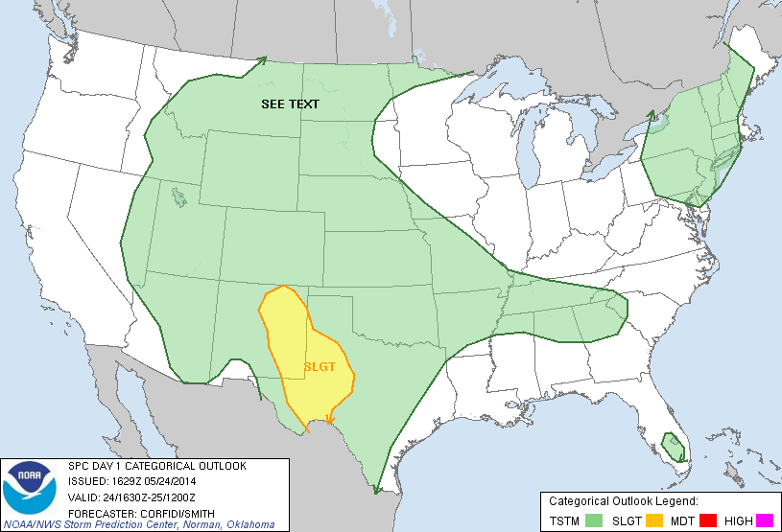
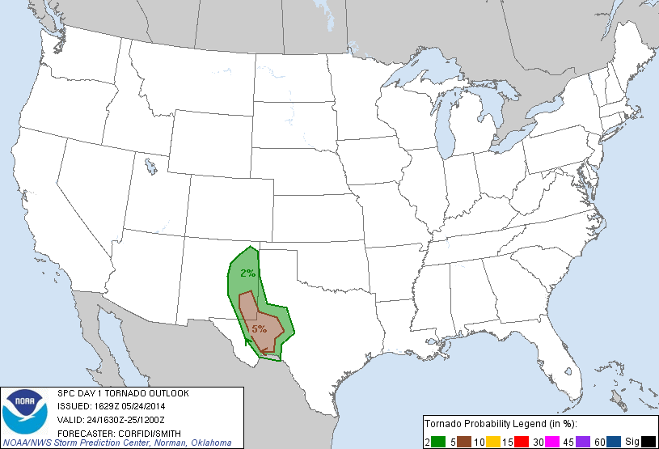
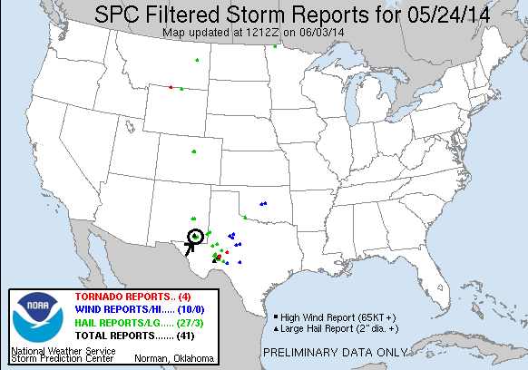
Day 6: May 25th, 2014
This has started to become the “New Mexico Tour”! We left Lubbock with two distinctly different targets for the day: South near Ft. Stockton where the outflow boundaries from the previous night’s convection intersected the dry line, or up near Roswell, NW where the models developed storms out of the mountains late in the day based on upslope flow and residual instability. With the two targets so far apart, we were going to have to commit to one or the other relatively early.
We headed south down to Midland, TX and stopped for lunch at the mall there. At the time, there was a single anchored tornado-warned supercell way down near Marathon, TX spinning away, but we decided it was too far to get to and ignored it. Still not sure if storms would fire in west Texas, we drifted west towards Monahans, by which time conditions were looking more and more favorable in the Carlsbad / Hobbs area yet again so we headed northwest through Kermit, TX and back into NM, stopping at the Allsups in Eunice to assess the situation, then heading west of town to wait for storms to develop. In the distance, we could see that the HRRR was correct about the Roswell target, with 3 cells exploding with rock-hard convection 90 miles north of us, two of which had big overshooting tops over the anvil clouds. We hung around in the gas fields (it’s amazing how much of southeastern NM and west TX are utterly dominated by the gas and oil industry, the whole region, for hundreds of square miles, smells like heavy oil from all the pumps and drilling) until a cell fired right over us. We headed north a bit to get out of the rain, and the storm seemed to be getting its act together with convection rolling over directly above us.
After a few more radar scans though, the storm was clearly not going to make it and we decided to blast north to try and get to the Roswell storms. We headed up Rt.18 through Hobbs and then up towards Lovington and watch as finally the storm that HRRR was predicting to develop over Carlsbad began to materialize, and soon the echo tops were heading for 40,000 feet. We were in easy intercept position so we aborted going after the Roswell storms and headed west out of Lovington, then south on 283 through the gas and cattle fields to get out in front of the storm, which was now right turning directly at us. As we got just east of the storm, it opened up a big hail core and split, with the left cell slowly dying off and the right mover intensifying rapidly with clear evidence of rotation on radar. After a couple of stops to observe the developing storm, we dropped south to Rt. 180 and drove right up to the base of the southernmost cell (after it had split again) between Carlsbad and Hobbs, and were treated to a beautiful structure-fest near sunset as the storm had a classic supercell look, with a corkscrew rain-free updraft, big precipitation core off the northeast, and numerous inflow bands flowing into the storm. The storm was a bit high-based, but at mid-levels it was spinning like crazy. The colors at sunset were spectacular, with the orange of the sunset behind the storm and the ice-blue base of the updraft, with white barber pole looking convection twisting up to the anvil.
After about 30 minutes of watching the beautiful storm, we headed east alongside it to try and get out in front more a more distant look of the structure, but darkness was falling and we eventually decided to go for lightning instead. This was one thing the storm lacked: it was not very electrified. We made a couple of lightning stops along Rt. 180, but the storm was weakening and we soon decided to call it a night. Luckily, our hotel for the evening was in Hobbs, so we were only about 10 minutes away!!
Another fun chase day. 399 miles for a 6 day total of 3062.
Day 6 1630Z Convective Outlook, Tornado Probability, and Storm Report:
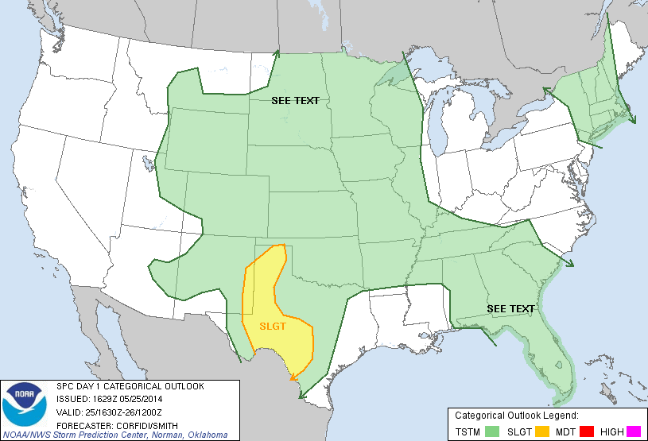
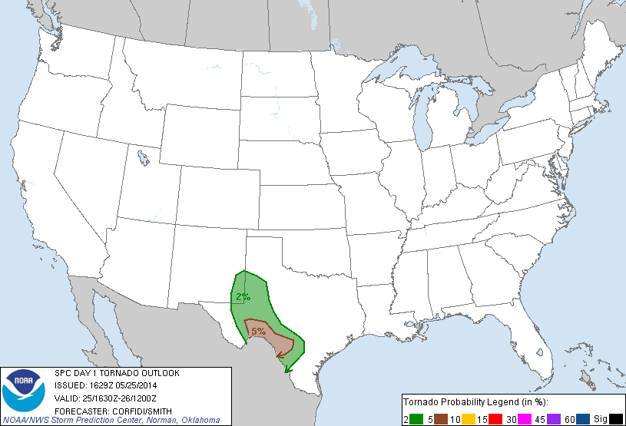
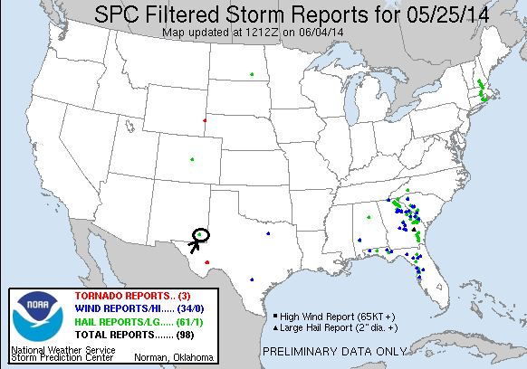

Day 7: May 26th, 2014
Finally a real adrenaline pumping chase day! The plan was to find the dryline intersection with the outflow boundary from the previous day’s storms and wait. We drove from Hobbs, NM to Big Spring, TX and had lunch, which was an adventure in and of itself: The Pizza Hut was partially close because it had been flooded out, but this biker standing nearby recommended the “Best Mexican food in Texas” at the Spanish Inn, talked it up said his brother or some other relative ran it, was going to call ahead, etc. etc. So we went over there and it was closed!... and by the look of it, we’re probably lucky it was! We went to Pizza Inn.
By the time we’d finished up lunch, a line of storms was firing to our northwest near Seminole, so we headed out of town to intercept the best looking cell with the plan being to chase that cell, then as storms fired down the line drop to the tail end storm, repeat, and repeat again. We didn’t have long before we intercepted the first storm as it went severe and was soon tornado warned near Patricia around 3 PM. We stopped and observed a big wall cloud low to the ground and within a minute or two there was a persistent dirt swirl on the ground with cascading motion above, tornado number one for the day! That tornado lasted only a minute or two, and the storm was right turning hard so we had to get ready to leave. We observed the rear flank downdraft winds plowing dirt into the sky and had to beat feet to get out of the way, running south down Rt. 137 towards Lenorah. We got plastered by flying dirt and strong cross winds as we blasted south, and a large spin up (probably a gustnado but can’t rule out a shearline tornado) formed just west of my van as we headed away.
The storm had quickly become a high-precipitation monster, making visibility into the notch area very difficult, and by now the chaser hordes had arrived, hundreds and hundreds of vehicles worth. This was by far the most difficult portion of the day, finding ways to safely navigate all of the traffic pulling in and out of every decent viewing position while trying to keep our four vehicles together.
By 4 PM, the storm was totally HP and any tornado that was in there was completely rain wrapped (in fact there were reports of a rain wrapped tornado crossing I-20 near Coahoma later), so we decided to drop to the next storm in line which was now becoming quite severe. We passed through Big Spring again and headed west on I-20 to intercept. At this point the storm had a tremendous radar return with a “scorpion tail” hook echo on radar indicating rapid rotation. As we charged towards the storm, we couldn’t see the updraft through the massive precipitation core that was racing towards the highway with baseball sized hail, so we got off the highway and headed south on Rt. 33 to get around the core and beat the storm to Garden City. We stopped for a minute to view the storm and had a neat vantage with our new storm our west, and our old storm chugging away to the northeast. We immediately saw another big dirt bob in the distance to our west but concluded that this was again RFD winds plowing around the south side of the storm. We continued south, now once again swamped in the convoy of chasers that had finally abandoned the northern storm.
We leapfrogged through the chaser-gaggle, heading east on rt. 158 at Garden City as the storm grew to peak intensity, with 3-4” hail and a massive hook echo still on radar. It was also getting HP quickly and ingesting an incredible amount of dirt from the dry fields in the area so it was getting difficult to see into the inflow notch. We finally got ourselves way out ahead of the storm and found a south pull off to set up and watch as the storm came right down the highway after us. The storm now had a big wall cloud and was rotating like crazy.
We stayed at that location for about 15 minutes as the storm closed in quickly, with RFD dirt plumes, gustnadoes, and all kinds of flying dirt in the air. Soon it was time to get out of the way, so we headed back to the end of the road when Roger started yelling to stop and sure enough, to our west there was a weak tornado occurring, wrapped up in rain. We waited very briefly as it closed on us and seemed to dissipate, then everyone in my van starting yelling and I turned to see a tornado forming less than 100 yards from the van! We hit the gas and got out of there as the tornado blasted through the field south of us then quickly dissipated.
Our next issue was that we were now getting into the Mosquite region of Texas, with lots of trees and big ridges on either side of the road so it was difficult to see. There were a variety of reports of a rain wrapped tornado, so we stayed well ahead of the storm. At one point we stopped for a few minutes and may have gotten a look at a small cone tornado off the distance but can’t confirm. After a brief stop south on 163 south of Sterling City, we headed down Rt. 87 southeast towards Water Valley. On the way we were able to see a short duration rope tornado coming from the storm, though I didn’t see it as I had to keep my eyes on the road (the downside of driving on chase days sometimes).
Northwest of Water Valley we stopped at a rest area, turned the vans around, and waited for the beast of a supercell to come right to us. The structure was incredible! The storm had little tornado potential by now but was packing huge hail. We watched for about 30 minutes as the storm came to us and passed just to the north. Meanwhile, right behind that storm was another tornado warned storm, so once our previous storm moved out of the way we headed back up Rt. 87 to take a look, but at this point it was getting dark and the storm seemed to be getting seeded by the water cooled air blowing out of our previous storm, so we decided to call it a day and head into San Angelo for dinner. We did have a little moment of excitement there as just as we finished eating dinner it became obvious that if we didn’t get clear in about 10 minutes, the storm we’d left was about to pummel the town (and us) with tennis ball hail! We scrambled to get in the vans and blasted northeast of town, just getting clipped by the edge of the core as we got away. The rest of the right up to Abilene was uneventful.
Fantastic chase day with 2 great storms, 3 brief tornadoes (and maybe glimpses of 2 more) and not that much driving: only 460 miles for a 7 day total of 3523 miles.

Day 7 1630Z Convective Outlook, Tornado Probability, and Storm Report:
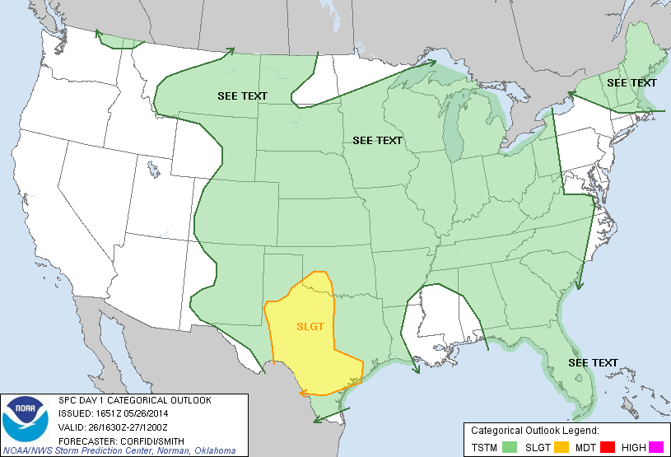
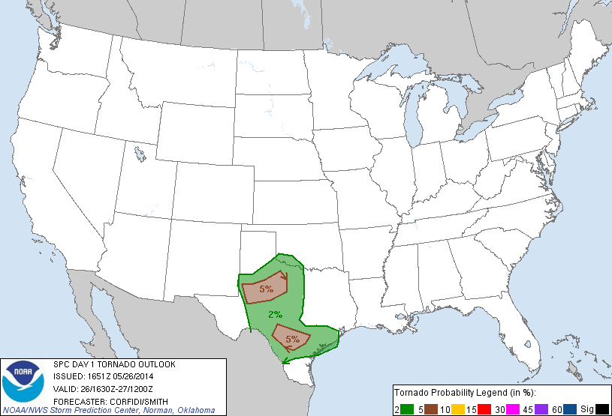
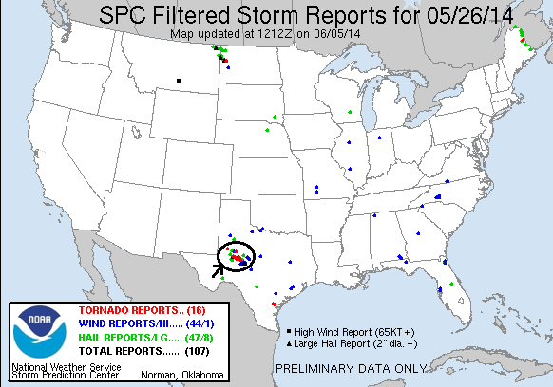
Day 8: May 27th, 2014
Not much of a chase day. We drove from Abilene to Weatherford where we stopped for lunch and to assess the situation. While SPC had at one point a 5% tornado probability, we did not see how that was going to come together given the model parameters, as HRRR was showing nothing more than borderline severe storms scattered south of Dallas-Ft. Worth. Eventually storms broke out and we took a look at a little low-top storm over Weatherford, and then pressed south and followed another storm down near Walnut Springs, but quickly gave up for the day and headed for the hotel. The main experience of the chase was trying to deal with Metroplex commute traffic during rush hour!
We drove 360 miles for the day, for a tour total of 3864.

Day 8 1630Z Convective Outlook, Tornado Probability, and Storm Report:
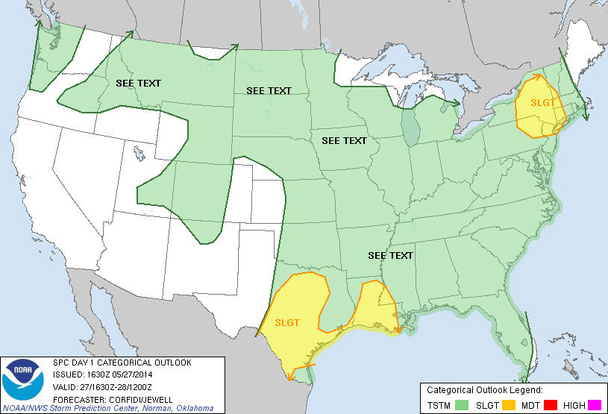
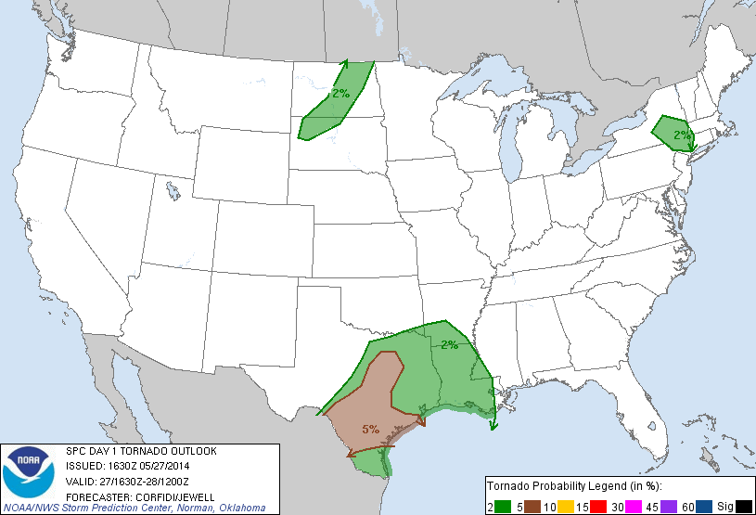
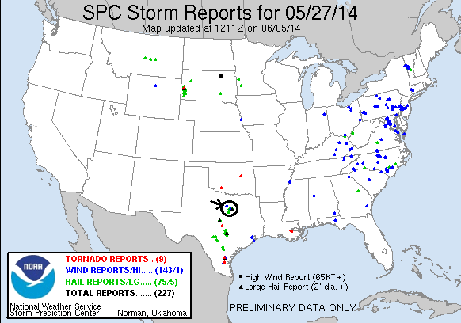

Day 9: May 28th, 2014
With the weather pattern dried up, days 9 and 10 were down days. Day 9 was spent driving from Gainesville, TX to Oklahoma City, an easy two hour drive of 138 miles for a final total of 4002 miles.
All and all considering the pattern a pretty successful tour! We chased for 8 days straight, witnesses 4 confirmed tornadoes (albeit very brief) and perhaps 2 or 3 more unconfirmed, and had supercells on 6 of those days. Perhaps an all-time low, we only chased in 3 states during the tour, Colorado, Texas, and New Mexico.

