Silver Lining Tours Prime Time Tour, 2012, Tour Log
Prime Time Tour, Pre-Arrival Day, May 20th 2012
Pre-arrival Day chase! A marginal day, granted, but better than hanging out at the hotel. About 10 minutes after I arrived at the hotel in OKC, Boris Konon picked me up and I grabbed my chase stuff and we were off heading towards Lawton, OK where the outflow boundary from storms that had occurred overnight in OKC was rushing southwest towards an obvious "hot spot" where storms were already firing. Our intention was to head for Frederick and go after any storm that took off after interacting with the boundary.
Approaching Lawton, the storm we were targeting was south of Frederick and heading generally towards us and was clearly visible in the distance, as was the boundary that was surging towards it. We decided that to get to the southeast of the storm we'd need to keep going south so we ended up heading down to Grandview. Good thing too as the target storm, when it hit the boundary, ended up doing an almost 90 degree right turn and instead of heading northeast was now moving south-southeast! In fact, we were going to end up on the north side of the storm and be blocked from getting to it by the Red River, so we headed into Burkburnett, TX, stopping to observe the storm for a few minutes and deciding our next move. Since the storm was still angling south, we went a little west then south on farm roads, emerging in Iowa Park, then Holliday, TX. Finally we were on the storm! We headed north out of Mankins and plowed right into the now linear core near Kadane Corner. The core was so thin at this point that when we were getting hailed on we could see blue skies just up the road! We went back out on farm to market roads as the first storm collapsed and then got behind a newer, better looking cell, following as it crossed Lake Diversion. Since all the storms were moving very slowly, we were able to get out in front, turn around, and run through the length of the core along Route 277 between Dundee and Mabelle, getting nickel and maybe a couple of quarter sized hail stones. The core was pretty cool looking in the sunlight as we passed through from west to east. Once that storm had gone south of the road and was dying, we decided to call it a chase since the only other option was a storm further southwest near Guthrie and that looked just like the two storms we'd already gone though. On the way back up north, we got a glimpse of the solar eclipse as the sun set, in which the bottom right third of the Sun was obscured.
So, not a bad pre-tour practice chase, and then to boot there was a nice line of storms that passed through OKC the next morning, with numerous nearby cloud to ground bolts hitting right near the hotel for a pretty cool show.

Pre-Arrival Day 1630Z Convective Outlook and Storm Report:
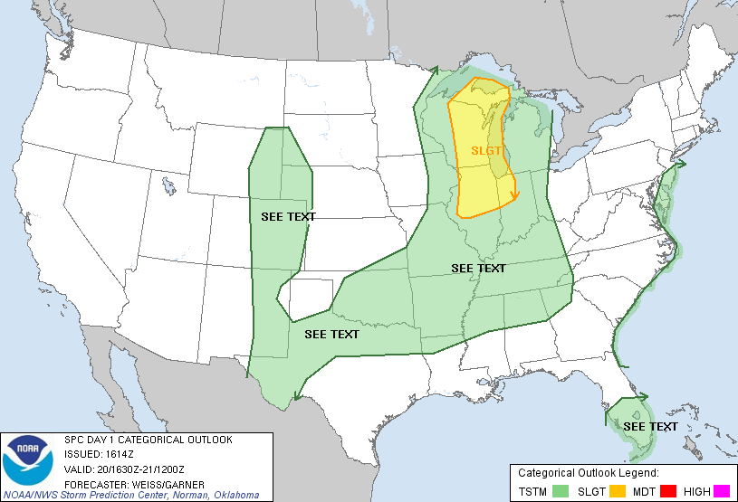
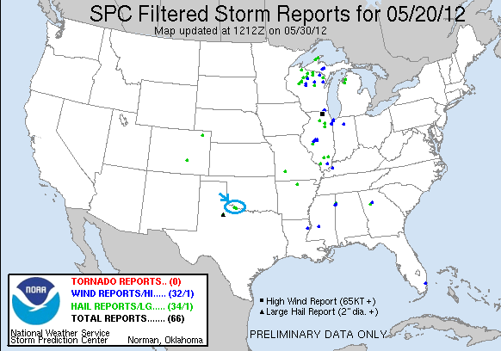

Prime Time Tour, Day 1, May 22th 2012
We left OKC at the crack of dawn (well, even before) with the goal of reaching Murdo, SD by 5 PM. We blasted north to Salina,KS then over to Hays and north to North Platte, NE where we stopped for lunch. Eventually, we made it to Murdo... at about 5 past 5 PM, then over to Vivian where we finally stopped and assessed the situation. To our north, the first towers were firing but struggling to break the cap. We watched as one updraft after another would hit the cap, shear over, and die. Finally, a storm seemed to be getting its act together, so we went after it, passing through Pierre and then heading northeast. By this time though, the storm looked choked, and with other cells north looking better, we dropped that storm and head north again towards Selby, then east on Rt. 12 towards, yes, Bowdle! An odd coincidence since it was the two year anniversary of the Bowdle wedge tornado we'd seen on the very same roads (not to mention the 1 year anniversary of Joplin and 4 year anniversary of the Wakeeney, KS tornado. May 22nd has been a prolific tornado day).
We headed east through Bowdle and Roscoe trying to catch up to two cells in front of us, but like all the cells in South Dakota that day, the moisture was just too shallow for the storms to really take off. We ultimately chased them all the way through Aberdeen, getting at least a decent lightning show before returning there for the night.
1004.3 miles is a LONG way to go for a car wash! This was a longest I've ever traveled on a storm chase day. Still, we picked the right target area and got there on time, but the storms just never really got going past severe parameters
Day 1 1630Z Convective Outlook and Storm Report:

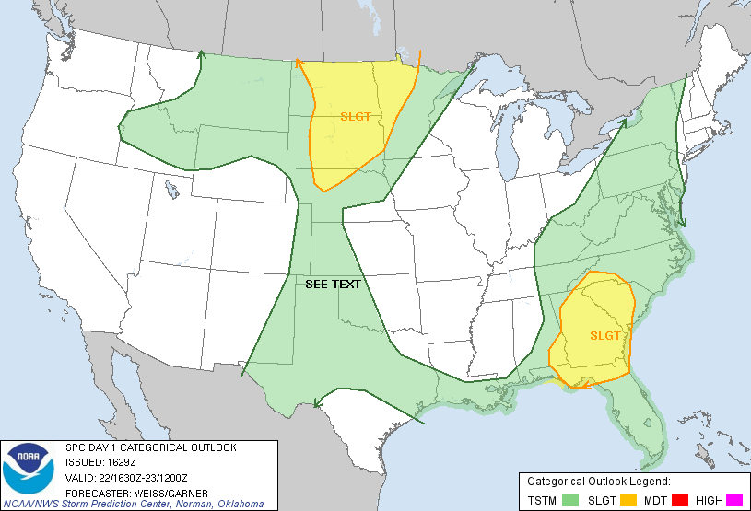

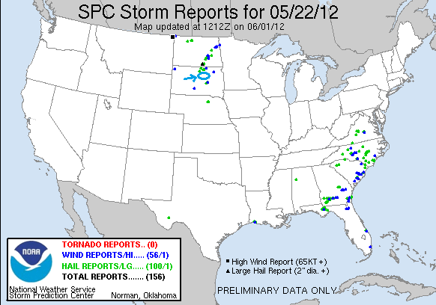
Prime Time Tour, Day 2, May 23th 2012
We started the day in Aberdeen, SD with the idea of playing the front somewhere from northwest Iowa to eastern Nebraska. Initially we targeted the Grand Island, NE area, but as we got down to O'Neill, it was looking as through the Iowa play might be the better of the two. After some debate, we decided to split the difference and head for Norfolk and defer the decision a little longer. By the time we neared the town, the new RAP model run had come back around and we headed south towards Columbus, NE. By the time we got there, the front was lighting up and we were off into chase mode, heading towards Fremont. As we plowed through the line to get out in front, we missed the hail core of our target storm by a minute or two as it crossed the road in front of us, but it produced an amazingly brilliant double rainbow with the lower arc virtually at ground level. It was stunning! The storms were moving very quickly to the northeast and the line was quickly becoming a gustnado-fest, and we drove through a big one as it crossed the road in front of us at one point. Our storm was showing some signs of rotation as we closed on it and stopped to take a look near Uehling, NE. At this point the Missouri River became a problem and we had to decide how we were going to get across while keeping up with the storm. Unfortunately, our only option was to go south to Blair and across. We went to Blair and crossed into Iowa, but the trip took us way out of pocket, and long delays in Missouri Valley, IA convinced us that the storm was uncatchable.
We crossed back into Nebraska and targeted another severe storm, briefly (and unnecessarily) tornado warned coming up from the Lincoln, NE area. As we headed for the storm, we passed through another cell with numerous close cloud-to-ground lightning strikes. We met the next storm near Waterloo, NE and let it roll right over us. As it got to us it had produced an impressive tail cloud with great horizontal rolling motion as it went right overhead. We hopped back into the vans to try and get into the hail, but the storm trucked off to the northeast before we could get into the core. We did however stop and find numerous quarter to half-dollar sized stones lying on the ground. By this point we decided to head for the hotel but as it turned out this allowed us to play with another storm as we headed that way near Wahoo, NE, then as it turned dark and as we got to the interstate a nice storm was coming towards us near Lincoln so we hit the highway east to stay out front, then stopped to watch an impressive display of CG bolts striking all around us north of Alvo. After that we decided to call it a night and headed into Lincoln.
Mileage total 623.5 for the day, for a total of 1627.8 for the tour already!
Day 2 1630Z Convective Outlook and Storm Report:
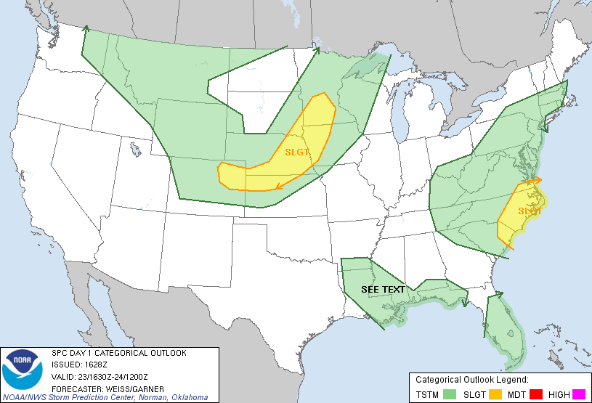

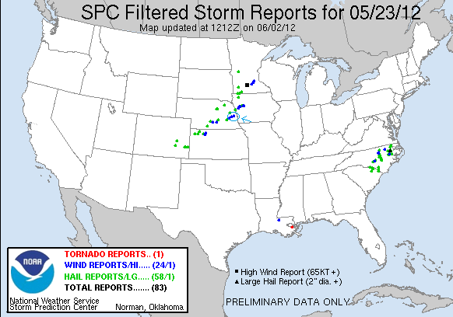
Prime Time Tour, Day 3, May 24th 2012
This day was sort of a pseudo down day that turned out to be a semi-chase day instead. We started in Lincoln, NE with the idea that we'd head east into Iowa and try to catch the tail end of what was sure to be a very fast moving linear system in a Moderate SPC threat area in eastern Iowa and Wisconsin. This was purely a speed-shear driven event with limited instability, and we knew that our only chance was to be on the line right as it started to form if there was to be any chance to see a discrete storm before everything became a messy line. Our hopes were not high to begin with, and as we proceeded towards Des Moines they got less and less with each new hourly RAP model data run. By the time we got to Adair, IA we decided it was a waste of time and gave up, heading towards are hotel in Kearney, NE to set up for the next day.
After stopping for lunch in Omaha, we noted that there was a small group of post-frontal thunderstorms roughly in our path to the hotel and decided that we'd check them out for small hail. We targeted the southernmost of the two more dominant cells and intercepted it near Stromsberg, NE (I believe the tagline on the welcome sign for the town was “the most Swedish town in Nebraska”. I’m not sure there is much competition!). The storm wasn't terribly exciting looking but did seem to be getting its act together to a degree and was soon sparking pretty well. Then suddenly, and for no apparent reason the storm 40+ miles to our north was tornado warned with a spotter sighted tornado near Leigh,NE! Sadly, it was too far away for us to get to, and the storm looked not even remotely tornadic on radar, so we figured well, if it could happen up north, why not on the tail end storm? We stayed with our storm east and it looked better and better, but sort of as a mini-version of a storm: mini-updraft, mini-rear flank downdraft surge, mini-anvil, and only 25,000 feet tall. As we got in front of it we were treated to a dust devil barrage as three of them went skitting by in the fields next to us. We chased the storm as far as Surprise, NE but it quickly pulsed down and died, and we called it a day and headed into Kearney. Later video of the tornado on the northern storm was posted to Facebook and it looked like a pretty nice elephant trunk tornado that lasted for a few minutes. Who would have guessed!?
496.2 miles for the day for a tour total of 2124 through 3 days.
Day 3 1630Z Convective Outlook and Storm Reports:
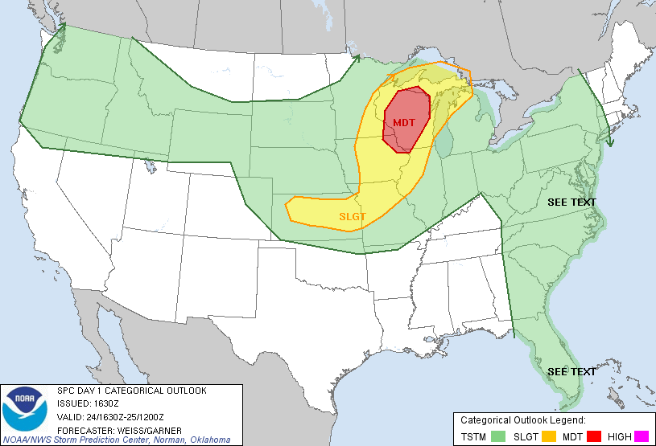

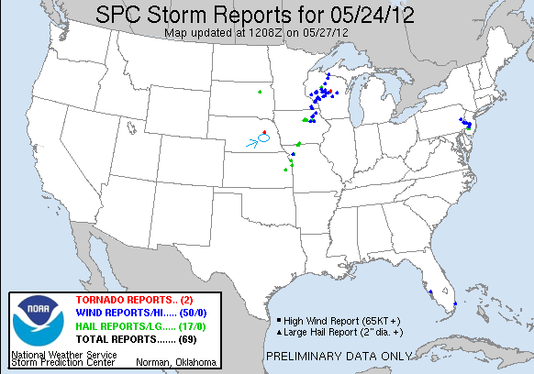
Prime Time Tour, Day 4, May 25th 2012
What a day!! The mood went from optimistic, to excited, to frustrated, to really frustrated, and then to maximum adrenaline! There were two plays for the day, the warm front around the northeast Kansas / northwest Missouri border, and the dry line in west central Kansas. The dry line play was the riskier because of the strong cap, but had the better ingredients for isolated, rotating supercells if the cap did indeed break. We started the day in Kearney, NE and headed down to Hays, KS where we stopped for lunch. We then drifted down to La Crosse and parked for about 2 hours at the Barbed Wire Museum / Park and waited, with the triple point just to our west. After relaxing for a couple of hours, we began to see agitated cumulus clouds to our west, and headed about a mile west out of town on a county road for a better view. We watched as several towers tried to go up on the triple point, hit the cap, sheared over and died, then kaboom! one of them finally broke through and the chase was on. We blasted towards Liebenthal,KS and in just minutes the storm had developed a fantastic base with an inflow band flowing into the storm from both the front and rear flanks of the storm. We ended up just on the north side of the base with the precipitation core to our northeast and the base, which was already developing a lowering, just to our south. The storm quickly developed into one of the dirtiest I've chased, blowing out an enormous RFD plume which got entrained in the updraft, resulting in flying dirt everywhere. It was around this time that a tornado was reported right on the front edge of the storm, with a big dust-bob and perhaps a nub funnel coming in from the base. This was recorded officially by NWS as a tornado, and some of my stills have me mostly convinced, so this was tornado #1 for the tour. The area of rotation rushed toward us, and we ended up driving right through it as it crossed the Munjor road as we paralleled I-70 West-East. I think I still had grit in my teeth that evening from all the dirt that was flying around!! Along with a boatload of other chasers we chased the storm as far as Russell, watching it struggle to stay organized.
Finally, as the storm looked progressively worse, our attention was drawn to the tail end of the 3 storm grouping that had developed along the front from the triple point, and we calculated that we could get there before dark so we blasted south on Rt. 281 to Rt. 4, then west back towards La Crosse. As we passed the middle storm, it developed a nice looking wall cloud and we became really torn about sticking with the middle storm or continuing to our target tail-end storm. But we grudgingly continued towards the tail-end storm, which was just coming into view and was still tornado warned, though we could not see the base through the front flank core. Here was a case where the fact that we blew off the northern storm earlier than most, which would normally be a good thing, actually ended up as a point of frustration: As we finally got to the tail end storm, the base looked horrible, and then the middle storm started dropping tornadoes!! Everyone who'd left the lead storm late was conveniently right in the slot of that storm and got to see the tornadoes from that storm (though in hindsight, aside from a neat looking ropeout from one of them, the tornadoes were nothing exciting, and certainly nothing compared to what we were about to see).

Meanwhile, we were in La Crosse completely flummoxed about what to do! Do we head back to the middle storm that we knew was tornadic, hoping to catch a glimpse just before dark, or stay with the tail end storm, which was the true triple point storm and on radar had clearly wrapped the boundary into it and thus should have the best conditions for tornadoes? It looked horrible visually though, so we decided to charge right back to Rt. 281 and try to get to the middle storm that we'd just driven by! As it happened before we got back into La Crosse, someone looked out the back window and alerted me that the lowering on the tail end storm was looking better and we stopped again, conferred for a minute and decided that we needed to stay with our tail end storm. We drove back west of town and found a place to stop, ironically only about a mile north of where we watched the first storm forming on the triple point several hours earlier.
Soon we were rewarded with a spectacular structure show, as the updraft became incredibly striated with inflow stingers entering the storm from 3-4 different locations and a beefy block-wall cloud spinning like crazy heading directly at us. The storm was highly electrified and we had CG's hitting all around us, so we kept the guests in the van for the most part until the front flank core got a little farther away. The bolts were of the positive variety, meaning that there were no branches in the bolts and the thunder was not the cracking variety you usually here but instead there was just the single BOOM as each bolt hit.

The storm looked like it would tornado any second as it got darker and darker and we waited.....and waited.....and waited.... 15-20 minutes as we got more and more frustrated until finally, at about 9:20 PM a big cone tornado developed and quickly had a large debris fan around it as it closed in and crossed Rt. 4 to our west only about a mile away! We were in great position to watch for about 10-15 minutes as the tornado approached our location but eventually we started getting hailed on and retreated towards the town. We stopped again and continued to watch as the tornado morphed into a tall stovepipe, again with a big debris fan. The town sheriff came over and made us move (no question emergency officials were more sensitive this year) so we quickly complied and got right to the edge of town and stopped, then decided to move to the north side of town and watch the tornado pass to the north of town. It didn't take long before the tornado was right back into view, a tall, almost Campo looking tornado, still with a large debris fan, continuously illuminated by the copious amount of lightning that was banging away. The tornado sirens were screaming as the long stovepipe passed just north of town and we got run over by the rear flank downdraft of the storm as the tornado got just to our north. Then the rain cleared out and we were able to leisurely watch the awesome tornado to the north, then northeast before it finally roped out. A check of the time between my first Facebook post and my last when it roped out: The tornado was on the ground for 54 minutes! Easily the longest I've seen. A nice reward for the 60th tornado I've observed overall!
The fun was not entirely over for us though; as we found out that the road north out of town was blocked by downed power lines, so we had to find another way out to get north to our hotel way up in North Platte, NE. We found that the road south into town was also closed (we found out later that the south side of town was hit by a second tornado), so we headed east out of town towards Bison. Only a mile out of La Crosse we caught back up to the storm and another big stovepipe had formed, looking much like the last! We watched that one for few moments as it drifted off slowly northeast peaking in and out of the rain before we headed west through town, past the point where we originally saw the tornado touch down and then north to Wakeeney and through to I-80 in Nebraska.
A great chase day! When we stopped at the tail end storm and saw how bad it looked and how the middle storm was now producing, it was the height of frustration, only to end up seeing the best night time tornado I've seen, along with two others. Although it seemed like we drove forever, the mileage total for the day was only 553.8 miles, the second shortest day we've had thus far, putting us at a tour total of 2677.8 miles.

The NWS office in Dodge City, KS has a full report on the tornado:

http://www.crh.noaa.gov/news/display_cmsstory.php?wfo=ddc&storyid=83548&source=0

Day 4 Tornado Damage Path, 1630Z Convective Outlook, and Storm Report:

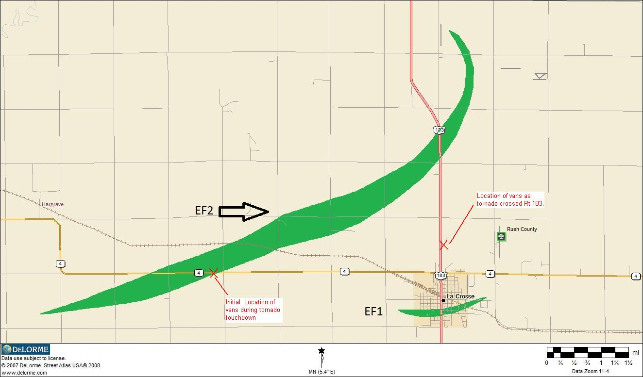

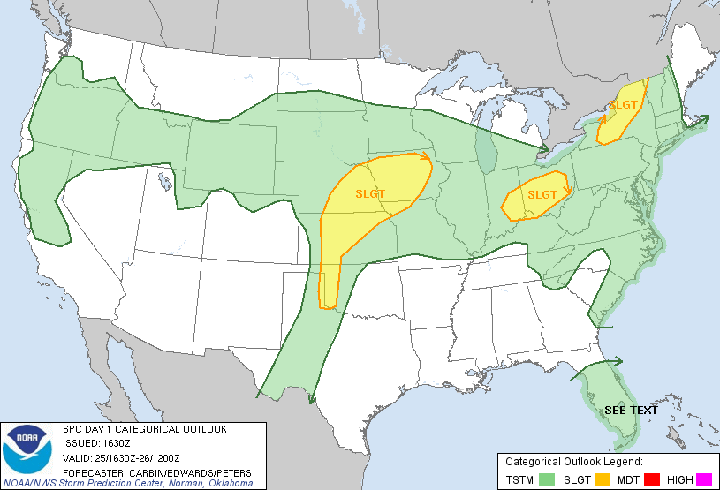
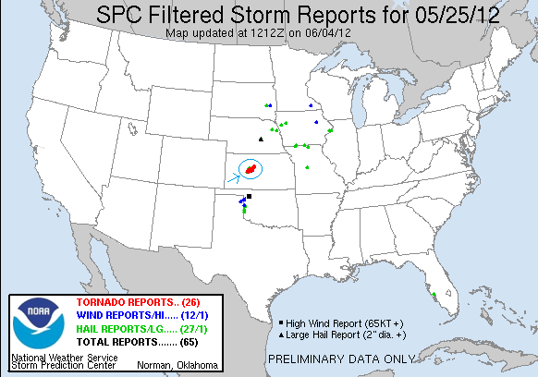
Prime Time Tour, Day 5, May 26th 2012
Bustola! At least it ALL was a bust on this day. We decided to blow off a potential Wyoming play, fearing that the 50 mph northerly storm motion would have us up in Gillette by the end of the chase and looking at a 400 mile drive back to the hotel and instead played the warm front in Nebraska, heading up to Broken Bow from North Platte and waiting. Nothing much ever happened there or anywhere else in the plains though and eventually we gave up and headed back to North Platte. Not an awful day to have for a down day though, given the 3 AM hotel arrival the night before.
285.8 miles for the day for a tour total of 2963.6

Day 5 1630Z Convective Outlook and Storm Report:

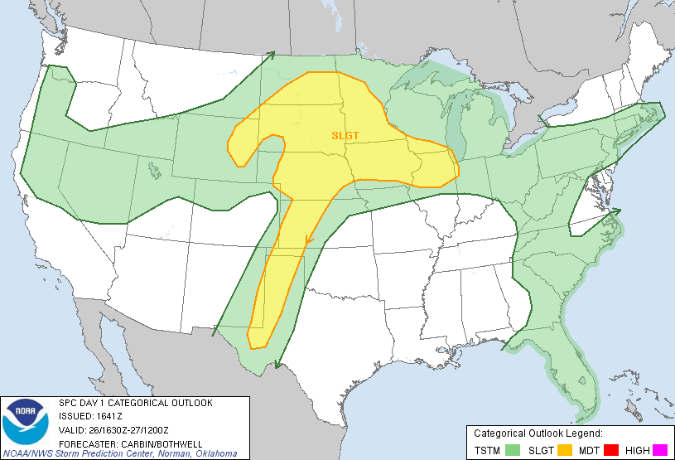
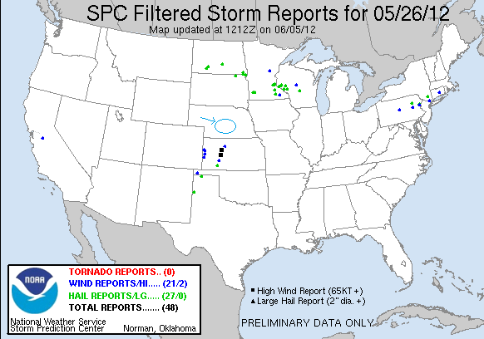

Prime Time Tour, Day 6, May 27th 2012
A day that followed the pattern of the rest of the tour: The keywords were "dirt" and "after dark". A moderate threat day, we again chose the triple point / dry line play over the warm front, and proceeded from North Platte to Holdredge, NE, where we stopped for lunch and waited for a while, then moved southeast to Franklin, NE where we waited for another hour or two before storms finally got going all along the dry line. We headed south towards Smith Center, KS and stopped just to the west to observe a storm coming up from the south straight towards us. We were just to the north of the hail core and first got blasted by outflow air kicking up tons of dirt, when suddenly hail from golf ball to tennis ball sized started falling out of the sky! Fearing that we'd lose the side windows of the vans, we quickly repositioned them to face south and waited out the bombardment until it ended, then collected hail including a couple of tennis ball sized stones. With mid-level lapse rates being really steep, we knew the day's storms were all going to be big hailers. We followed the storm up north back into Nebraska and noted a monstrous hail core opening to our west, and once the storm to our north started falling apart we dropped south of that one to avoid getting clobbered, then west towards Kensington, KS to take a closer look at a strange looking hail shaft that appeared so big that it almost looked like a big white cone tornado.
We stopped and watched the hail core (and I had a good conversation with a Smith County Sheriff who was also spotting the storm) then headed south to meet another storm coming up from Hays, KS. But, one after another the storms would come off the dry line and croak within a few scans. Nearing dark, we stopped in between three storms south of Osbourne: the tail end of the group of cells we'd been watching earlier, the Hays storm that was fighting a losing battle to keep together just to our west, and a new storm coming from La Crosse (site of the night time tornado two evenings earlier). We decided to head to Russell to meet the last storm as it reached I-70, but were treated to two shows as we headed south, with the Hays storm eventually going into an LP phase with neat structure and a lot of updraft and anvil lightning, and the La Crosse storm spitting a ton of anvil crawling lightning as we closed on it. As we turned south towards Russell, the La Crosse storm suddenly re-intensified and went severe, with half-dollar sized hail and signs of rotation. It was right in our path to I-70, so we had no choice to race it to Russell and blast through the front flank core. Just north of town, we headed east down Business Rt. 40 to cut the corner to I-70 and this seemed to make a big difference as although we still got ripped by the core that did indeed have half-dollar and quarter sized hail, we managed to blast through with little damage (van one's communication antennas got messed up and we lost communication, but that was all) and fly down I-70 east out in front of it, and were treated to a fantastic lightning illuminated mother ship updraft behind us. We stopped in Dorrance, KS and later near Sylvan Grove to watch the striated updraft spin away to our north and put on a great lightning show, made even better by the fact that the moon and stars were out just behind the storm. Finally, with a long drive coming the following day, we called it a night and headed for the hotel in Salina, KS.
Kind of a disappointing day given the Moderate SPC threat that pretty much busted, but still a couple of good storms, some big hail, and a nice night-time lightning show. I won't complain!
433.7 miles today for a new total of 3397.3 miles.

Day 6 1630Z Convective Outlook and Storm Report:

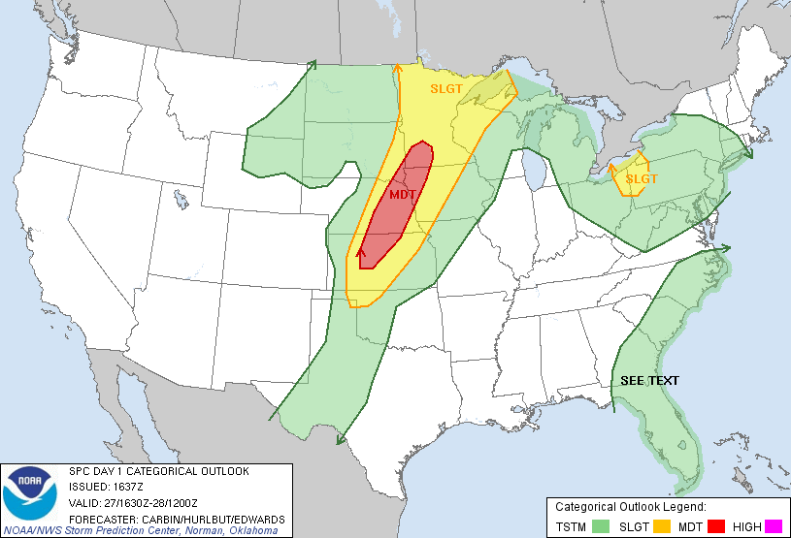

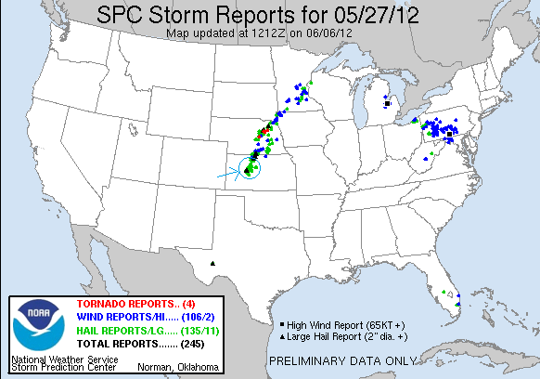

Prime Time Tour, Day 7, May 28th 2012
A really fun chase day! We started the day in Salina, KS, targeting the Wichita Falls, TX area. We got down there in pretty good time and arrived in Seymour, TX just as the boundary was lighting up all the way from the Childress, TX to almost the Midland / Odessa area. Waiting in Seymour there were towers going up all around us but they were all VERY high based. We ultimately decided to target the one nearest us as it had the highest VIL in the area and headed northwest out of Seymour on FTM 1919 towards Crowell, running into Tim Marshall, the Southern Kentucky University team, and later a couple of the other tour groups. Nonetheless once we were out of town it was one of those great storm chasing kinds of moments when you are out on the scrublands and it feels like it's just you and the storms. We watched the storm dump an enormous rain core, probably a wet microburst, well off to our northwest and right turn directly towards us. We sat and photographed the storm for a solid half hour before we started heading back towards Seymour, stopping every few miles to watch until the big RFD plume the storm was producing starting catching up to us. As we got close to Seymour, the VIL's were maxed out and GRLevel3 was projecting 4" hail so we knew we didn't want to mess with that core. Additionally, the storm to our east was looking progressively better and we could see a distinct lowering in the distance and wanted to keep an eye on that one as well, so we headed southeast towards Olney, stopping briefly on the road to Archer City to check in on the eastern storm, but by now our original storm was really the big dog. The only probably was that the storm not only was now a huge HP hail machine, but all of the storms were forming a bow echo complex a hundred miles wide and we didn't really have a way around it. We charged west towards Throckmorton but decided we'd never beat the hail core there about 1/2 way along the way (in hindsight we probably could have made it but didn't want to risk it) so we headed south on FTM 578 to try to buy a little more time. Down near Woodson, TX, the structure to our north was awesome with the usual green glow of hail and an impressive sharks teeth shelf cloud. We clearly weren't going to get around the monster core so we drove into Woodson and put the vans up against the south side of a school building and let it run us over. We expected to get bombarded with big hail, but instead got none at all. We did however get torrential rain and hurricane force winds along with VERY close CG strikes as the core rolled over us. The church steeple just about 1/4 of a mile from us got hit twice by lightning strikes.
Once the core rolled over us, the next challenge ensued as there had been so much rain that one of the vans got stuck in the mud! Luckily for us the town brush fire unit just happened to drive by and they quickly attached a tow rope and dragged us out. For all the talk of getting a hard time from police / emergency services this year, this was the second day in a row we had a really good experience with law enforcement.

That little issue taken care of, the colors on the rear flank of the storm that had just passed over us, contrasted with the bright blue sky behind us, were fantastic. As we drove through Throckmorton and Seymour on the way up to Wichita Falls, we were treated to a nice anvil-crawling lightning show from the bow echo complex to our southeast and a great cloud-to-ground lightning show on a small cell just north of Seymour.
All in all, a really fun chase day. Mileage for the day was 659.6 miles, bringing the tour total to 4056.9 miles.

Day 7 1630Z Convective Outlook and Storm Report:

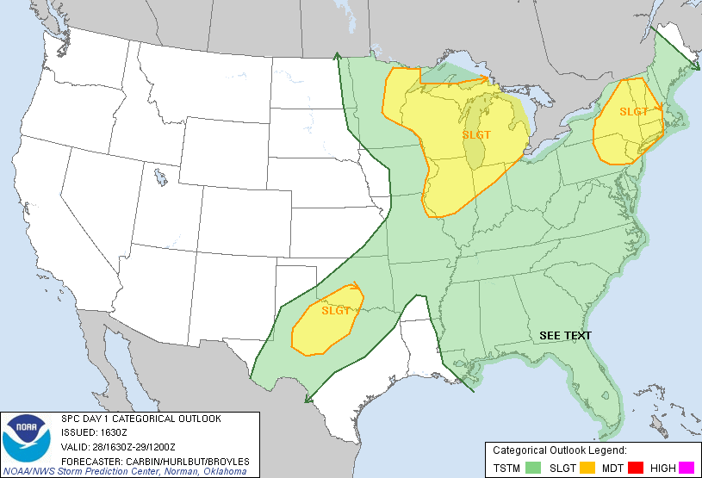

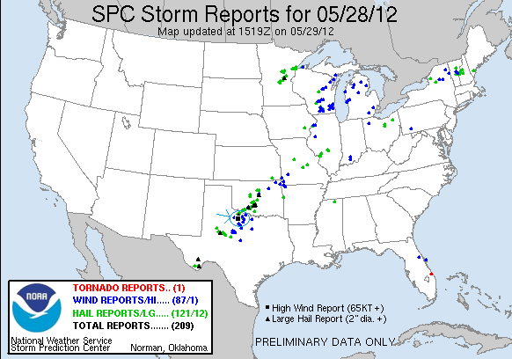

Prime Time Tour, Day 8, May 29th 2012
Best chase day of the tour so far!! We started in Wichita Falls, TX and headed up to El Reno, OK where we stopped to have lunch and look at data. We were looking at a target somewhere from Woodward to Enid, with the HRRF model blowing up a bomb of a storm up somewhere in the Woodward area and storm motion to the southeast. We headed up to Fairview (right along that path we drove when following the Canton tornado on May 24th last year) and waited as the boundary went from flat cumulus, to enhanced, and soon towers were going up all over. We waited for quite a while and soon one on the updrafts got started pretty much right over us and would be the target of our attention for the next 5-6 hours.
As the storm started getting organized, we headed south and east to get a better view of the storm since we couldn't see much detail being right under the base, traveling through Isabella and then down to a point northwest of Hennessee. Initially, the storm looked to be struggling but by this stop it was now a very nicely structured barber pole LP storm, twisting and turning just to our west. Not much later the storm went into a more classic mode and as we watched near O'Keene, spitting out numerous CG's east of the updraft and starting at least one and maybe two lightning induced fires in the wheat fields. Here the storm took on a look very similar to the Topeka storm of May 21st last year with great striations, a nice carousel mesocyclone, and a wall cloud producing multiple funnel clouds. Just like at Topeka, we couldn’t have been in a better spot for photos and the storm spun like crazy while we waited.... and, also like Topeka, nothing! To get back out ahead of the storm we went out on county roads which went east and then south into Kingfisher. Already the storm was starting to take on a more HP look to it and produced another big wall cloud then cycled through a number of meso-cyclones while inflow raged into the storm from our south, right over Kingfisher. Once again, though there was violent rotation at times, it never got focused enough to produce a tornado (though I believe one was reported at this time, we didn't see any evidence).
We were in danger of getting cutoff so we charged south to Okarche, stopping several times along the way to observe the storm trying to wrap up several times despite the fact that it was now a big HP supercell with 4+" hail! As we headed towards Piedmont, the storm had amazing structure, with a jellyfish looking updraft as it was raining out of the base and incredible striations! By now chaser convergence had just about maxed out with people streaming south trying to get away from the hail core. As we sat there watching the fantastic structure just to our west, the storm collided with a left moving storm and that seemed to tighten up the rotation from the storm, and quickly a bowl shape wall cloud developed and produced a rain wrapped elephant trunk tornado for about a minute! It was difficult to see clearly but it had an obvious debris fan for a few moments. Tornado number 4 of the tour.
Just as fast as the cell merger tightened up the storm and caused a tornado, it killed or storm and now the entire group of cells was developing into a bow echo complex charging towards Oklahoma City, which had the tornado sirens blaring. As it started getting dark we noted that the westernmost cell on the line had an awesome liberty bell updraft, and we headed south to Mustang, then west towards Union City to intercept. As we got to Union City, we noted a massive dirt plume rising to our southwest and considered whether it might be a tornado. We passed it just as we crossed the Canadian River, and though it was reported by someone as a tornado, we don't think it was. It simply appeared to be a big RFD plume, with no apparent funnel above it or obvious strong rotation. We made it as far as Tuttle before realizing that we needed to get north very quickly to avoid getting cored in a big way and charged between two supercells north on Rt. 81 to get to I-40. As we got to Minco, we got slammed by the RFD from a supercell to our east, getting strong winds and torrential rain but not much hail luckily. We headed east and hit another big core near Yukon, again with torrential rain but no hail. As we got to the hotel, Oklahoma City was recovering from significant hail damage and we noted that some restaurant signs on our road had lights knocked out and there was very heavy hail damage to a car dealership about a mile north of us. As we settled in for the night, there are still significant power outages in town.
What a fun chase day! Possibly the best structure I've seen on any storm, and it was especially gratifying to have literally been under the updraft when the storm's first tower went up all through the cycle, staying with it from LP supercell to classic supercell, on to HP supercell and finally bow echo as it lined out. It seemed like a long day, but in fact we only traveled 362.3 miles for a tour total of 4419.2 miles.
Day 8 1630Z Convective Outlook and Storm Report:

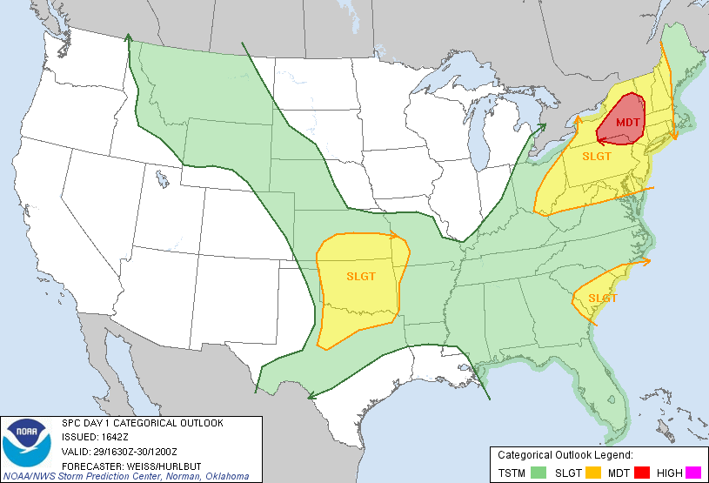

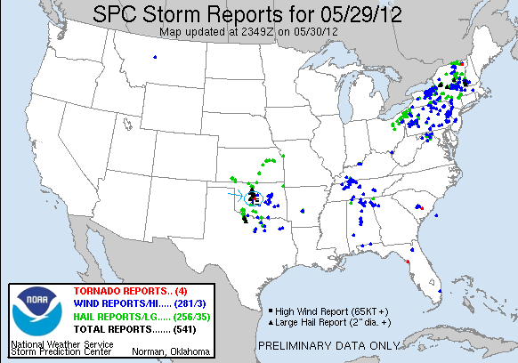

Prime Time Tour, Day 9, May 30th 2012
Another great chase day! We were presented with a dilemma in the morning between two chase targets, the "SPC Recommended" warm front up in southwestern Kansas, and the dry line play in southwest Oklahoma and into Texas. Leaving Oklahoma City, we were torn over the targets, though quickly information came in from Dr. Dave who strongly favored the area of Childress, TX. As we headed west, it was clear that there was a great deal of shear through both target areas as a large field of convective roll clouds were clearly visible from the ground, on satellite, and even on radar. About half way to the Texas border we committed to the Texas target, believing (correctly as it turned out) that the storms up in Kansas would be a large, messy cluster of cells, while the RAP model, which had been pretty much dead on all tour, developed a massive, relatively isolated supercell near Childress. As an aside, the Kansas storms also ended up developing quite a bit farther north than expected, firing all along I-70 from Russell to Salina. If we’d gone for the Kansas target we’d have been some very unhappy chasers.
We stopped for lunch in Shamrock, TX, and then headed south, targeting the Wellington area, but before we got there, the dry line quickly fired and soon we could plainly see several towers with developing anvils to our west. We headed west out of Wellington towards Memphis, stopping about half way there to watch the storms develop. The storm in front of us to our west became the dominant one, with a large rain-free updraft and a pair of long inflow bands feeding into the storm. As the storm developed, it was very slowly tracking to the northeast but as it increased in intensity it turned to the east, and then eventually to the southeast. We were able to stay in our position watching the storm develop for about half an hour before the lightning threat got too great and we needed to get south to avoid getting cut off. We also wanted to keep an eye on the next storm to our south, which didn't look as good on radar but had an unimpeded path of inflow air from the southeast, whereas our storm was in danger of getting it's inflow path severed by the storm to the south. We went through Memphis and started heading south and now the storm was rotating wildly, with numerous shear funnels and mid-level funnels developing then dissipating. Continuing the theme of this tour of structure and dirt, the storm had a terrific corkscrew updraft and was ingesting an incredible amount of red dirt entrained in the inflow that was streaming into it. We stayed with the storm as it tried to cycle up a wall cloud, driving directly along the low-level inflow jet with flying dirt, tumbleweeds, and other debris. We proceeded south to Rt. 86, passing just south of the mesocyclone as it demonstrated rapid rotation and stopped to watch as the storm tightened up. There was now 3" hail reported with the storm and we were in danger of getting pounded by the hail core so we charged east towards Estelline trying to beat the core there. Though we didn't get the really big hail, we did get pounded by golfball sized hail and got two more spiders on our already broken windshield, while the lead van re-broke the just recently repaired windshield. We blasted south on FTM 658 to stay out ahead of the storm. We were now directly in between our storm and the southern storm, which was quickly becoming an absolute monster supercell. Interestingly enough, though that storm was developing a well defined hook echo, it was not tornado warned, while ours was. As our storm seemed to be cycling down, we started thinking about targeting the southern storm. We stopped for a moment west of Cee Vee, TX and had a great view out on the open scrublands, but the storm looked like it was weakening significantly. We went through the small town and then headed south towards Paducah, but our storm intensified for one last gasp and had great structure one last time before the updraft sheared over literally before our eyes and the storm collapsed. That made our decision easy as the southern storm had become a beast of a supercell, showing velocity couplets on radar of well over 100 knots and reports of huge hail. The problem was we were now northwest of the storm, i.e. exactly on the wrong side of it, and with hail and velocity markers like it was exhibiting, there was no way we were going to attempt a core or hook punch as it would have been way too dangerous.
As we headed down Rt. 83 with the rear flank of the storm's hook echo just about 10 miles to our southeast, we observed multiple significant lightning-induced fires on both side of the road. Heading into Paducah, the sight was pretty eerie: There was a giant plume of red dirt suspended in the air just east of town, and the town itself had clearly suffered some significant wind damage, with limbs broken off trees, sheet metal roofing blown off buildings, and debris all over the place. One spotter report suggested 100 mph rear-flank downdraft winds or a potential landspout tornado has caused the damage. Sure enough, as we exited the town, a long ropey landspout tornado with a red debris fan was visible on the rear flank of the storm and remained for a minute or two before it dissipated. Whether that was what hit the town or RFD winds I don't know, but my guess would be RFD damage. Still, that was tornado number 5 for the tour. Having cleared Paducah, we were still cutoff from the inflow notch of the storm and were forced to continue another town south, down to Guthrie. While we could still not see into the inflow notch of the storm, the mammatus clouds hanging out of the anvil were absolutely spectacular.
Getting to Guthrie, we had a new challenge. We had 30 minutes to get east to Benjamin and were 36 miles from the town, which was doable, except that we were also down to about 1/4 of a tank of gas, and absolutely could not risk having a fuel issue with a potentially killer storm bearing down on us. There was no fuel in Benjamin or Guthrie according to a search on the smart phone that took an agonizingly long time because of the continuous data issues we were having, but we found that to the south of Benjamin there was a little town called Knox City that had gas, and as it turned out going southeast would buy us a little time to get out in front of the storm and present us with great road options, so we took a farm to market road to Knox City, gassed up, and headed northeast toward Munday. Just outside of town we stopped to witness the breathtaking structure of the storm off to our north with incredible striations wrapping around and multiple long inflow bands streaming in. One thing that can never be truly documented on film is the way these monster storms just take over the environment for miles around the storm. As far as we were away from the updraft, the inflow at our backs was still blowing into the storm at 40-50 mph and it was almost possible to lean backwards and be held up by it. We stopped again east of Goree, looking right up the inflow notch where there was probably a rain wrapped tornado in progress, but the notch had wrapped up to the point that you could no longer see anything. Interestingly, if we had been sitting at the exact location we'd been at two days ago on FTM 1919, our view up the notch would have been just about perfect.
Finally, it was getting dark and there really wasn't much point in staying out ahead of what was now a large HP hail storm, so we headed up Rt. 277 through Seymour towards Wichita Falls, witnessing a terrific lightning show and a blood red sunset caused by the Sun setting with tons of flying debris still suspended in the air. After dinner in Wichita Falls, we raced up towards OKC trying to beat the derecho that had formed out in front of the Kansas storms to the city. We didn't quite make it and got hit with heavy gusts of wind just as we got to the hotel and observed several power flashes as we approached the town, but the show there was just about over and, arriving at the hotel, we called it a night and a tour.
Day 10 was a down day with nothing in range to chase, so we were done. The mileage on the last day was 587.7 miles for a tour total of 5006.9 miles for the tour, right around average but lower than I’d expected considering the 1000 miles the first day. My tour total was 5 tornadoes over 3 different days in 3 different states, the "classic" tornado states of Oklahoma, Texas, and Kansas.
Of all the chasing I've done over the years, this tour was the best in terms of storm structure, with magnificently structured storms on at least 4 separate days. Considering how mediocre May was on a whole, and how marginal the pattern looked, it was a great tour! Looking back at the storm reports, there were not very many good storms on the days we chased, yet we always seemed to be on the “storm of the day”. We ended up chasing 9 out of 10 days and saw nice storms on at least 6 of them, so who could complain!?

Day 9 1630Z Convective Outlook and Storm Report:
