The following is the tour summary for Silver Lining Tours Tour 3, 2011.
Tour 3 Day 1, May 17th 2011
An excellent chase day for such a marginal setup and a good way to start the tour! We left Oklahoma City bright and early with the idea of chasing storms somewhere between Limon and Fort Morgan, Colorado, so we knew we had a long drive in front of us. The group was ready to roll at 7:30 and we made good time, getting into Colorado by about 3:30 Mountain Time. What we saw when we got there was not good however! A cirrus deck near the Colorado / Kansas border had slowed heating all day and was still there as we got into Colorado. On satellite, it was clear elevated cumulus were forming to the west once it cleared, but the question was whether storms would fire on the excellent convergence projected by the models on the east side of the Denver Convergence Vorticity Zone (DCVC).
We were discussing dropping the bags off in Limon and waiting when the first storm blew up near Byers and quickly went severe. We got to Limon and blasted north towards Last Chance and the storm was suddenly tornado warned! While mesocyclone tornadoes weren’t likely because of the extremely high cloud base, landspouts were definitely in play. We continued to charge north, but soon it was clear we would not be able to get through the core to where we had to be, so it was off onto the mud roads between Woodrow and Akron. Despite getting rained and hailed on pretty hard, the roads were in great shape and after stopping and observing for a bit, we hit the pavement south of Akron, but instead of heading north decided to head south as a new cell down there had been tornado warned with one reported tornado. As we charged south around the back side of the line, we plowed directly into the hook echo of the rotation of the tornado warned cell and were hammered by strong winds and rock-hard quarter sized hail. As we got through there was violent rotation to our east, but it was very high based and didn’t produce.
After a while longer observing several attempts of the storm to get its act together, we headed south to try and intercept a new severe cell which was right along I-70. We picked up the storm near Siebert and went blasting through the hail core on I-70 near Vona. As we neared the core, the sun was setting, so the storm was pitch black, but the hail was reflecting white in the Sun so you could clearly see the sheets of hail coming towards us, then it was like someone dropped a giant bucket of ping-pong balls in front of us! It was an awesome core punch and we got through unscathed. We stopped in Stratton to refuel and as the storm caught us we headed to Bethune and stopped and filmed the now highly electrified storm. After we’d had enough of that, we plowed through the hail core again and off to the hotel in Limon. There was enough hail that the plows were out on the highway and the fields were covered in white.
What a fun day to start out when the setup looked bad, and when we reached the target area it got worse! The target area verified almost exactly.
It was a long day of driving, 828 miles, but worth it.

Day 1 1630Z Convective Outlook and Storm Report:

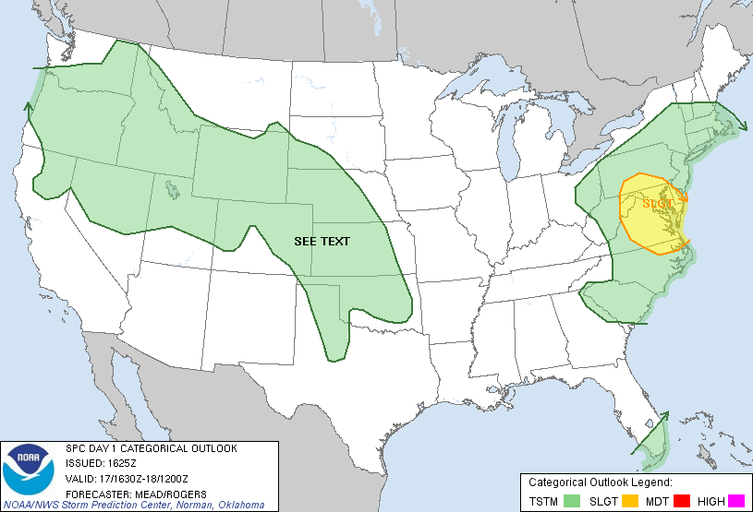

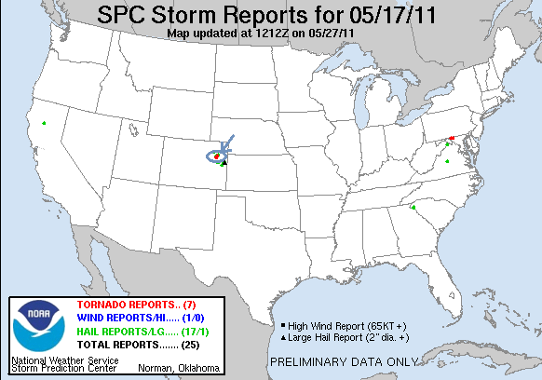

Tour 3 Day 2, May 18th 2011
Capola Bustola! Well, we had a lot of newbies on this tour, and let's face it; everyone needs to experience a cap bust before they can really understand the storm chasing experience. We started the day in Limon in extremely un-storm chasing like conditions: fog, a low stratus deck, and 44 degree temperatures. We spent quite a bit of time trying to decipher the mixed signals being sent up by the RUC, GFS, and NAM models. The setup looked good on the dryline bulge in Western, OK, but the models didn't break any storms out there despite the fact that it didn't look capped. Finally, the 14Z RUC broke out a line of storms near Woodward, OK and south, so we hopped in the vans and headed back to Oklahoma, heading east to Oakley, KS then south through Dodge City and into Oklahoma, stopping in Woodward.
We had made excellent time to Woodward, and once there the atmosphere looked primed to fire off storms at any moment. Then.........nothing happened. A few towers started to go up, but quickly sheared over as they either were too weak to overcome the shear or hit the cap and flattened out. We sat there outside of town for about an hour with a great vantage, but nothing ever got going and eventually we had to give it up. We hit road to Wichita, KS for what looked to be a nice setup for the next day. I'll have to post the total mileage later since we've got about 3 hours of driving to go.
Mileage for the day 619 miles for a 2 day total of 1447.
Day 2 1630Z Convective Outlook:

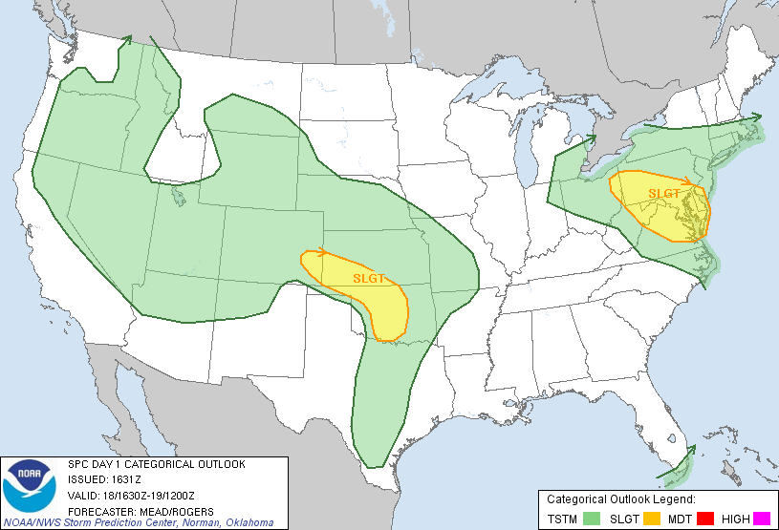

Tour 3 Day 3, May 19th 2011:
A long, wild and wooly chase today! Our plan was to chase the triple point, catching storms as they came off the dry-line and hoping they would go crazy as they interacted with the cold front, before passing over into the cold air and dying. Starting in Wichita, we headed west to Pratt, stopping for lunch and waiting for development. The satellite imagery showed the triple point in crystal clear fashion, near Kinsley and moving north fairly quickly. Storm chasing took on an international flavor this day as not only were the Italian Storm Chase team there, so were the Dutch "Tornado Jagers"! After waiting a while and watching towers build to our west, we were concerned that the atmosphere where we were was mixing so we headed straight north, stopping first in St. John, then Great Bend.
By the time we got to Great Bend, one of the updrafts had finally broken the cap, followed quickly by another and another and soon the whole dry line was lit up all the way down to Oklahoma, linking up with the severe storms that had been going on down there for hours, but that hadn't been tornado warned because of the lack of directional shear down there. We targeted a storm just to our northwest and charged through Hoisington, then jogged east, turning north again towards Wilson. By now, the storms from Hill City arcing over the dry line bulge were all tornado warned, and we were confident ours soon would be. Though each of the other storms rotated wildly when they hit the cold front and died after they crossed it, our storm maintained its intensity after crossing the front. As we closed, the scene was very eerie: Being on the wrong side of the cold front, there was an extremely low hanging stratus deck and dense haze under the anvil of the storms. As we got to Wilson the storm was showing signs of very strong rotation and we closed on the mesocyclone right at I-70 in Dorrance. We drove right up under the meso which was spinning hard, so close that we had to turn around and run for it to the east lest we get run over by anything that developed.
As we headed back to Wilson and north of the interstate, the scene became even more strange as we came up to a large lake, zooming along the east side of it while the storm was right over it. The inflow of the storm was INCREDIBLE as we plunged downward into the valley where the lake was, probably at least a constant 50 mph and Matt struggled mightily to keep us on the road. The clouds above us were screaming into the storm. As we got to the northern end of the lake we came to a dam across to the west, where a large rotating mesocyclone was just arriving over a hill on the west side. We blasted across the dam, but as we got to the other side we realized that in the near zero visibility anything that formed would come right over the hill and be on top of us before we could get out of the way. So, we turned and again ran for it to the east, then stopped on the east side of the dam for a fantastic view of the violent rotation all along the shear line of the storm. Later, when I put the tour photo gallery together, looking at one of the video stills I took from the time appeared to show a rain wrapped tornado in the rain just west of the dam! Adjusting the contrast of the photo appears to prove it, though as I did not see it with my naked eye I will not count it in my tally. We began to stair-step to the east and north, going through Sylvan Grove as the tornado sirens were going off and then headed west again back under the edge of the meso. Here, as was repeated a couple more times, we got under the meso and waited until the absolute last second before running to get out of the way. One time the violent rotation was only about a hundred yards away and as we sped east I watched as the rain curtains spun wildly in a full circle in the fields just south of us, but we could never confirm that anything made it to the ground.
Eventually making it to Lincoln we decided we'd had enough and decided it was time to head south to get to the next cell. We proceeded back south of the interstate to Ellsworth, but the new storm collapsed before we got there. After managing to turn around only with difficulty in the growing chaser hoard, we more or less called it a day and headed north to the interstate, but then one more cell got going and we played around with it a bit through Lincoln and Tescott, but again it was difficult to see anything in the haze and low hanging stratus, plus tons of cloud debris, and we finally called it off and headed to the hotel in Salina.
So, no tornadoes but a very fun and exciting chase day. Mileage for the day was 340 for a total of 1787.
Day 3 1630Z and Storm Reports:

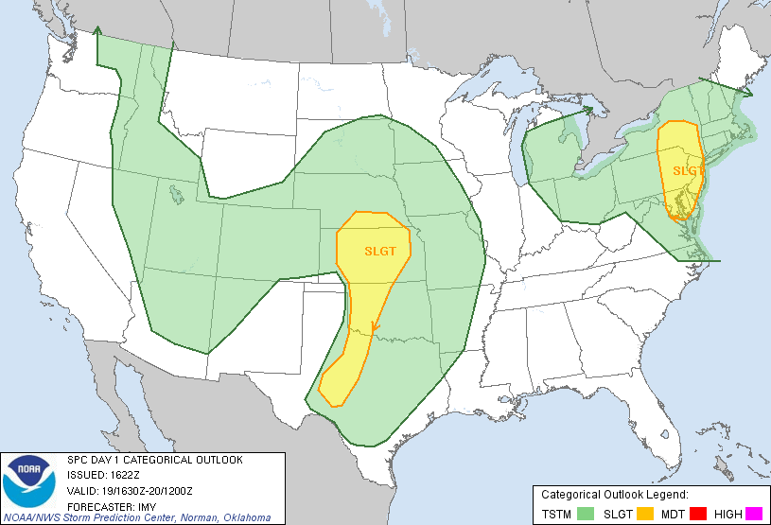

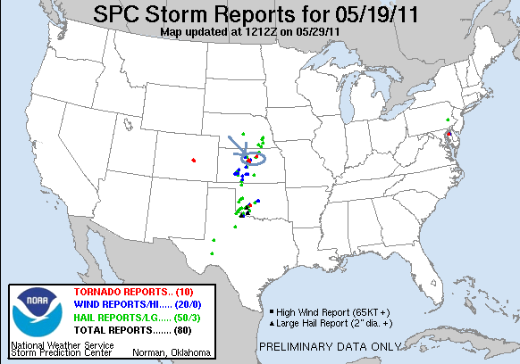
Tour 3 Day 4, May 20th 2011:
We awoke to discover a raging MCS scrambling the atmosphere all the way from Salina, KS where we were down to the Mexican border! There were really only two places to play with any potential: East Texas ahead of the MCS where there was potential for discrete supercells out in front of the MCS, and the second back on the dry line if the clouds cleared out enough with the hope of some big hail. The Texas play had the best tornado chance but sadly there was no way we'd get there in time, so dry line it was. That meant heading down to Wichita and back out to Pratt, where we'd been yesterday. As we headed west, things were looking pretty grim as the low stratus hung out for a long time and when clearing finally did occur, temperatures only made it to the low 70's. There was a little line of showers for us to keep an eye on that were slowly intensifying. As we waited, we passed through Greensburg, KS, site of the devastating 2007 tornado, so we got to see the progress of the reconstruction. The town is still scarred severely. As it is being rebuilt as a "green" town, I noted several wind turbines that have been built since the last time I was there in '08, and a lot of new houses but the damage is quite evident still.
After Greensburg, we continued west right under the line of developing cells and visited Mullinsville and the hundreds of political satire iron sculptures alongside the road of someone's property. After we finished there, a cell was taking a more interesting shape and we headed back to Greensburg and the chase was on. We ended up chasing 2 or 3 borderline severe cells and ended up having a very fun day, better than I expected to be sure. We core punched a couple of times and saw some very neat structure chasing northeast Greensburg, through Iuka, Preston, Turon and back towards Pratt. Considering the borderline quality of the storms, it was amazing how many chasers were out there. Once we finished, we headed back to Wichita once again.
Mileage for the day was 375 for a tour total of 2162.

Day 4 1630Z Convective Outlook and Storm Report:

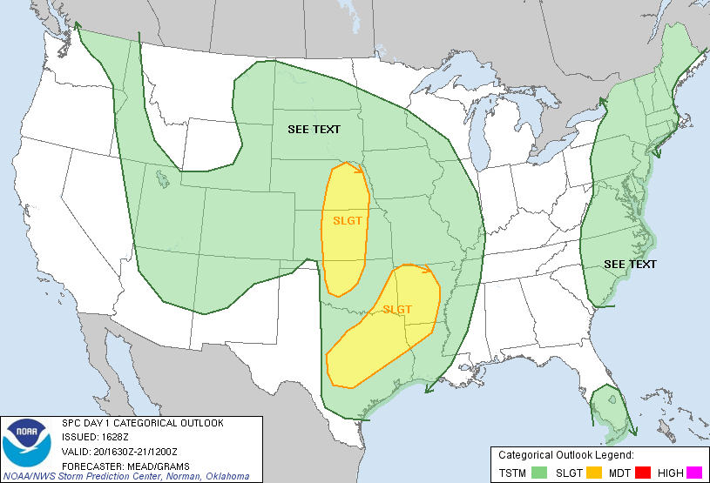
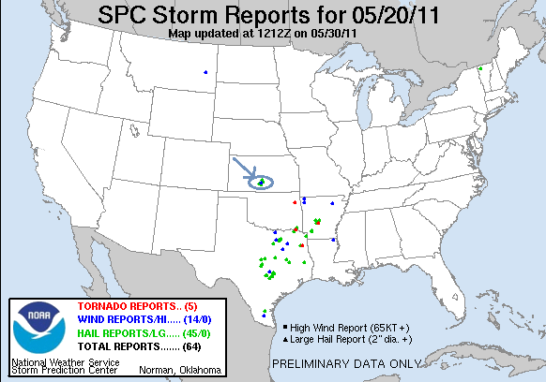
Tour 3 Day 5, May 21st 2011:
The best day of the tour so far, with some great storm structure, numerous funnel clouds, and even a brief tornado. We started the day in Wichita, KS and headed towards Topeka with the intent of chasing the dry line once it lit up late in the afternoon. First, we headed up to Emporia, and waited…. Then up to Topeka and the mall, and waited, waited, and waited some more. After two 30 minute waits at the mall, watching radar (and the tornado warned storm that was going on up in Nebraska on the true front), things started percolating on the dry line and soon we were in business.
We headed west of town and found some high ground from which to observe the big updrafts exploding along the dry line both to our north and south. The storm to the south was coming into an area with better conditions, the one to the north the better wind shear. We spent about 20 minutes out in the open country watching the storms, and the horses in the field right next to us, then targeted the southern storm.
We proceeded south and west of Auburn and stopped as the storm developed its first mesocyclone and wall cloud just to our west. The storm has fantastic structure and we were in the perfect position for great photography. As the meso slowly approached, the sky became a merry-go-round above us and three times we felt the surge in in-flow winds that often mean the storm is about to tornado. Several funnels reached towards the ground, but it never quite tornadoed. Eventually we had to move to keep up with the storm heading over to Rte. 75 and north towards Topeka, now with no less than three mesocyclones, the old dying one, the dominant one, and a new one out ahead, arrayed in front of us as we approached up the highway, where we stopped to observe again. We headed northeast on the turnpike with the meso hanging precariously low to the ground. As we went through the off-ramp of the turnpike near Grantville, the storm dropped several funnels in a few minutes, but again, would not tornado!
Finally heading east out of Newman the storm got obscured in the trees to the north, and off in the distance we caught a very brief glimpse of a white stovepipe tornado over Perry Lake, which apparently did quite a bit of damage. By the time we got back on the storm, it had become a big HP beast, and though it almost surely had a tornado in it, the area of rotation was completely rain wrapped, so the show was over, though the overall structure was fantastic. We paused to watch lightning for a bit, then headed west of Topeka again for a dinner stop and an even better lightning show, and then proceeded south back towards the hotel in Wichita. On the way, we passed right along the flanking line of a violent storm to our east and were treated to another even better lightning display. That storm was nasty looking on radar, and apparently did a lot of damage in Reading, KS which I later found out caused some fatalities.
Mileage for the day was 425 for a 5 day total of 2587.

Day 5 1630Z Convective Outlook and Storm Report:

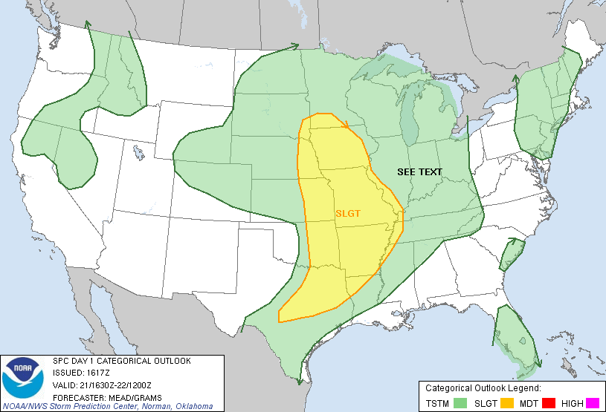
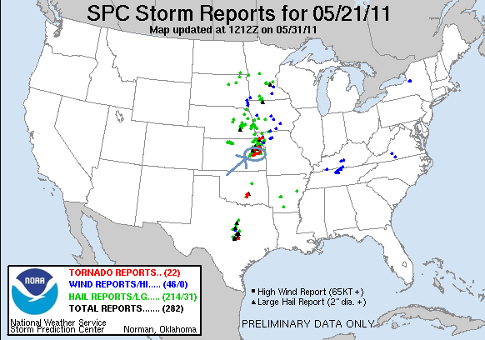

Tour 3 Day 6, May 22nd 2011:
May 22nd, 2011 is a day that no storm chaser is going to forget anytime soon. For me, it was interesting in that the day was mostly a bust until pretty late, and it also marked the first time I’d ever chased in Missouri. Who would know that my brief 2-hour chase experience in that state would include one of the most devastating tornadoes in US history?
The day started with us in Wichita, KS, expecting a big day in southeastern Kansas and later into Missouri. Our initial target was Independence, expecting to move on later towards Parsons. The setup was excellent with ample moisture, very high CAPE, and good surface winds. The one problem on the day however was going to be the limited upper level winds. While on the one hand, this can help in that the storms don’t move terribly fast and so are easier to chase, but it also means that the storms aren’t well ventilated: without strong upper level winds, the precipitation doesn’t blow too far away from the updraft, and that is a recipe for high-precipitation supercells. Ultimately this meant that visibility would be tough all day and you’d have to be close to the mesocyclones to see anything, and also that we’d be under rain and hail cores all day.
The first storms went up near Independence, KS and we headed north after them. For a time, they were not well organized, and we decided to kill some time by driving into a hail core and playing with the storm near Galesberg. After a bit, we realized that not only were we close to getting clobbered by big hail, we were also in danger of getting out of position on the next storm in line that was becoming the big dog of the day. We rushed out of the core and proceeded to run circles around several cells in the area of Parsons, Oswego, and Altamont. A couple of times the storms generated big wall clouds, but never really looked close to dropping a tornado. One thing they did have however was incredible cloud to ground lightning, and we spent hours in a significant lightning threat with CG’s landing all over the place near us. Between the lightning and the constant precipitation falling out of the cores, we rarely were able to get out of the vans all day.
This became the pattern of the day: As we hopped from updraft to updraft driving in roughly clockwise circles around the gridded road network, edging eastward as we went, the multicellular mess over us blew out an outflow boundary to its south. As each new cell came north and hit that boundary of rolling, cold air, it would spin like crazy for a bit and get tornado warned, then eventually cross the boundary into the colder air and die. We chased a number of these cores, slowly moving east through the towns of Rosewood, Columbus, and Cherokee. All the while the terrain was getting more and more wooded, making it harder and harder to see. Eventually, we drifted into Missouri…
As we continued to chase in the wooded hills, getting almost right under one meso after another, we got a little surprised as one of the cores got more violent than the previous ones and suddenly we were hammered by rock hard golf ball and larger sized hail. We abandoned ship and headed east into Webb City, MO then south into Joplin to get south of the cells and refuel.
It should be noted that what was about to happen in Joplin occurred when we were not even really chasing. Not that our guards were down, because if they were, I probably wouldn’t be around to write this, but we were sort of at a pause in the chase. We headed into town along Business Route 71, not aware of what had changed to our west: A cell coming north had hit the boundary like all the rest, but this one did not cross the boundary into the cold air. Instead the storm turned right hard and rode right along the boundary towards Joplin, with all of the horizontal vorticity along the boundary available as fuel for the storm.
We headed down BR 71 and found a gas station to stop of and refuel, and those who really needed to use the facilities were allowed out as it had been a long while since we’d taken a break. Fortunately as it happened, the attendants at the store would neither allow folks in, nor allow us to pump gas, because we were under a tornado warning. Of course, we’d been under tornado warnings for hours, so we were not overly fazed; after all, we are always in tornado warned areas when chasing.
As we mounted back up, Roger took a look at the radar and screamed “Holy $%^!! We got a tornado coming right at us, everyone back in the vans, we gotta get south NOW!!” We piled in and hit the road in a hurry. Unfortunately, there was very heavy traffic on the road, and traffic lights every block, so progress was very slow and the situation became more and more serious. We needed to get to Interstate 44 to get east and out in front of it. You could see the highway down the road about ½ a mile, but progress was painfully slow. Soon off in the distance as the dark black cloud neared, guests started seeing one power flash after another, getting closer and closer (right about this time was probably when the hospital was hit). We started hammering on the horn and weaving through traffic as best we could, as the guests were yelling out the windows to people aimlessly driving, or even strolling along the sidewalk north into the path, to take cover immediately! Then, another stop light and we were stuck. Panic was starting to set in and we discussed possibly driving out behind the Home Depot for shelter before quickly dismissing the idea because it would be too close to the tornado. We pressed on. The Home Depot was destroyed completely, with many fatalities.
It was beginning to look like we were in big trouble when suddenly the power went out, including the traffic lights. We were moving again! We started weaving around traffic and charging towards the on ramp only a hundred yards or so away. Then from my right, I saw the wrapping rain curtains coming over us. We were in the outer rotation under the mesocyclone. By now the guests were all screaming because they could see power flashes only a block or two away, and some captured the east wall of the large wedge tornado on video. Suddenly we were blasted by wind and rain as we got to the ramp. The next minute or so was the scariest I’ve had chasing. The on-ramp exited to the right, meaning we turned directly INTO the rotation as we swung around to the east. As I charged up the ramp I turned as hard as I could as we were being thrashed with wind and rain and debris was flying overhead in the rain curtains. At the top of the ramp, the car in front of me stopped!!! I hammered the horn over and over and was considering whether I should literally bump him out of the way when he finally moved and we zoomed east on the highway. The highway however traveled northeast out into the path of the tornado. We made it to the next off-ramp maybe ½ a mile along and jumped off south on Rte. 71. Many tractor trailers were flipped and destroyed on the Interstate just up the road. We screamed south several miles until we were well clear of the hook, and then stopped to collect ourselves.
Everyone was completely rattled by what had happened, but nobody really knew the magnitude of what was going on, and while we knew it was a strong tornado, nobody expected anything like an EF-5, the strongest tornado rating possible. Only after stopping for a few minutes did we start hearing reports of heavy damage and as we headed south we noted many emergency vehicles heading north towards Joplin. It would be well into the evening before we understood the true magnitude of the disaster that had occurred.
In hindsight, three seemingly random events might well have saved us:
1. The gas station refusing us service. If they had, we very likely would have been run over by the tornado before we could escape.
2. The decision not to shelter at Home Depot. As stated above, the Home Depot was completely destroyed.
3. The power going out, taking the traffic lights down. If not, I’m not sure we could have gotten moving fast enough to get out.
We headed south to Neosho, finally stopping for fuel. At this point the terrain got really horrible, with dense groupings of trees and the roads were like roller-coasters, up and down the valleys around the Neosho River. At the bottom of these valleys, visibility was essentially nothing, and another tornadic supercell with a known tornado was coming upon us. We blasted south on Rt. 43 from Seneca through the precipitation core in awful chase terrain, all the way south of Southwest City. We realized we were far south of the hook and turned around, heading back through the town and then north into the woods. I have to admit at this point that I was more inching forward than charging forward. The tornado which turned out to be another big wedge, had been plowing through the woods for quite a while, and as we crept northward tree debris was falling out of the sky all around us. Eventually we saw it in the distance as it passed, a rain wrapped ghostly cone with suction vortices dancing along the trees as it went by.
After finishing with that storm, there was yet another tornado warned storm to our south, and of we headed down Rt. 59 into Arkansas, my first time in that state. As we reached Siloam Springs, it was just about dark, and the hook of the storm was just to our west. We stopped in a parking lot to observe in the dark in the pouring rain. We soon figured out that we’d never see anything from where we were and got back on the road west into West Siloam Springs across the state line into Oklahoma. As we did, something loomed in the lightning illuminated storm. Another flash confirmed it, a big stovepipe tornado crossing the road a mile or two ahead of us! We stopped as the tornado passed to our north and dissipated, then as we got closer we observed a gray-white funnel halfway to the ground near the road. We headed west and drove into the damage path: Insulation and roofing all over the road, sheet metal and wood all over the place. I later learned that the tornado had hit an RV park, destroying 6 or 7 of them and sending a few people to the hospital, but fortunately there were no fatalities.
We finally called it a night after that, but had one more surprise in store. As we entered Tulsa where our hotel for the night was, we ran into a big hail core from another storm that had just popped up to the southwest. It was on top of us before we knew it and soon we were getting hammered with huge hail! I witnessed two hail stones of at least tennis ball size slam into my windshield, which literally bowed with the force but somehow did not shatter! Then off to our left KABOOM! A bright blue flash and the power went out over the entire southern part of Tulsa. A power main must have been damaged by hail is all we can guess, but of course with everyone jittery from Joplin, people were worried about a rain-wrapped tornado. In only a few seconds, the power was back on and we finally got to the hotel, ending a long, dramatic chase day.
Mileage on the day was 522 miles, but it seemed like an eternity. A chase I will never forget. 3109 miles for the tour.

NWS Springfield has a page dedicated to the Joplin tornado with damage reports, radar images, damage paths, and pictures located at:
http://www.crh.noaa.gov/sgf/?n=event_2011may22_summary
Day 6 1630Z Convective Outlook and Storm Report:

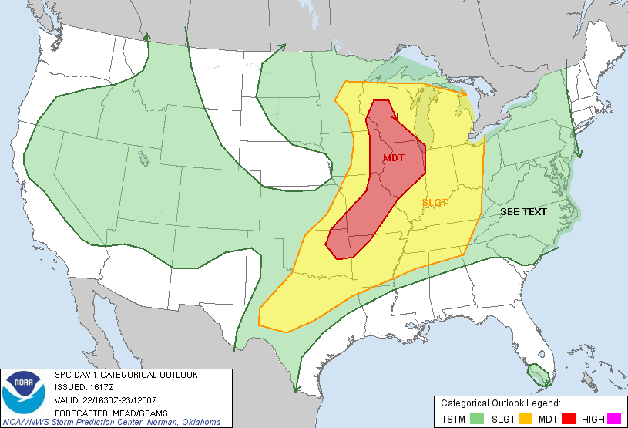

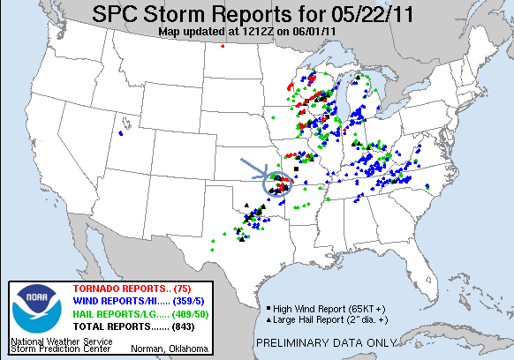

Tour 3 Day 7, May 23rd 2011:
After the Joplin day, there were a lot of differing emotions from members of the group as we awoke at the hotel. It was one of the more interesting breakfasts I’ve had on tour as everyone had a slightly different perspective. But, regardless, it was day 7 and time to get back on the chase. We stayed in Tulsa that night (first time I've ever been to that neck of Oklahoma). Today's target was the triple point formed by the dry line advancing into Western Oklahoma and the outflow boundary draped over the northern part of the state, so we headed to Enid for our first stop. Since it was a short drive, we had a lot of time to wait before the storms got going, so we had time for lunch (an aside, A&W just ain't what it used to be) and then parked at a mall and let people walk around. After about an hour the dryline was clearly ready to light up and we headed west out of town, stopping near Lahoma to observe. There were 3 cells building to our west and clearly they had some spin to them as they produced 2 or 3 shear funnels right away. We debated for a moment about heading after the northern or southernmost of the cells and decided on the southern cell, heading south and stopping just to the east of Homestead to observe. The storm was VERY electrified and CG's were popping all around. But, our cell didn't look all that good and we were thinking about heading north when suddenly the storm produced a stout funnel directly west of us, so we charged down a dirt road towards it and soon it produced a very nice rope tornado that was on the ground for a couple of minutes. After that the storm cycled and we headed east to stay with it, but it collapsed on itself. Then, after some indecision, we chose to blow off the northern storms that were looking like a multi-cell mess and head south for a monster supercell far to the south near Anadarko.
As we turned south out of Hennessey and blasted through Kingfisher, a small LP supercell in between our storm and us really got going, and as our storm to the south was turning so hard that we decided we'd never get to it, we targeted that storm which now had a nice couplet on it and a huge inflow band. We charged west towards Calumet and got there just as the storm developed a large twisting wall cloud. The storm had several massive in-flow surges of 70 MPH or more, giving us all a serious dirt bath and looking like it was ready to tornado but it could never get it done and shortly thereafter the updraft totally collapsed.
We headed south to see if we could get on the southern most storm, getting as far as El Reno, but that storm was dying, then we headed back north to a big shelf cloud and could see that everything to the north was completely undercut, so we decided to call it a night and head for the hotel, which is the host hotel in Oklahoma City, in time to relax and have a real dinner. We did have an interesting moment as getting back to the hotel room after dinner I checked radar only to find a severe storm with a big hook, strong shear marker, and TVS (tornado vortex signature) turning right hard such that the hook was going to pass right over us! The storm had great cloud to cloud lightning so I set up the tripod and watched. Even in the dark you could see two big inflow bands streaming into the storm and warm inflow was heading into the storm at my back. A little later, the outflow came and things got windy and cold, and looking at the radar it was clear that the storm had fallen apart, blowing out a big outflow boundary in the process.
So, the moderate risk for today didn't really verify as the shortwave coming through was not in sync with the advance of the dryline, but at least we got the only tornado anyone saw in Western OK and it was a fun chase day.

The mileage for the day was only 345, bringing the total to 3454 miles for the tour.

Day 7 1630Z Convective Outlook and Storm Report:

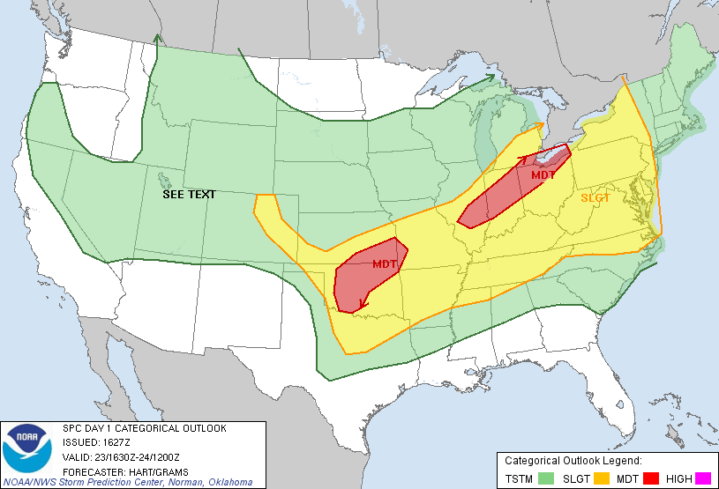

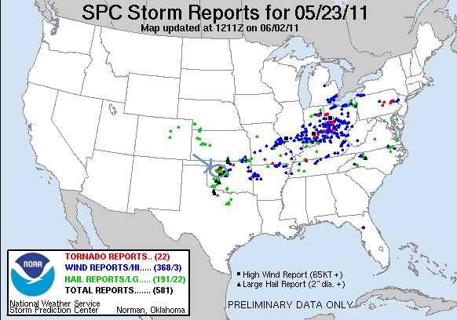

Tour 3 Day 8, May 24th 2011:
A High Risk day in Central Oklahoma! Usually just the kind of setup that yields hordes of chasers and traffic jams on the Plains! We had spent the night in Oklahoma City, so we were in no particular hurry to go anywhere. There were two clear plays for the day: Play the outflow boundary up in Kansas, or the dry line in Oklahoma. We elected to go with the dry line play expecting more discrete supercells at the dry line than there would be in Kansas.
After waiting around the hotel until about 11, we headed down I-40 west to Weatherford, watching as storms fired in Kansas but resisting the temptation to go charging north. Once in Weatherford, we stopped for lunch and waited some more, until about 3 o’clock when the dry line exploded with a line of supercells: a “string of pearls” as Roger likes to call it. We headed north out of town to intercept our target storm, getting up to the nice supercell between Thomas and Putnam. As we got to the storm, it was clearly not yet ready to do its thing yet, having a broad, flat base but not much of a wall cloud. We watched for a bit and then the cell started to get away from us and we headed northeast after it. Once we got to Eagle City the storm had matured and was now ready for business. We watched as it produced a brief multi-vortex tornado north of that town that quickly dissipated. We chased the storm north again and just as we got to Canton the storm produced for us a whole menu of tornado types. First, a beautifully backlit Wizard of Oz-like tornado, which then grew into a big stove pipe as it passed to the north of the town, then an even bigger cone, then wedged out as it headed off to the northeast, all tremendously photogenic. We were able to get through town quickly and got on a northeast road that let us drive more or less right alongside the now huge but mostly rain-wrapped wedge. We chased it past Longdale and all the way to near Fairview before it finally roped out, but as it did, the meso jumped and a white elephant trunk formed on the right side of the road in front of us while the original tornado died on the left side. We headed north then east out of Fairview, where the storm produced a long ropey tornado north of us near Isabella, the 4th tornado of the storm. Once that tornado finally died, we drove alongside the white-lit updraft, a fantastic corkscrew that I was able to get a couple of nice shots of even though I was driving.
The storm finally weakened and was getting away from us, but it was only 5 PM, so there was plenty of chase time left! The next two storms to our south were both producing big, dangerous tornadoes, one of which was to pass through Piedmont on the northwest side of OKC and the other through Norman on the south side. We decided to try and intercept the Norman storm but to do so we needed to get around the northern storm and in front of the southern one: A trek of about 150 miles! We blasted east out of O’Keene all the way to Stillwater, just as the northern storm was about to hit Guthrie not far to our southwest. We then turned south and plunged towards the interstate, then passed it and went all the way to Tecumseh in order to be sure that we were clear of the big hook that had been housing a large tornado for hours. We charged back north of the interstate and there it was backlit in orange, a large stovepipe to our northwest. We headed west towards McLoud and as we popped out of the trees, the tornado was just to our south-southwest roping out! As the tornado disappeared, it quickly became clear that the rotation was going to pass almost right over us, so we rushed back east and then south, and as the meso passed directly above us several people in the van complained of popping ears and you could actually smell the remnants of the long-track tornado: a burning, moldy, “funky” smell.
We hopped on I-40 and headed east, trying to stay in front of the next storm in the line and ended up in a big rain core, finally getting off in Cromwell and heading north. We headed north of the interstate and got under the ugly black base of the storm, but it didn’t look like it was going to do much. Then we got into one of those situations where every time we wanted to give up on the storm it showed a little more. We chased the storm northeast for about an hour through winding, wooded roads, around Lake Okmulgee and into the city of Okmulgee itself. The storm was now far out of reach to the north, but we were fairly certain we observed a couple of power flashes, which seemed to be confirmed by later spotter reports as a tornado.
After dinner, we headed for the hotel in Ft. Smith, AR, but the day was still not over. By now, there was a raging squall line in front of us and several very nasty looking tornado warned supercells to the south that were going to arrive in Ft. Smith about the same time as us! The closest of the supercells had about the nastiest looking radar return I can remember. As we plowed through the squall line seemingly forever, several of the guests, clearly still a little spooked about Joplin 2 days earlier, were seeing lowerings in the lightning flashes and worrying that there was a tornado but they were generally just seeing cloud debris around the shelf cloud in front of us.
We beat the storms to Ft. Smith by only minutes, and were still unloading the vans when the tornado sirens started sounding, frightening the other guests at the hotel. I planned to get up to my room, setup the radar on my laptop, then go down and watch the show, but the storm was moving even quicker than we thought! The first gusts from the violent bow echo hit as I was coming down the stairs, knocking big limbs off of several of the trees near the hotel, including one that landed on a truck parked right in front of the lobby. Then, boom, boom, BOOM! Three transformer explosions and the power was out…. and stayed out the rest of the night, meaning that there was no breakfast or coffee in the morning, cold showers only, and with nobody getting any sleep in the warm, muggy rooms with no AC, we had a bunch of grumpy guests and drivers the next morning. Still, we were lucky we got hit by the nose of the bow echo and that it had kept the tornadic supercell to our south, as it produced a deadly tornado that killed 4, injured 18, and leveled the town of Denning one county east of us.
So, another wild chase day that wasn’t over until well after we thought it was! The tornado count for the day was five as we can’t count the power flashes off to the north of Okmulgee. One benefit to chasing the supercell away from OKC was that chaser convergence really wasn’t that bad.

The mileage actually wasn’t that high for the day, 535 miles but it sure seemed like a LONG day driving the lead van to me! Tour total 3989 miles.

Day 8 1630Z Convective Outlook and Storm Report:

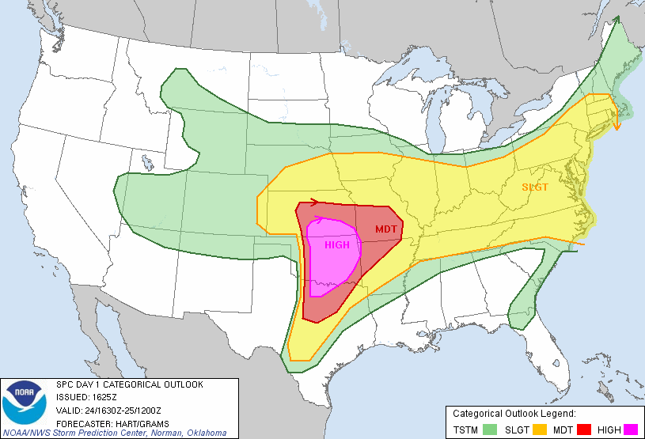

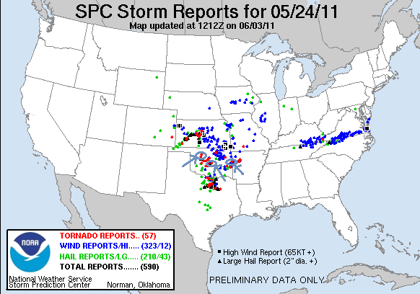

Tour 3 Day 9, May 25th 2011:
The setup for Day 9 was much like the setup for Day 8, another High Risk day, except this time it was shifted east into Arkansas and Missouri. We started the day in Ft. Smith and headed east, passing through the damage path of the previous night’s killer tornado that had hit Denning. There were numerous trees down near the interstate as we went by. Later that morning our course took us through Vilonia where the damage from the powerful April tornado there was still clearly evident. The area we went through had been hit very hard, with many trees down and just about every building we saw was damaged or destroyed.
We proceeded to Searcy and stopped for lunch, then moved north to Newport and sat at Walmart waiting for things to get going. Today was going to be more challenging than the previous day because of the proximity of the jet core: The storms were going to be flying. Sitting at Walmart, a couple of people including the assistant manager and customer service manager came out to talk to us. They were obviously both curious and a little worried that we were there. With Joplin still close on our minds, it was a little uncomfortable to talk to them, knowing that these were nice people who were “under the gun” today.
We didn’t have too much longer to wait before storms began to fire and things got busy quick. There was a storm off to our west that went tornado warned almost immediately, but it was off in the Ozarks which, along with its great speed, made it impossible to chase. There were two more storms coming up the line and we elected to chase the tail end and headed back down the highway towards Searcy. We beat the storm there and maneuvered a little south to Griffithville but much like the previous day, the storm was not yet mature enough to produce tornadoes. Because the storm was moving 50+ MPH this was more of the problem than it had been the day before, since keeping up would be difficult. We watched the storm for a bit but it didn’t look very good, and soon we decided to target the next storm down. The only problem was to get to it we’d have to go well east before turning to the northeast again. We raced through Des Arc and Cotton Plant then turned northeast. Before continuing I need to comment on the amazing amount of flooding in northeast Arkansas. Every bit of low ground was covered with water, and in the forested areas, the bases of all the trees are submerged.
As we headed northeast, we somewhat surprisingly were able to catch the storm near Hickory Ridge, and were able to drive right up alongside the wall cloud as we turned east. As seemed to be the case a lot of the time on this tour, the wall cloud produced a number of funnels but never got that close to dropping a tornado. We stayed with the storm for about ½ an hour before it started to drift off to the north. Meanwhile, a tornadic storm to our south that was closing in on Memphis, TN was catching our eye, and we decided to target it. This one was a race against time as we had to cover a lot of ground in a short period of time in order to make it to Memphis before the storm and the entire trip was going to be in the front flank core. As it happened we were lucky that while we got blasted with wind and rain the whole time, we never got into any hail.
With each step closer to the Mississippi River, the flooding got progressively worse. At one point, we were on a raised road through what were normally dry crop fields, but now it was like a big lake, and with the wind whipping up because of the storm, there were breakers on the water sending spray across the road in front of us! It was almost like driving along an ocean sea wall! Anyway, we finally made it to I-55 at Marion and as we crossed the Mississippi into Tennessee we could see the wall cloud with a rain wrapped cone tornado to our west. We dropped to the south side of Memphis and found a big parking lot with a great vantage north and watched the storm roll right into metro-Memphis, spinning like crazy and dropping funnels ½ way to the ground. Luckily for the city, the storm did not produce another tornado. It did however have fantastic structure and was nicely backlit in orange as the Sun was beginning to set.
We now had to decide between staying with our storm or dropping south into Mississippi on another tornadic storm, but given how ours looked at the time, there was no way we could have left it. We followed the storm east until we were 35 miles from Memphis before finally giving up. The storm did try to get its act together one more time near the end of our trek, but didn’t get it done. We actually ran into the TIV way out there, I was surprised to see it that far to the east. With darkness coming, we gave up and headed back west to Little Rock for the night.
A tough day. On review, we executed the chase well except for one decision that ultimately killed us, which was charging south to meet the tail end storm. As it stood, nearly all of the storms that tornadoed were up in Missouri near the surface low, or in the northern part of Arkansas by the time the storms got mature. Had we stayed in Newport, we could have seen a tornado 4 miles west of where we’d been sitting in the Walmart parking lot. Oh well, at least we got a brief Arkansas tornado (my first) and chased into Tennessee (also a first for me).
The Memphis storm was effectively the last of the tour, as after that we headed for Little Rock, AR for the night, then the following day it was back to OKC. Mileage for the day was 650, second largest of the tour, bringing the total to 4639 miles with one day left.
Day 9 1630Z Convective Outlook and Storm Report:

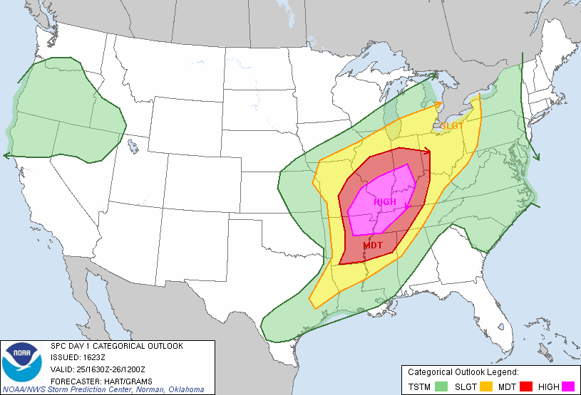
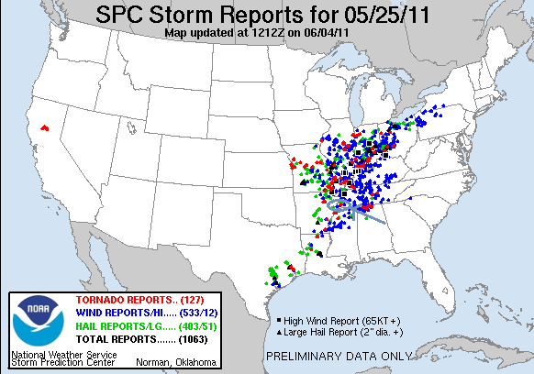
Tour 3 Day 10, May 26th 2011:
This was just a travel day from Little Rock, AR back to Oklahoma City, OK.
352 miles for a final tour total of: 4991.
A tour we’ll never forget!
9 out of 10 chase days,
5 tornado days
Tornadoes in 4 different states (Kansas, Missouri, Oklahoma, and Arkansas)
11 tornadoes total.

