Silver Lining Tours, 2001 Tour #2 Route Guide.

Total Miles: 4936

Day 1:
Start Point: Oklahoma City, OK

Route: Travel Day. Took I-35 North into Kansas, stopping on I-135 just North of Wichita for lunch. Took 254 East to I-35. Proceeded North on I-35 until Emporia, then North on 99 to explore intercept on a storm near Concordia, KS. Took 99 North all the way to near Beattie, KS and turned East on Rte. 36. Took 36 to near Fairview, turning onto Rte. 75 North into Nebraska. Took 75 North all the way to I-80 in Omaha, going West briefly to get to the hotel.

End Point: Omaha, NE

Day 2:
Start Point: Omaha, NE

Route: Chase Day. Took I-80 East into Iowa, to Des Moines, then I-35/80 bypass to I-35 North. Took I-35 North all the way to Albert Lea, MN. Proceeded North to Otawonna, MN, then West on Rte 14. Stayed on 14, stopping in New Ulm for gas.

Chase route: Started North on Rte 15, stopped just outside of New Ulm. Reversed to Rte. 15 South through New Ulm down to near Madelia. Turned Northeast on Rte 60 back to Mankato, then South on 22, East on 2, Southwest on 83, and East on 30. Stopped in Ellendale to watch lightning. Rushed North on I-35 on tornado warning near Otawonna. At Otawonna, turned East briefly on Rte. 19. Then stopped chase.

Return Route: Went South on I-35, having dinner just South of Albert Lea. Got on I-90 West all the way to Sioux Falls, SD, then South on I-29, stopping in Sioux City.

End Point: Sioux City, IA

May 9th, 2001 NOAA Storm Report:
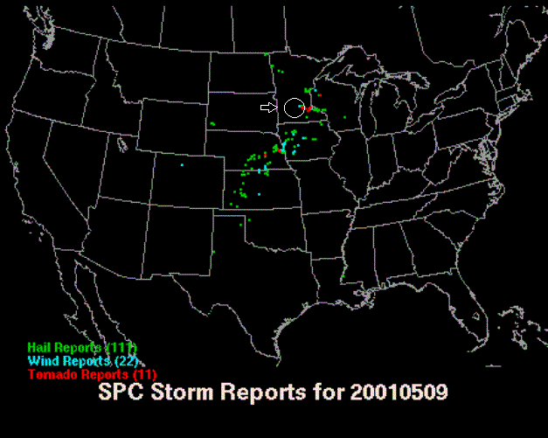

Day 3:
Start Point: Sioux City, IA

Route: Chase Day. Took Rte 20 East with target city Carroll. Turned onto 71 South until reaching Carroll.

Chase Route: Chase began after stop at K-Mart in Carroll. Took Rte. 30 East out of Carroll and proceeded roughly down 30 with some side road maneuvering all the way to Jordan, IA. Briefly proceeded South on Rte. 17 to Luther, then back North to 30 and East through Ames. Took 133 East into Nevada, then 210 South to 14 East through Baxter. Stayed East until 224 South, Intersecting with I-80. Headed West on I-80 in pursuit of new storm. Gave up near Des Moines.

Return Route: Drove South out of Des Moines on Rte. 65/69, stopping for dinner in Indianola. Proceeded South on 69 to I-35, then South on I-35 into Missouri and almost to Kansas City. Turned North on I-435 to I-29 to Platte City, KS.

End Point: Platte City, KS

May 10th, 2001 NOAA Storm Report:
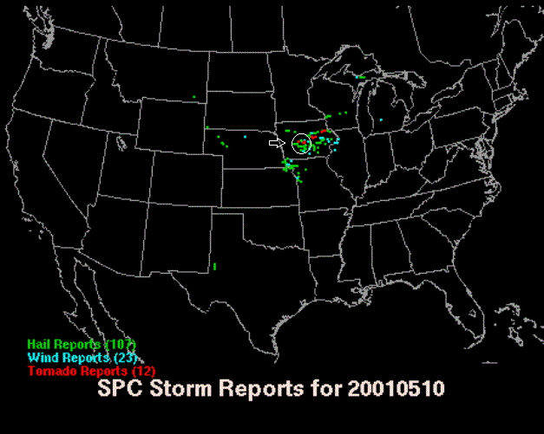

Day 4:
Start Point: Platte City, KS

Route: Travel Day. Took I-435 South to I-35 into Kansas until Emporia. Took Rte 50 West to 150 West to 56 West until hitting I-135. Proceeded North on I-135 to Salina, KS. Short Day.

End Point: Salina, KS.

Day 5:
Start Point: Salina, KS
Route: Travel Day. Took I-135 North, changing to Rte 81 in Minneapolis, KS. To 81 North into Nebraska until hitting I-80 in York. Took I-80 West to Grand Island, then Rte 281 North all the way to South Dakota, stopping at the dam near Lake Francis Case and the Missouri River. Took 281 all the way to Huron, SD then briefly on Rte 14 East of town.

End Point: Huron, SD

Day 6:
Start Point: Huron, SD

Route: Recreation, brief chase day: Took Rte 14 West to Rte 281 South to I90. Took I-90 West stopping to eat in Belvidere, then to 240 (Badlands Natl Park Road). Spent time in Badlands then at Wall Drug back on I-90. Drove back East out of wall to check out distant storms, then stopped near Murdo. Turned Back West to Rapid City, SD. Good Chinese food recommended by Ian!

End Point: Rapid City, SD.

Day 7:
Start Point: Rapid City, SD.
Route: Recreation / Travel Day. Went West on I-90 to Alt-14 South to Deadwood. Had lunch and Bob was the big winner on the slots. Took 385 North to Spearfish, then Back on our favorite highway, I-90 East all the way back to Sioux Falls, SD.

End Point: Sioux Falls, SD.

Day 8:
Start Point: Sioux Falls, SD

Route: Rest / Minor Chase day. Stayed at hotel until after Noon, then scrambled North on I-29, then East on Rte. 324 into Minnesota. Took 324 to Rte 14 with brief detour through windmill farm due to construction. Took 14 East until Rte 23, then 23 East to Willmar.

Sort of Chase Route: Proceeded North on Rte 71 to Sauk Centre then Rte 28 Northeast to Rte 27 East to Little Falls and beginning of tree line. Turned South onto Rte 25 near Pierz until hitting Rte 23. Took 23 West into St. Cloud and stopped for dinner.

Return Route: Took 23 Southwest from St. Cloud to Beaver Creek, Then I-90 West back to Sioux Falls, SD.

End Point: Sioux Falls, SD.

Day 9:
Start Point: Sioux Falls, SD

Route: Chase Day. Took I-29 South to Rte 18 West past Turkey Ridge, then Rte 81 South in Nebraska. Proceeded South to York.

Chase Route: Continued South on 81 into Fairmont, stopping to observe convection. Turned East on Rte 6, then South on 15 near Dorchester. Went South on 15 with some stops and detours on county roads until Fairbury, then East on 136 until just past Harbine where the storm petered out.

Return Route: Went West on 136 back to Rte 81, then South on 81 into Kansas. Continued on 81 South until it became I-135, then stopped in Salina, KS.

End Point: Salina, KS.

May 16th, 2001 NOAA Storm Report:
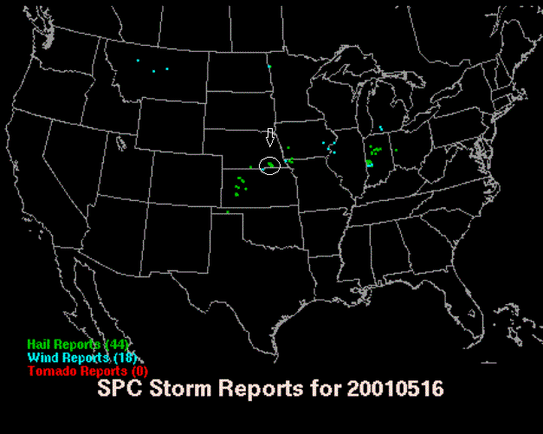

Day 10:
Start Point: Salina, KS

Route: Return, Minor Chase day. Started South on I-135, then I-35 once through Wichita. Continued into Oklahoma, stopping in Tonkawa for “lunch” and a data download. Stayed South on I-35 until Rte 64/412, then West to Enid.

Kinda-Sorta chase route: Drove South on Rte 81 from Enid down to Kingfisher, then West on 3/33 through Watonga. Turned SouthWest on 33 through Custer City then South on Rte 183 into Clinton, then East on I-40 to Weatherford. Stopped for food. Many members of tour clearly out of gas at this point. Storm developed while we ate. Drove West on I-40 to Foss, then South on Rte 44 chasing what turned out to be phantom storm. Stopped near Burns Flat.

Return Route: Turned Back North on 44 then East on I-40 to Oklahoma City.

End Point: Oklahoma City, OK.

